Vacation Packing List

Packing
So what to bring on a trip to Iceland? When you hear people say, the weather is unpredictable in Iceland, it’s no joke! In a given day, you can literally experience multiple seasons, so layering is a must.

Clothing
Raincoat – You never know when it will start to rain in Iceland. Throughout most of the trip, I wore a lightweight raincoat which was great for the constantly changing weather.
Packable Down Jacket – For days when I needed extra warmth, a packable down jacket is incredible to have and layer underneath.
Tops/Sweaters – A lot of our trip was spent in a car driving the Ring Road and stopping at destinations along the way. Being comfy sitting in a car for hours is important to an enjoyable road trip. I loved having cozy sweaters for the car ride.
Base Layers – Be prepared with a few base layers to give you extra insulation, especially if you plan to hike.
Pants – A pair of denim and hiking pants/leggings will go a long way.
Shoes – We spent the first and last day of our trip in Reykjavik. Depending on what you prefer to do in the city, I would suggest a pair of casual shoes to explore the town. Don’t forget hiking boots/athletic shoes though. You’ll definitely need them to explore the country.
Undergarments and socks – I recommend smartwool socks. Not only are they comfy, but they wick away sweat.
Knit cap, scarf and gloves – The wind can be pretty brutal but having a few little essentials to cover can your extremities will help make your time outside in the cold weather manageable.
Swimsuit – Even if you don’t plan to visit the Blue Lagoon, there are natural hot springs throughout the country. I highly suggest seeking one out and going for a little dip.
>>Read our tips for packing light for winter travel.
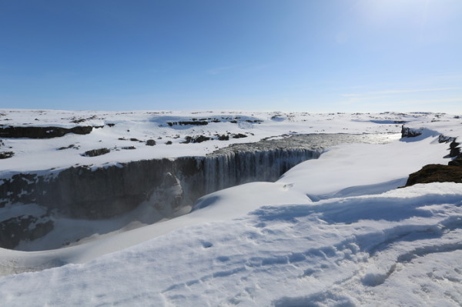
beautiful, snowy Iceland

Toiletries
Essentials – Shampoo, conditioner, soap, toothpaste, toothbrush, floss, deodorant, and other hygiene supplies
Makeup bag – Cosmetics, lotion, sunscreen
Medications – Put together your travel medical kit.

Gadgets
Camera – Don’t forget a camera! The scenery in Iceland is breathtaking! You will want to stop and take pictures everywhere.
Video camera/GoPro – We mounted a GoPro to our car to capture the landscape while driving throughout the country.
Memory cards, external batteries and chargers
Laptop/tablet
Headphones
Adapter

Other
Music – I love having a specific playlist for road trips. There are songs that I can hear today which will remind me of specific moment from an adventure that I had.
Books – Most of the places we stayed at did not have internet, so I spent nights curled up reading a great book.
Water bottle
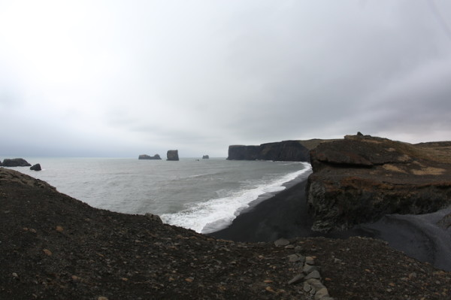
dramatic landscapes in Iceland

Tips for visiting Iceland
Iceland is magical during the winter but be aware that some of the side roads may be impassable if you are visiting during that time. If you drive the Ring Road,rent a vehicle with 4WD and make sure to get GPS. GPS coordinates are incredibly helpful in finding certain locations.
Outside of Reykjavik, we opted to stay at Airbnb options along the Ring Road. Some of the locations are quite remote. If you decide to use this service, plan to get exact routes from your host especially if you are getting to your destination late.
Flights are relatively inexpensive from the east coast of the United States, but once you get to Iceland things can be pricey. If you are looking to explore on a budget, stay at a hostel and stock up on food at the grocery stores. Don’t forget to allow yourself to splurge on an adventure or two, such as glacier or ice cave trekking, scuba diving, or possibly a helicopter tour.
Finally, be prepared to fall in love with Iceland!

