Lakdasun Trip Report Template

Start with a summery of your trip.

Provide a brief summery of your trip. The information in this section will help the viewers to quickly overview of the trip. We also use this information to categorize your trip for easy searching.

Year and Month | e.g. May, 2006  This will help reader to asses how current the information may be
Number of Days | e.g. 3
Crew | e.g. 8 (between 25-30 years of age)  This is help the reader to gauge whether the trip is suitable for the crowd he/she has in mind
Accommodation | e.g. Camping  Its better if you can make a post in the accommodation options board in the forum about the place(s) you stayed at and post those links here
Transport | e.g. Jeeps  Just explain how you got around. If you utilized several mods of transportation you can even say “from Colombo to Kandy by train and then to xxxxx by bus and thereafter to the cottage by foot”
Activities | e.g. Wildlife, Photography, off-road driving  What ever that you did in the trip goes here. Just give a flavor of what can be done to the reader
Weather | e.g. Excellent  Say a few words about how weather co-operated with you during the trip. You can even say something like “It was ok for the most part but rained a bit in the second day”
Route | Colombo->Puttlam->Vilpattu and return on the same route.  If you can crate a Google earth .kml file of the route you covered. Please submit it with the trip report.
Tips, Notes and Special remarks | e.g.  - Camp sites should be reserved in advance from the department of Wildlife  - It’s better if you can carry a stock of water at least for drinking purposed.  List the important things you planed in advance which actually helped you. Also list any important notes that you would think that will help anyone who will travel the same path. Things that you thought that you should have done, mistakes you made which you will never repeat or things that you felt “good that I thought about it!”
Author | Mithila  Your forum username and a link to the forum profile will be added here

Title – Whatever you would like to call the experience

E.g. A Three Day Trip to Vilpattu, One of My Favorite National Parks

Text and Pictures

- Use text to create the skeleton of the trip report. In other words the skeleton story.

- Then use pictures with captions to illustrate the trip

- “a picture is worth a thousand words” so more pictures are welcome
  - Chose the most memorable pictures of the trip to tell the story. Think about a short caption (description) for each picture.
  - Resize your pictures to have longest side between 400px and 800px
  - Insert pictures in to the appropriate places along with the text. (See the sample below)
  - When you chose pictures, chose the ones that illustrate your trip. Pictures that capture the moments and the beauty of the surrounding are the best. Also include pictures of the main attractions if possible.
  - Be cautious about posting pictures with people. While there is no restriction, you should be 100% sure that the people pictured are ok with you posting them on the web!
  - Please refrain from posting pictures taken at sites where photography is restricted and where you were aware of such restrictions at the time of taking the particular picture. While we generally do not believe that such restrictions are rational as discussed in this thread, as a responsible group we should always respect the rule while it is in force.

Below is a sample we came up with, just to illustrate how the main trip report body can be organized. This is just a sample and you need not be restricted to the writing style or presentation below. Just use your own style. Jus adhere to the above three simple guidelines.

e.g.

We started form the suburbs of Colombo at about 4.00 in the morning. The crew was eight in two Land Cruiser BJ43 jeeps. I was driving mine and Hari was driving his, both jeeps were packed with gear and rations for two nights camping.

The drive to Vilpattu was quite effortless. It was early morning and road up to Puttlam is in great shape. With just two stops, one for fuel and the other for breakfast, we were at the park entrance well before noon.

I’m a big fan of Vipattu. One reason I love it because of its shear size. The camp site we reserved is known as the “Kali-Villu” which is 40km in side the park from the entrance. For a country that is just 400km long from the top to bottom, that is quite a bit of a distance away from civilization!

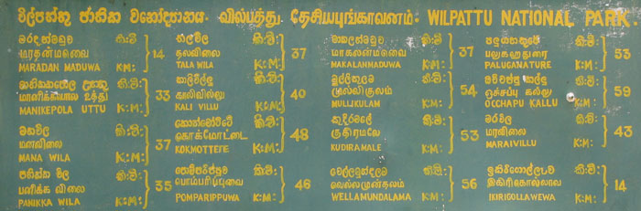
The main points of interest inside the park. Note how far they are from the entrance!

After completing the formalities we started our journey to the camp site at around 10.00 a.m. Just half and hour later, may be after driving about 15km, an unexpected happened. Hari had a flat tire. Changing the tire was not a big deal but now we are down to just one spare for both jeeps with a lot of driving to be done in the wild!

From there the rest of the journey to Kali Villu camp site was incident free but full of excitements. The leopard mother with two cubs that we met on the way was the highlight of the journey.

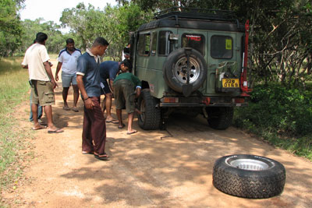
Changing the flat. Having to rely on just one spare is not a good thing
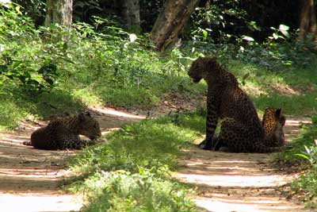
Mother leapard and the two cubs was the first sighting of the day

At the camp site we settled for lunch and relaxed a bit before the late afternoon drive to explore more of this magnificent park.

The camp site “Kali-Villu” did not excite us that much. Located at the edge of one of the larger lakes, their location wasn’t too great. Access to water was not easy either. The sandy camp ground and strong winds made it even more hostile.

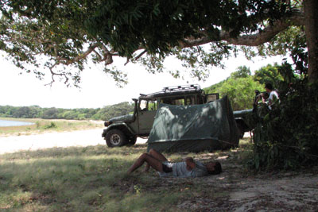
Sandy and hot Kali Villu Camp site - not the greatest in the park
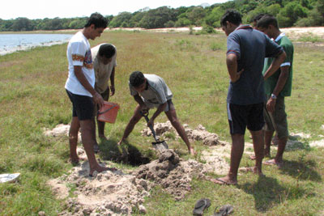
even though the large water body was right next to us, we had to dig a small well for easier access

