Travel Packing List to the Beach

Clothing:
2-3 pairs of shorts – you can wear it over your swimsuit when you go to the beach, or to stroll around the streets of the island, or if you go hiking.
3 tank tops or t-shirts – you will match them with your shorts.
1 casual dress – for your day activities if you don’t want to wear shorts. (Try amaxi dress for airy versatility.)
1 formal/party dresses – for your nights out. (Your LBD should do the trick.)
1 pair of trousers – in case it gets really windy at night
1 light jacket – Although it can be really hot in Greece in the summer months, at night especially in the islands, there is a sea breeze and a light jacket is a must.
2 bras – You don’t need many since you will be wearing your swimsuit all day
7 pairs of underwear – I usually take 1 for each day. If you need more you can wash them in the sink.
2 pair of socks – To wear with your trainers if you go hiking
1 pajamas – or you can sleep with a T-shirt but it has to be light

Shoes:
1 pair flip flops – I use them at the beach since the sand can be very hot
1 pair leather sandals – They are good for all day use and at night if you don’t won’t to wear heels
1 pair non slippery trainers – They are ideal for hiking
1 pair platforms (optional) – I don’t recommend wearing high heels in the Greek islands since many of the roads are cobbled. But if you want to take with you something that has heels I recommend platforms.

For the beach:
1 bag for the beach – it can be either a shoulder bag or a backpack. If you are planning to go hiking as well, a backpack is better.
2 swimsuits – Since you will be spending most of your days on the beach. You wear the one and let the other dry. I usually have 3 swimsuits with me but 2 will do.
1 Sarong – I usually use it over my swimsuit, to cover up my legs or shoulders when visiting a monastery, or as a shawl at night over your dress.
1 Beach Towel – to lay it out on the sand. (Consider a Turkish Travel Towel to save space.)
1 Sunscreen – for your face and body. I think this is the most important thing to carry with you since the sun burns a lot.
1 Hat – not only for the beach but for your walks around the island since you don’t want to have a sunstroke or get burned. (Check out these packable sun hats.)

Toiletries:
Shampoo & Conditioner – Travel size is enough for a week
Body Wash – I prefer the 250ml bottles (You’ll need to pack 100ml or less if you plan on traveling carry-on only.)
Body Lotion – It is vital since your skin will get dehydrated from the sea and sun.
Razor – 1 razor is enough
Deodorant – it is very hot so you will need one to keep smelling nice
Toothbrush – select one with a case to keep it clean
Toothpaste – 1 travel tube is fine
Hair Brush – I use travel size
Hair Ties – to keep your hair up on the hot days
Face and Eye Cream – it’s good to hydrate after so much salt and sun.
Make up – If you want to use make-up on your nights out.
Mosquito repellent for your body – I usually spray myself at night to avoid being bitten. They usually smell of citronella.
Mosquito repellent for your room – If you want to sleep at night you should use them. You can also find them in supermarkets across Greece.
Prescriptions – take whatever pills you use at home. I always take painkillers, something for the bites (mosquito etc), digestion pills (if you eat more one day) etc.
Motion sickness pills – for the ship if it is windy and for boat trips around the island. (Read about how to prevent motion sickness.)
Birth Control & Condoms – It’s good to be prepared.
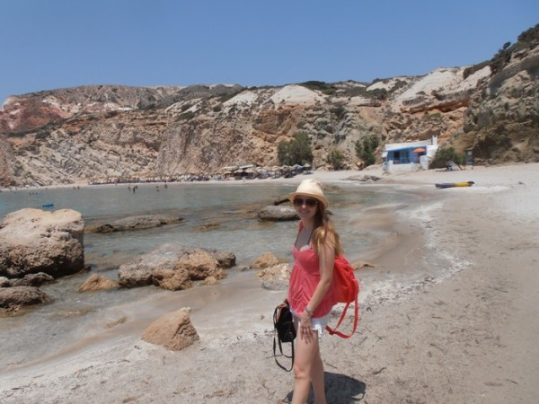
Chrysoula on Milos Island

Tech Gear:
Camera – In order to take the most amazing photos of your holiday.
Memory Card – I always take a second one with me just in case.
Mobile Phone – To get in touch with your friends and family, to connect online, to listen to music etc.
Necessary chargers – For your mobile phone, camera etc.
European Adapter – If you need one.
Laptop or Tablet – I usually take my tablet with me

Other:
Small shoulder bag – For your walks around the island. Big enough for your wallet and camera.
Passport and visa – Check if you need a visa with the Greek embassy in your country.
Books – To read on the beach, on the boat etc

