AR 12 (TP) Transition Plan
AR12 Transition Plan for a young person NC Year 9 and above

Name:
School:

Date of birth: National Curriculum Year:

This Transition Plan started on: My link person is:

List all those who are, or will be, involved in the transition planning process

Name | Role | How these people were involved in my (appropriate)
 |  | Involvement requested | Contributed to Transition Plan | To be involved in follow up | Sent copy of Transition Plan

Record below all the issues and needs which will be part of the transition process, what action will be taken and who will do this.
At the next review of this plan, the ‘What happened?’ section can be filled in using the code: Achieved, Ongoing, Next Priority, or No Longer Relevant

 | Issues we needed to think about | What we decided should be done | Who is taking action? | When will the action be completed? | What happened?
My education, skills and training

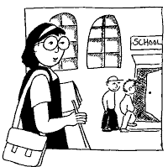

My social development

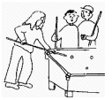

 | Issues we needed to think about | What we decided should be done | Who is taking action? | When will the action be completed? | What happened?
My family and the people around me

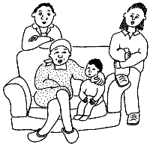

My health

What are the agreed long-term aims for the young person? (If everyone does not agree with these aims, please explain why they do not)

What are the agreed available options for the young person after school? ( please as appropriate)
Leave school at 16 years of age | Application to LSC for specialist college
Local FE college | Other (please specify)

Date of meeting
We will meet again on
Completed by
Signed

