20XX-20XX Transition Plan Guidance Document
The yellow highlighted sections indicate that it is new for the 20XX-20XX school year.

Individualized Education Program
Post Secondary Transition Plan, Page One
Student Name: __________________________________________ IEP Meeting Date: ____/____/____
Current Grade Level:_____________________ Expected Date of Graduation: _____/_____/_____
Evidence of involving student & related agencies: Identify method(s) of outreach to student and interagency partners, e.g., letter/date, phone call/date, email/date

List Age Appropriate Transition/Vocational Assessments (by name of the Assessment and the Date Administered):
Example- Brigance Life Skills/ Employability Skills Inventory 8-25-09

Summary of Assessment results (what we learned about the student):
Example- Student showed strong preferences for careers in the culinary / food service occupation strands. Additionally he demonstrated high capacity for social interaction and visual tasks. Career exploration should connect all these assests and be conducted within the food service / hospitality industry.

Student’s post graduation expected outcomes (These outcomes are developed in collaboration with the student and the family. They are generally understood to refer to those outcomes that a child hopes to achieve after leaving high school.)

Post-Secondary Employment Outcome (required):
Example- The summer after leaving high school, student will obtain a part-time position in a community retail environment.

Post-Secondary Education or Training Outcome (required):
Example- Upon completion of high school, student will enroll in courses at Community College of Vermont.

Independent Living Outcome (as appropriate):
Example- Upon completion of high school, student will independently prepare for work each day, including dressing, making his bed, making his lunch, and accessing transportation.

Page __ of __ Form 5
Individualized Education Program
Post Secondary Transition Plan, Page Two
Coordinated, Measurable, Annual Transition Goals based upon student preference, interests and required transition assessments listed above. (Consider various options such part-time employment, supported job placements, service learning projects, work experience, job shadowing, internships, practice in resume writing and interviewing skills, the use of resource centers and job specific skills regarding customer service or technology):  Community Employment Goal (required):  See samples on TRIPSCY  TRIPSCY Transition Resources  Vocational Training Goal (if needed): (think “pre-employment” skills. For example: a student may need to seek time with a mentor/counselor to develop anger management skills to deal with the work related frustrations. A student may need to spend time with an SLP to develop clear, appropriate speech and good eye contact while talking to co-workers. A student may need to acquire the skills to drive a fork lift before applying for a warehouse job. A student may have to practice community mobility in order to get to a job site independently.)  See samples on TRIPSCY  TRIPSCY Transition Resources  Post-Secondary Education Goal (if appropriate, if not indicate with an N/A):  See samples on TRIPSCY  TRIPSCY Transition Resources  Back to top | Progress Review  Dates
Page __ of __ Form 5

Individualized Education Program Post Secondary Transition Plan, Page Three
Coordinated, Measurable, annual Transition Goals based upon student preference, interests and required transition assessments listed on the previous page. (Consider options such as participation in community based experiences, learning how to independently access community resources, building social relationships, managing money, understanding health care needs, utilizing transportation options and organizational skills):  Independent Living Goal (if appropriate, if not, indicate with an N/A):  See samples on TRIPSCY  TRIPSCY Transition Resources  Community Participation Goal (if appropriate, if not, indicate with an N/A):  See samples on TRIPSCY  TRIPSCY Transition Resources | Progress Review  Dates
Describe the Coordinated Interagency Linkages and Responsibilities (services provided or paid for from another agency and a timeline for completion):
Back to top
If the student will be reaching age 17 during the duration of this IEP, they have been notified that parental rights will transfer to the student upon reaching the age of 18 ⁭ Yes ⁭ No
If not, please specify how they were notified):

State and Local Transition Course of Study Requirements:
Requirement: You must check the appropriate box below and develop the corresponding course of study form that follows for either specialized courses or alternative credits earned through a multi-year plan.
⁬ Standard Course of Study ⁬ Specialized Course of Study for Post-Secondary Annual Outcomes
⁬ Multi-year plan for Graduation Requirements

Page __ of __ Form 5

Individualized Education Program
Post Secondary Transition Plan, Page Four
Student Name: __________________________________________ IEP Meeting Date: ____/____/___

Document the specialized course of study or alternative credit courses/programming to support the transition plan:

School Year | Grade Level | Course Required for Graduation and/or Post-Secondary Annual Outcome | Credit Required | Alternative Course or activity | Alternative Credit
09-10 (Example) | 11 | Algebra 2 | 2 | Life-skills math 1 | 2
If alternative credits are being granted through a multi-year plan, this page must be signed by the Superintendent or their designee:

_______________________________________ ___________________________________ Superintendent or Designee Signature Date

Vermont Post Graduation Expected Outcomes:

Definition- 1: A post graduation expected outcome is “generally understood to refer to those outcomes that a child hopes to achieve after leaving secondary school (i.e., high school)” (IDEA 2004 Part B Regulations, §300.320(b), discussion of Final Rule p. 46,668) A postsecondary outcome is not the process of pursuing or moving toward a desired outcome.

Back to top

Post Secondary Employment Outcomes
EXAMPLES (1.3a – 1.3t, 1.5a – 1.5d)
1.3a: This is an example of a measurable postsecondary outcome in the domain of employment.
Example:
- John will work in an on-campus part-time job while in college.
  - This outcome meets I-13 standards for Item #1 for the following reasons:
    - Obtaining employment is the focus of the statement.
    - Working part-time is an explicit outcome that can be observed.
    - The phrase “while in college” indicates that the outcome will occur after John has graduated from high school.
1.3b: Nonexample:
- John will attend a job fair on the college campus.
  - This outcome statement does not meet I-13 standards for item #1 for the following reasons:
    - While “attending a job fair” is measurable, this statement suggests an activity toward a postsecondary outcome.
    - This activity could occur while John is still in high school.
1.3c: This is an example of a measurable postsecondary outcome in the domain of employment.
Example:
- After college, Allison will have a career in the field of early childhood education.
  - This outcome meets I-13 standards for Item #1 for the following reasons:
    - The focus of the outcome statement is Allison’s postsecondary employment.
    - While this a long-term outcome statement, it does indicate an outcome (having a career in a particular field) that can be observed as occurring or not.
    - The outcome must occur after high school.
    - The outcome is supported by Allison’s postsecondary education/training outcome.
1.3d: Nonexample:
- Allison hopes to work with young children someday. Back to top

  - This outcome does not meet I-13 requirements for Item #1 for the following reasons:
    - “Hopes” is not a measurable outcome.
    - “Work with young children” does not necessarily indicate an employment outcome.
1.3e: This is an example of a measurable postsecondary outcome in the domain of employment.
Example:
- In the future Jamarreo will be a self-employed welder.
  - This outcome meets I-13 standards for Item #1 for the following reasons:
    - The action will occur after high school.
    - The result of this outcome is observable (i.e., Jamarreo will or will not be a self-employed welder).
1.3f: Nonexample:
- Jamarreo wants to work as a welder.
  - This outcome does not meet I-13 standards for Item #1 for the following reasons:
    - “Want” is not an outcome.
    - This outcome statement is not measurable.
1.3g: This is an example of a measurable postsecondary outcome in the domain of employment.
Example:
- Immediately after graduation, Rolanda will receive job development services from vocational rehabilitation or a community rehabilitation program and will participate in technologically supported self-employment or volunteer work within 1 year of graduation.
  - This outcome meets I-13 standards for Item #1 for the following reasons:
    - It is stated that the outcome will occur after graduation from high school.
    - The outcome is stated measurably: “receive services” and “participate” can be observed as occurring or not, within 1 year of graduation.
1.3h: Nonexample:
- Upon completion of high school, Rolanda will apply for services through vocational rehabilitation to support her participation in a vocational center program.
  - This outcome does not meet I-13 standards for Item #1 for the following reasons:
    - Applying to vocational rehabilitative services is an activity not an outcome.
    - This outcome is an activity that should be achieved while Rolanda is still in school and does not reflect a postsecondary outcome for her employment.
1.3i: This is an example of a measurable postsecondary outcome in the domain of employment.
Example:
- The summer after leaving high school, Jodi will obtain a part-time position in a community retail environment.
  - This outcome meets I-13 standards for Item #1 for the following reasons:
    - Participation in employment is the focus of this outcome.
Back to top
    - Attaining a part-time position in a retail environment can be observed, as in Jodi is hired or she is not.
    - The expectation, or behavior, is explicit, as in Jodi either attains the identified position or does not.
    - It is stated in this outcome that community employment will be sought after graduation.
1.3j: Nonexample:
- Upon graduation from high school, Jodi hopes to improve her vocational skills through work experiences.
  - This outcome does not meet I-13 standards for Item #1 for the following reasons:
    - “Hopes” is not an observable behavior.
    - The expectation for learning, or behavior, is not explicitly stated.
1.3k: This is an example of a measurable postsecondary outcome in the domain of employment.
Example:
- After finishing high school Alex will increase his work hours in the business department of a local office supply store, contacting XYZ Adult Agency for employment support services.
  - This outcome meets I-13 standards for Item #1 for the following reasons:
    - Participation in employment is the focus of this outcome.
    - Increasing work hours is measurable.
    - The expectation, or behavior, is explicit, as in Alex continues employment, or does not and Alex accesses adult agency services monthly (or does not).
    - It is stated in this outcome that increased employment and use of adult services will occur after Alex leaves high school.
1.3l: Nonexample:
- Alex will work with vocational rehabilitative services to ensure community employment.
  - This outcome does not meet I-13 standards for Item #1 for the following reasons:
    - Working with VR is not measurable as stated.
    - The expectation for learning, or behavior, is not explicitly stated.
    - “Ensure community employment” suggests a process, not an outcome.
    - It is not clear that the activities will continue to occur, or will occur after high school.
1.3m: This is an example of a measurable postsecondary outcome in the domain of employment.
Example:
- After graduation, through the assistance of VR and the staff of the non-degree program, Lissette will obtain part-time employment on campus at MCC that does not interfere with the schedule for her program there.
  - This outcome meets I-13 standards for Item #1 for the following reasons:
    - Obtaining part-time employment is observable. Back to top
    - This employment outcome is also consistent with both of Lissette’s postsecondary education and independent living.
    - The action will occur after graduation.
1.3n: Nonexample:
- Lissette will get a job. Back to top
  - This outcome does not meet I-13 standards for Item #1 for the following reason:
    - While “getting a job” is measurable it is unclear that this needs to occur after graduation from high school. Further, Lissette is in her final year of school (i.e., 20 years old), she should have a clearer awareness of her employment future than simply “getting a job”.
1.3o: This is an example of a measurable postsecondary outcome in the domain of employment.
Example:
- After graduation, Jeremy will be employed part-time in the community with supports.
  - This outcome meets I-13 standards for Item #1 for the following reasons:
    - The outcome statement includes an observable behavior.
    - The criterion “with supports” is unnecessary for this to meet the standards for I-13, but provide additional information that may assist in planning and linking Jeremy with services that will support his postsecondary employment outcome.
1.3p: Nonexample:
- Jeremy hopes to work at a store near his home part-time after high school.
  - This outcome statement does not meet I-13 standards for Item #1 for the following reason:
    - “Hopes” is not observable.
1.3q: This is an example of a measurable postsecondary outcome in the domain of employment.
Example:
- After graduation, Paulo will get a job at a grocery store, where he enjoyed a job-shadowing experience during school.
  - This outcome meets I-13 standards for Item #1 for the following reasons:
    - The action in the statement is observable.
    - The outcome statement is focused on postsecondary employment.
    - While not required, this postsecondary employment outcome statement corresponds to Paulo’s postsecondary education/training outcome and is founded on Paulo’s interests (i.e., job-shadowing experience he enjoyed).
1.3r: Nonexample:
- After graduation, Paulo will be referred to Vocational Rehabilitation for assistance with job placement through assessments and temporary supports
  - This outcome does not meet I-13 standards for Item #1 for the following reasons:
    - A referral to vocational rehabilitation is an activity, not a outcome.
    - A referral to vocational rehabilitation is a transition service that should occur to support a postsecondary employment outcome while Paulo is still in school. Back to top
1.3s: This is an example of a measurable postsecondary outcome in the domain of employment.
Example:
- Within three months of graduation, Kevin will obtain a supported employment position that allows him to work to his maximum stamina and incorporates the use of assistive technology.
  - This outcome meets I-13 standards for Item #1 for the following reasons:
    - It is stated that the outcome will occur after graduation from high school.
    - The outcome is stated measurably: “obtain” and “work” can be observed as occurring or not, within three months of graduation.
1.3t: Nonexample:
- Upon completion of high school, Kevin will express his preferences related to his postsecondary employment options, given picture symbols and the iTalk2, an augmentative communication device.
  - This outcome does not meet I-13 standards for Item #1 for the following reasons:
    - Expressing preference about employment preferences is an activity. Expressing preference about employment is not an outcome.
    - This outcome is an activity that should be engaged in with Kevin prior to and throughout secondary transition. It does not reflect a postsecondary outcome for his employment.
1.5: It is possible to include the postsecondary areas of education/training, employment, and, if applicable, independent living in one postsecondary outcome statement. The following examples illustrate outcomes that meet the criteria for measurable postsecondary outcomes for item #1 of the NSTTAC Indicator 13 Checklist in more than one domain.
1.5a: This is an example of a measurable post-secondary outcome in the domains of education and employment.
Example:
- After graduating from high school, Jason will enroll in a four-year college to obtain his undergraduate degree in history and education, to become a high school social studies teacher
  - This outcome meets I-13 standards for Item #1 for the following reasons:
    - Enrolling in a four-year college is observable.
    - Obtaining an undergraduate degree in history and education is measurable.
    - Becoming a high school social studies teacher is also observable.
    - The expectation, or behavior, is explicit, as in Jason performs the required activities or he does not, after graduating from high school.
    - These outcomes logically must occur after high school (and it is stated that the outcome will occur after graduation).
1.5b: Nonexample:
- Jason will meet the criteria for passing Spanish II, so that he can apply to college where he wants to major in education
  - This outcome does not meet I-13 standards for Item #1 for the following reasons:
    - It occurs before Jason will have left high school.
    - “Apply” is an activity or process, not an outcome. Back to top
1.5c: This is an example of a measurable post-secondary outcome in the domains of education/training, employment, and independent living.
Example:
- The summer after leaving high school, Stephanie will independently ride the bus each work day to her job with Marriot Food Services, where she will participate in classes each year, as offered by her employer, to advance industrial kitchen skills.
  - This outcome meets I-13 standards for Item #1 for the following reasons:
    - Development of an independent living skill, specifically transportation independence, and participation in on-the job training (employment implied), are the focuses of this outcome.
    - Independently riding the bus is observable, as in Stephanie demonstrates the skill or she does not.
    - Reporting to her job with Marriot Food Services is also a skill that can be observed.
    - Participating in employer-offered job skill training will occur in conjunction with Stephanie’s employment with Marriot Foods (as she does not need additional job training after high school) and participating in these courses is also observable.
    - It is stated that the outcome will occur after Stephanie exits high school.
1.5d: Nonexample:
- Stephanie wants to get a job in food services and will develop skills to access the county’s public transportation system
  - This outcome does not meet I-13 standards for Item #1 for the following reasons:
    - The outcome is not measurable as stated.
    - Part of the outcome as stated (i.e., developing transportation skills) would likely occur while the student was in school.
This document was produced under U.S. Department of Education, Office of Special Education Programs Grant No. H326J050004. Marlene Simon-Burroughs served as the project officer. The views expressed herein do not necessarily represent the positions or polices of the Department of Education. No official endorsement by the U.S. Department of Education of any product, commodity, service or enterprise mentioned in this publication is intended or should be inferred. This product is public domain. Authorization to reproduce it in whole or in part is granted. While permission to reprint this publication is not necessary, the citation should be: National Secondary Transition Technical Assistance Center (2007) Indicator 13 Training Materials, Charlotte, NC, NSTTAC. Back to top
Post Secondary Education and/or Training Outcomes
1.2a: This is an example of a measurable postsecondary outcome in the domain of education/training.
Example:
- Upon completion of high school, John will enroll in courses at Ocean County Community College*.
  - This outcome meets NSTTAC Indicator 13 (I-13) standards for item #1 for the following reasons:
    - Participation in postsecondary education is the focus of this outcome. Back to top
    - Enrollment at a community college can be observed, as in John enrolls in courses or he does not.
    - The expectation, or behavior, is explicit, since John enrolls at the community college or he does not.
    - Enrollment at a community college occurs after graduation, and it is stated that this outcome will occur after graduation.
1.2b: Nonexample:
- Upon graduation, John will continue to learn about life skills and reading.
  - This outcome does not meet I-13 standards for item #1 for the following reasons:
    - Participation in learning is the focus of this outcome, but no specific place or program is specified.
    - The expectation for learning, or behavior, is not explicitly stated.
1.2c: This is an example of a measurable postsecondary outcome for I-13 item #1 on the NSTTAC Indicator 13 Checklist in the domain of education/training.
- Allison will obtain a four-year degree from a liberal arts college with major in Child Development**.
  - This outcome meets I-13 standards for item #1 for the following reasons:
    - Participation in postsecondary education is the focus of this outcome.
    - Obtaining a degree at a college can be observed, as Allison gets a degree or does not.
    - Obtaining a college degree occurs after graduation from high school.
* Note that there would likely be less specificity in the postsecondary outcomes articulated by younger students, than those in their last years of high school. John’s outcome could be made more specific by including a phrase such as “will enroll in the general Associates Degree program at….”
** It is not necessary to specify the student’s major for the outcome to be measurable, however, increased specificity in postsecondary outcome statements (when the student articulates this information) can improve the relevance of services provided during high school. Back to top
1.2d: Nonexample:
- The fall after graduation from high school, Allison plans to enroll in a four-year university in the Southeast.
  - This outcome does not meet I-13 standards for item #1 for the following reasons:
    - “Plans” does not indicate something that must occur after high school and can be ongoing after exit: “will enroll” would make this a measurable postsecondary outcome.
1.2e: This is an example of a measurable postsecondary outcome in the domain of education/training.
Example:
- Upon graduation from high school, Jamarreo will successfully complete welding courses at Central Piedmont Community College to attain the Entry Level Welding Certificate.
  - This outcome meets I-13 standards for item #1 for the following reasons:
    - Participation in training is the focus of this outcome.
    - Successful completion of a welding certificate can be observed, as in Jamarreo meets the requirements of the coursework or he does not.
    - The expectation, or behavior, is explicit, as in Jamarreo attains the certificate or he does not.
    - It is stated in this outcome that the training will occur after graduation. Back to top
1.2f: Nonexample:
- Jamarreo will learn about welding.
  - This outcome does not meet I-13 standards for item #1 for the following reasons:
    - Learning about welding is not measurable as stated. This outcome is not measurable, as no criterion or timeframe is identified.
    - The expectation for learning, or behavior, is not explicitly stated.
    - It is not stated that the outcome will occur after graduation.
1.2g: This is an example of a measurable postsecondary outcome in the domain of education/training.
Example:
- After graduation, Rolanda will participate in an in-home or center-based program designed to provide habilitative and vocational training with medical and therapeutic supports.
  - This outcome meets I-13 standards for Item #1 for the following reasons:
    - Participation in training is the focus of the outcome.
    - “Participation” is an observable behavior. Back to top
1.2h: Nonexample:
- After leaving high school, Rolanda’s family plans for her to receive habilitative training through Medicaid Community Alternatives Program (CAP) services.
  - This outcome does not meet I-13 standards for Item #1 for the following reason:
    - “Plans” does not indicate an explicit behavior by the student that will occur after high school that can be observed as occurring or not occurring.
1.2i: This is an example of a measurable postsecondary outcome in the domain of education/training.
Example:
- The fall after high school, Jodi will enroll in courses (non-degree) at Gaston Community College.
  - This outcome meets I-13 standards for Item #1 for the following reasons:
    - Enrolling in courses in a postsecondary education environment is the focus of the outcome.
    - Enrolling in courses (or not) can be observed.
    - The outcome will occur after Jodi leaves high school. Back to top
1.2j: Nonexample:
- After leaving high school, Jodi wants to take some classes
  - This outcome does not meet the I-13 standards for Item#1 for the following reason:
    - “Wants” does not indicate an explicit behavior by the student that will occur after high school that can be observed as occurring or not occurring.
1.2k: This is an example of a measurable postsecondary outcome in the domain of education/training.
Example:
- After high school, Alex will take a business math class at Kings College (a technical school)
  - This outcome meets I-13 standards for Item #1 for the following reasons:
    - Enrolling in a course in a postsecondary education environment is the focus of the outcome.
    - This outcome corresponds with Alex’s other postsecondary outcome of continuing employment (that is highly math skill focused) with a local business.
    - This outcome reflects Alex’s strengths in the area of math. Back to top
1.2l: Nonexample:
- Alex thinks he’ll major in math in college
  - This outcome does not meet I-13 standards for Item #1 for the following reason:
    - The outcome is written as a process, rather than an outcome that can be demonstrated.
1.2m: This is an example of a measurable postsecondary outcome in the domain of education/training.
Example:
- After graduation from high school, Lissette will complete the non-degree program at Montgomery County College
  - This outcome meets I-13 standards for Item #1 for the following reasons:
    - Completing a postsecondary education program is the focus of the outcome statement.
    - This outcome is consistent with Lissette’s other employment and independent living postsecondary outcomes and could support her attainment of her other outcomes.
    - The outcome is stated as occurring after Lissette is no longer receiving services in high school.
1.2n: Nonexample:
- Lissette wants to go to college
  - This outcome does not meet I-13 standards for Item #1 for the following reasons:
    - “Wants” is not measurable.
    - There is no component of the outcome statement that indicates the outcome will occur after Lissette’s secondary school experience. Back to top
1.2o: This is an example of a measurable postsecondary outcome in the domain of education/training.
Example:
- After high school, Jeremy will improve his social, self-advocacy, and self-care skills by attending instruction at a center-based adult program
  - This outcome meets I-13 standards for Item #1 for the following reasons:
    - Attending a center-based program focused on training is the focus of this outcome statement.
    - Improving the skills noted is an explicit outcome for Jeremy.
    - Improving skills and attending the program are observable outcomes.
1.2p: Nonexample:
- After high school, Jeremy will need to continue to work on his self-care skills
  - This outcome does not meet I-13 standards for Item #1 for the following reason:
    - The statement provided is not written as a outcome for Jeremy, but as a need that will need to be addressed after high school.
1.2q: This is an example of a measurable postsecondary outcome in the domain of education/training.
Example:
- After graduation, Paulo will participate in training to improve his work skills in his job at a grocery store.
  - This outcome meets I-13 standards for Item #1 for the following reasons:
    - On-the-job training in a postsecondary environment is the focus of this outcome statement.
    - Participation in the training is measurable and is stated as an explicit outcome for Paulo. Back to top
1.2r: Nonexample:
- After graduation, Paulo will get a job at a grocery store
  - This outcome does not meet I-13 standards for Item #1 for the following reason:
    - Obtaining employment is not a postsecondary education/training outcome.
1.2s: This is an example of a measurable postsecondary outcome in the domain of education/training.
Example:
- Immediately after graduation, Kevin will participate in habilitative and functional skill training through CAP services and will attend courses designed to provide specialized academic, functional, and occupational preparation for individuals with disabilities 2 times per week at the community college.
  - This outcome meets I-13 standards for Item #1 for the following reasons:
    - Participation in training is the focus of the outcome.
    - Participating is an observable behavior.
1.2t: Nonexample:
- After leaving high school, Kevin plans to attend courses the local community college.
  - This outcome does not meet I-13 standards for Item #1 for the following reason:
    - “Plans” does not indicate an explicit behavior by the student that will occur after high school that can be observed as occurring or not occurring.
    - This outcome does not state the purpose of attending a community college. Stated in observable terms, this may be a reasonable outcome for Kevin if specialized academic, functional, and occupational curricula (e.g., compensatory education) are available at the community college.
Back to top
1.5: It is possible to include the postsecondary areas of education/training, employment, and, if applicable, independent living in one postsecondary outcome statement. The following examples illustrate outcomes that meet the criteria for measurable postsecondary outcomes for item #1 of the NSTTAC Indicator 13 Checklist in more than one domain.
1.5a: This is an example of a measurable post-secondary outcome in the domains of education and employment.
Example:
- After graduating from high school, Jason will enroll in a four-year college to obtain his undergraduate degree in history and education, to become a high school social studies teacher
  - This outcome meets I-13 standards for Item #1 for the following reasons:
    - Enrolling in a four-year college is observable.
    - Obtaining an undergraduate degree in history and education is measurable.
    - Becoming a high school social studies teacher is also observable.
    - The expectation, or behavior, is explicit, as in Jason performs the required activities or he does not, after graduating from high school.
    - These outcomes logically must occur after high school (and it is stated that the outcome will occur after graduation).
1.5b: Nonexample:
- Jason will meet the criteria for passing Spanish II, so that he can apply to college where he wants to major in education
  - This outcome does not meet I-13 standards for Item #1 for the following reasons:
    - It occurs before Jason will have left high school.
    - “Apply” is an activity or process, not an outcome.
1.5c: This is an example of a measurable post-secondary outcome in the domains of education/training, employment, and independent living.
Example:
- The summer after leaving high school, Stephanie will independently ride the bus each work day to her job with Marriot Food Services, where she will participate in classes each year, as offered by her employer, to advance industrial kitchen skills.
  - This outcome meets I-13 standards for Item #1 for the following reasons:
    - Development of an independent living skill, specifically transportation independence, and participation in on-the job training (employment implied), are the focuses of this outcome.
    - Independently riding the bus is observable, as in Stephanie demonstrates the skill or she does not. Back to top
    - Reporting to her job with Marriot Food Services is also a skill that can be observed.
    - Participating in employer-offered job skill training will occur in conjunction with Stephanie’s employment with Marriot Foods (as she does not need additional job training after high school) and participating in these courses is also observable.
    - It is stated that the outcome will occur after Stephanie exits high school.
1.5d: Nonexample:
- Stephanie wants to get a job in food services and will develop skills to access the county’s public transportation system
  - This outcome does not meet I-13 standards for Item #1 for the following reasons:
    - The outcome is not measurable as stated.
    - Part of the outcome as stated (i.e., developing transportation skills) would likely occur while the student was in school.
This document was produced under U.S. Department of Education, Office of Special Education Programs Grant No. H326J050004. Marlene Simon-Burroughs served as the project officer. The views expressed herein do not necessarily represent the positions or polices of the Department of Education. No official endorsement by the U.S. Department of Education of any product, commodity, service or enterprise mentioned in this publication is intended or should be inferred. This product is public domain. Authorization to reproduce it in whole or in part is granted. While permission to reprint this publication is not necessary, the citation should be: National Secondary Transition Technical Assistance Center (2007) Indicator 13 Training Materials, Charlotte, NC, NSTTAC Back to top

Postsecondary Outcomes: Independent Living
EXAMPLES (1.4a – 1.4n, 1.5c & 1.5d)
1.4a: This is an example of a measurable postsecondary outcome in the domain of independent living.
Example:
- Upon completion of high school, Lissette will learn to utilize public transportation, including the public bus and uptown trolley.
  - This outcome meets I-13 standards for Item #1 for the following reasons:
    - Participation in independent living skill development, specifically community participation, is the focus of this outcome.
    - Use of the bus can be measured, as in Lissette performs the necessary activities or does not perform the activities.
    - The expectation, or behavior, is explicit, as in Lissette performs the required activities or she does not.
    - It is stated in this outcome that the instruction will occur after graduation.
Back to top
1.4b: Nonexample:
- Lissette will learn to use the bus system.
  - This outcome does not meet I-13 standards for item #1 for the following reasons:
    - Participation in independent living, specifically community participation, is the focus of this outcome.
    - The expectation for learning, or behavior, is not explicitly stated.
    - It is not stated that the outcome will occur after high school.
1.4c: This is an example of a measurable postsecondary outcome in the domain of independent living.
Example:
- Upon completion of high school, Jeremy will independently prepare for work each day, including dressing, making his bed, making his lunch, and accessing transportation.
  - This outcome meets I-13 standards for item #1 for the following reasons:
    - Participation in independent living skill development, specifically residential skills, is the focus of this outcome.
    - Independently preparing for work each day is observable, as in Jeremy performs the necessary activities or does not successfully perform the activities necessary.
    - The expectation, or behavior, is explicit.
    - It is stated in this outcome that the outcome will occur after graduation.
Back to top
1.4e: This is an example of a measurable post-secondary outcome in the domain of independent living.
Example:
- Upon completion of high school, Paulo will play soccer in a recreational soccer league at the YMCA.
  - This outcome meets I-13 standards for item #1 for the following reasons:
    - Participation in independent living skill development, specifically community recreational activities, is the focus of this outcome.
    - Joining a team is observable, as in Paulo joins the team or he does not, as in Paulo either performs the required activities or he does not.
    - The expectation, or behavior, is explicit, as in Paulo performs the required activities or he does not.
    - It is stated that the outcome will occur after graduation.
1.4g – 1.4i: These examples effectively reflect item #1 on the NSTTAC Indicator 13 Checklist, illustrating measurable postsecondary outcomes in the domain of independent living.
Example:
- 1.4g: After graduation Rolanda will live at home and participate to the maximum extent possible in her daily routines (e.g. feeding, dressing, bathing, activating small appliances/media devices, choice making, etc.) and environment through the use of technology.
- 1.4h: After graduation Rolanda will participate in community-integrated recreational/leisure activities related to music, movies, and art at movie theaters, concerts at the local community college, art and craft museums downtown, and the entertainment store at the mall.
- 1.4i: After graduation Rolanda will effectively utilize an augmentative communication device at home and in the community that allows familiar and non-familiar individuals to communicate with her regarding needs, wants, and desires.
- The above outcomes meet I-13 standards for Item #1 for the following reasons: Back to top
  - Each outcome is focused on Rolanda’s independent living (residential, self-care, community participation, communication skills).
    - Each outcome is stated in a manner that can be observed (i.e., “will live”, “participate”, “effectively utilize”.
    - There are criteria for performing the postsecondary outcomes that make them explicit and observable.
    - The outcomes are stated as outcomes for Rolanda after high school, not activities or processes toward outcomes.
1.4j: Nonexample:
- Rolanda should continue to use her facial expressions as a reliable mode to communicate her preferences as well as practice increasing her communication skills via eye gaze at concrete objects.
  - This outcome does not meet I-13 standards for Item #1 on for the following reasons:
    - While “using facial expressions” is measurable, it is not a postsecondary outcome, because Rolanda has already developed this skill.
    - “Practice increasing” is an activity toward an outcome of effective communication skills.
1.4k – 1.4m: These examples effectively reflect item #1 on the NSTTAC Indicator 13 Checklist, illustrating measurable postsecondary outcomes in the domain of independent living.
Example:
- 1.4k: After graduation, Kevin will continue to live with his parents and will participate in his daily care routines to the maximum extent possible.
- 1.4l: Immediately following graduation, Kevin will participate in 1- 2 age-appropriate community and individual community-based activities per week related to horticulture, socialization with young adults, animals, and music.
- 1.4m: After graduation Kevin will effectively utilize an augmentative communication device at home and in the community that allows familiar and non-familiar individuals to communicate with his regarding needs, wants, and desires.
  - The above outcomes meet I-13 standards for Item #1 for the following reasons:
    - Each outcome is focused on Kevin’s independent living (residential, self-care, community participation, communication skills).
    - Each outcome is stated in a manner that can be observed (i.e., “will live”, “participate”, “effectively utilize”).
    - There are criteria for performing the postsecondary outcomes that make them explicit and observable.
    - The outcomes are stated as outcomes for Kevin after high school, not activities or processes toward outcomes.
1.4n: Nonexample:
- Kevin enjoys watching DVD’s, looking at books, listening to his IPod, watching his younger sister play video games, sitting with family for meals, and making music on his electronic keyboard.
  - This outcome does not meet I-13 standards for Item #1 on for the following reasons:
    - While this information includes a consideration for Kevin’s preferences and interests, he has already developed this skill. Back to top
    - No timeframe or date is stated for this outcome. It is stated as an activity that is currently happening rather than a outcome for the future.
    - “Enjoys” is neither observable nor measurable.
    - This is a statement of Kevin’s preferences, not what he will do after exiting secondary education.
1.5: It is possible to include the postsecondary areas of education/training, employment, and, if applicable, independent living in one postsecondary outcome statement. The following examples illustrate outcomes that meet the criteria for measurable postsecondary outcomes for item #1 of the NSTTAC Indicator 13 Checklist in more than one domain.
1.5c: This is an example of a measurable post-secondary outcome in the domains of education/training, employment, and independent living.
Example:
- The summer after leaving high school, Stephanie will independently ride the bus each work day to her job with Marriot Food Services, where she will participate in classes each year, as offered by her employer, to advance industrial kitchen skills.
  - This outcome meets I-13 standards for Item #1 for the following reasons:
    - Development of an independent living skill, specifically transportation independence, and participation in on-the job training (employment implied), are the focuses of this outcome.
    - Independently riding the bus is observable, as in Stephanie demonstrates the skill or she does not.
    - Reporting to her job with Marriot Food Services is also a skill that can be observed.
    - Participating in employer-offered job skill training will occur in conjunction with Stephanie’s employment with Marriot Foods (as she does not need additional job training after high school) and participating in these courses is also observable.
    - It is stated that the outcome will occur after Stephanie exits high school.
1.5d: Nonexample:
- Stephanie wants to get a job in food services and will develop skills to access the county’s public transportation system
  - This outcome does not meet I-13 standards for Item #1 for the following reasons:
    - The outcome is not measurable as stated.
    - Part of the outcome as stated (i.e., developing transportation skills) would likely occur while the student was in school.
This document was produced under U.S. Department of Education, Office of Special Education Programs Grant No. H326J050004. Marlene Simon-Burroughs served as the project officer. The views expressed herein do not necessarily represent the positions or polices of the Department of Education. No official endorsement by the U.S. Department of Education of any product, commodity, service or enterprise mentioned in this publication is intended or should be inferred. This product is public domain. Authorization to reproduce it in whole or in part is granted. While permission to reprint this publication is not necessary, the citation should be: National Secondary Transition Technical Assistance Center (2007) Indicator 13 Training Materials, Charlotte, NC, NSTTAC.
Back to top
Transition Assessments –see TRIPSCY
http://www.uvm.edu/~cdci/tripscy/?Page=TransPlanRes.html&SM=TnsSubmenu.html
Below are 2 screen shots from the free assessment guide on TRIPSCY. This is an A-Z guide with information on over 100 transition assessments.
Back to top
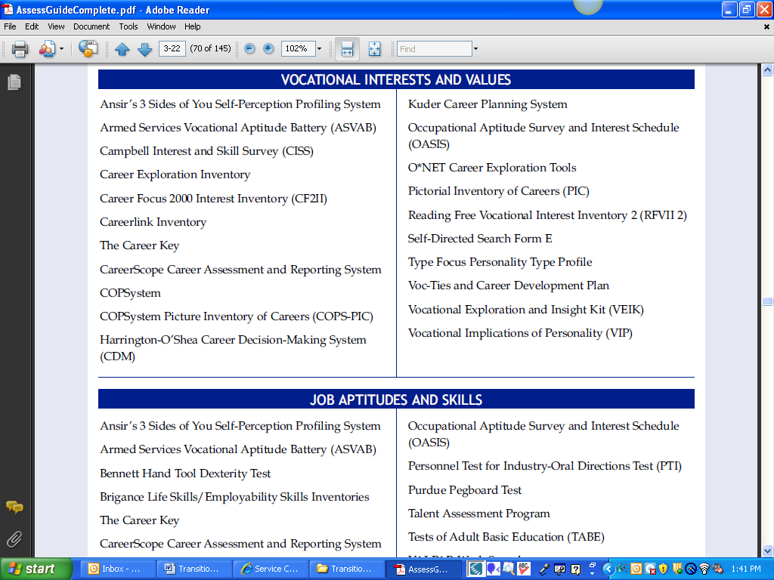

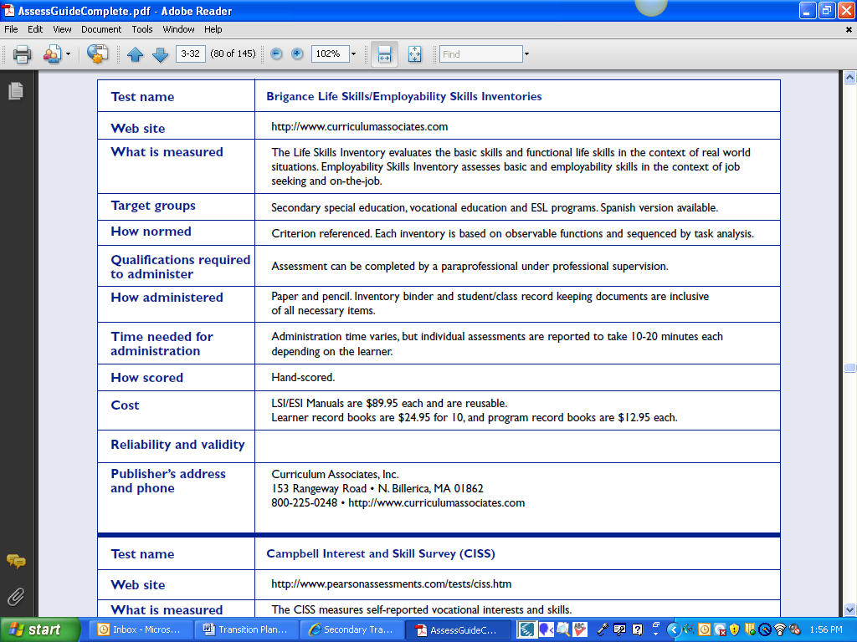

Back to top

Inviting the student to the IEP team. US DOE special education regulations

http://www.ed.gov/legislation/FedRegister/finrule/2006-3/081406a.pdf
§ 300.321 IEP Team
(a) General. The public agency must ensure that the IEP Team for each child with a disability includes—
(7) Whenever appropriate, the child
with a disability. (b) Transition services participants.
(1) In accordance with paragraph (a)(7) of this section, the public agency must invite a child with a disability to attend the child’s IEP Team meeting if a purpose of the meeting will be the consideration of the postsecondary goals for the child and the transition services needed to assist the child in reaching those goals under § 300.320(b).
(2) If the child does not attend the IEP Team meeting, the public agency must take other steps to ensure that the child’s preferences and interests are considered.

SERVICE COORDINATION
9: “The term service coordination reflects current concepts of family and person-centered philosophies, and emphasizes the central role the individual/family plays in identifying needed services. Service coordination will assist individuals and families in working with complex systems across agency lines, and will enhance their ability to live full lives in the community and school.”
Source: Minnesota System of Interagency Coordination. (2001, Spring). Service coordination for children and youth with disabilities ages 3-21. Minneapolis, MN: Author.
IDEA 2004 requires that, “to the extent appropriate, with the consent of the parents or a child who has reached the age of majority, in implementing the requirements of paragraph (b)(1) of this section, the public agency must invite a representative of any participating agency that is likely to be responsible for providing or paying for transition services” (300.321 [b][3]).
Back to top

COURSES OF STUDY
11: Courses of study are defined as a description of coursework to achieve the student’s desired post-school outcomes, from the student’s current to anticipated exit year.
Specialized course of study must include:
- A multi-year description of coursework to achieve the student’s desired post-school outcomes, from the student’s current to anticipated exit year
Multi-Year plan must include:
- A multi-year list of graduation requirements not able to meet based on the effect of student’s disability
- Alternative means to meet graduation requirements
- Signature of superintendent or designee
Back to course of study

