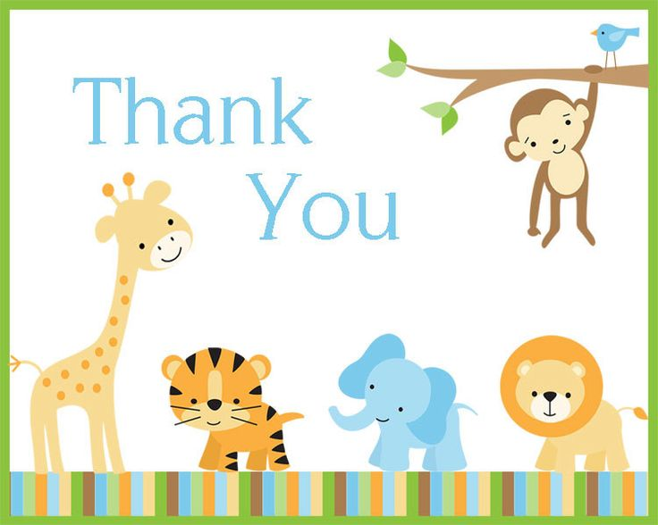
Front

Birthdays and parties will come and go, but the priceless memories will stay in my heart forever. Thanks for coming

