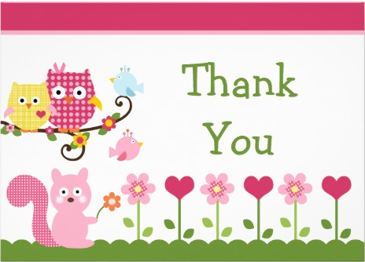

The best selfies of my life were clicked

Yesterday at my party,

all thanks to friends like you who made it a perfect memory.

Thanks