 |  | 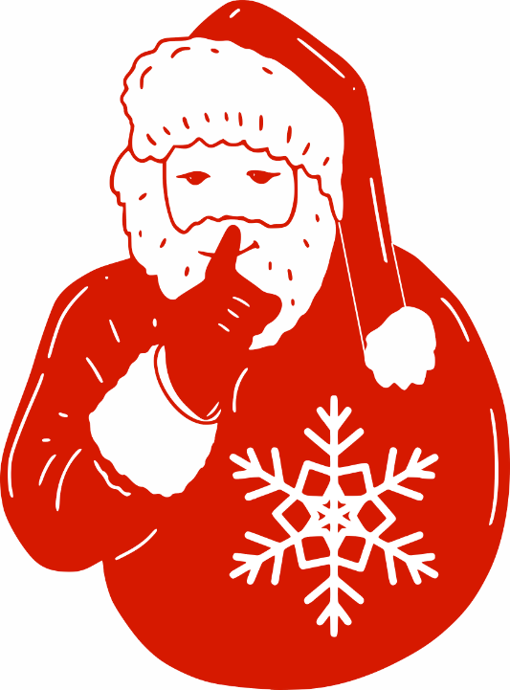 |  |  |  |  | 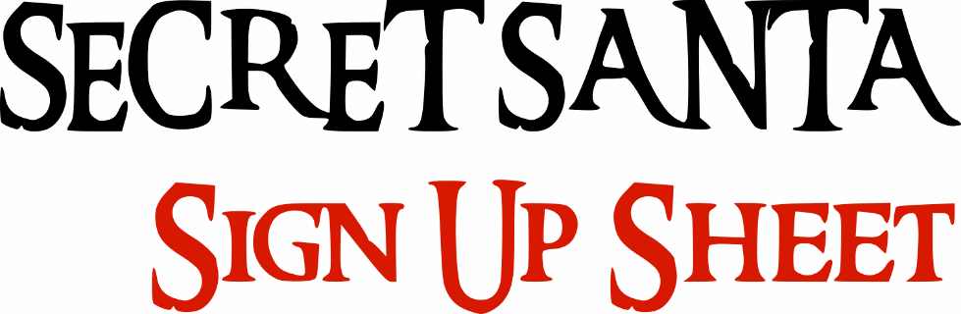
 |  |  |  |  |  |  | NAME
 |  | 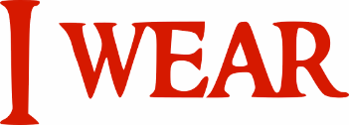
 |  | Shirt size |  |  |  |  | Pant size |  |  |  |  | Shoe size
 |  | Snacks and Candies
 |  | Drinks
 |  | Stores
 |  | Scents
 |  | Colours
 |  | Sports Teams
 |  | Hobbies
 |  | My Kids
 |  | My Pets
 |  | I need
 |  | Don't need
 |  |  |  |  |  |  |  |  |  |  |  | Templatelab.com

