**Title of research:**

Young Children’s Drawing Behaviours: Supporting Young Children Drawing

**Objectives:**

This is a continuation of an existing project. The overall objective is:

to explore the impact upon the young child’s drawing behavior’s of the views and beliefs of significant others across home, pre-school and school settings.

Research Questions

* What is the adult’s role when supporting young children drawing?
* What forms of child/ adult interaction supports rather than constrains young children’s episodes of drawing?
* How does the adult ‘tune in’ to young children’s needs in relation to drawing?
* How does the adult recognise when it is appropriate to intervene?
* Does the form of interaction appear to change with the age or perceived drawing ability of the child?
* Is the form of interaction between child and adult influenced by gendered behaviours?
* How does the environment best support child/ adult interaction? (Time, space, organisation of materials.)
* Does adult support for young children drawing differ from support given in relation to other activities?
* How important is the adult’s awareness/ knowledge of the child’s holistic needs when supporting young children’s drawing behaviours?
* How important is the adult’s awareness/ knowledge of the child’s particular patterns of meaning making when supporting young children’s drawing behaviours?
* What is the impact upon young children drawing of an adult’s own experience/ knowledge and understanding of drawing behaviour?

**Please give a brief justification of your proposed research project:**

This research builds upon previous research completed by the project leader.

Within the field of early years education, development and care there is currently a focus upon the role of the adult when interacting with very young children. The outcomes of three influential research projects, The Effective Provision of Pre-School Education Project (EPPE, 2003), Researching Effective Pedagogy in the Early years (REPEY, 2002) and Study of Pedagogical Effectiveness in Early Learning (SPEEL, 2002) all draw attention to the need for ‘sustained shared thinking’ between the child and the adult and careful consideration of what this looks like in practice. In addition, the Primary National Strategy’s current promotion of ‘creativity’ across the curriculum gives practitioners permission to consider different approaches to children’s learning.

Given a cultural pre-occupation with young children achieving conventional literacy early, in this country their use of drawing is generally seen by parents and practitioners as merely a stage along the way to writing, to be discarded once this has been achieved. The documented outcomes of previous stages of this project forms part of a small amount of material which looks at drawing and its role for children in re-presenting their ongoing thinking (Ring, 2003, Anning and Ring, 2004). With a focus upon writing and the lack of attention paid to the arts over a long period of time, including both initial teacher education and continuing professional development, it is unsurprising that practitioners feel that they lack a clear understanding of how to support a child who is drawing and either over direct or are afraid to involve themselves in what they consider is a ‘creative’ activity.

This project gathers data from a group of twenty ‘expert’ practitioners as they:

* support young children drawing within their own settings
* document the process and their ongoing thinking in relation to their role
* come together with peers to share, discuss and analyse the data they have collected and ways of moving forward

**Please outline the proposed sample group, including any specific criteria:**

The sample group is a group of up to twenty ‘expert’ early years practitioners, acknowledged for their expertise by their appointment as Advanced Skills Teachers, Head Teachers, Deputy Head Teachers etc.

**Describe how the proposed sample group will be formulated:**

The group will be drawn from a group of such practitioners who are attending a three-day course given by the project leader. Participation by the practitioners will be through self-selection.

**Indicate clearly what the involvement of the sample group will be in the research process:**

**Stage 1**

The group will be involved in documenting their work with young children – both the process and the product. A multi-method approach will include the use of questionnaire; observation; collection of visual data via digital images and video tape; and the ongoing completion of a learning journal. Focus group discussions will take place with all participants having the opportunity to contribute.

**Stage 2**

Visits will be made by the project leader to a sub-set of the sample in their settings. Once again participation by the practitioners will be through self-selection. A multi- method approach will include the use of semi-structured interview; observation; collection of visual data via digital images and video tape; examination of documentation collected by the participants.

**Specify how the consent of subjects will be obtained. Please include within this a description of any information with which you intend to provide the subjects:**

A group meeting of all adult participants will take place prior to commencement of the project. All participants will be given a copy of the British Educational Research Association (BERA) (2004) Revised Ethical Guidelines for Educational Research (Appendix 1). These guidelines will be read at the meeting and fully discussed as to their ramifications for the research project in the particular early years settings. Agreements made by all at the meeting, where all parties have reached ‘an ethically acceptable position in which their actions would be considered justifiable and sound’, (BERA, 2004), will form the basis of a research consent form which will be signed by participant and researcher.

Indicate any potential risks to subjects and how you propose to minimise these:

Particular attention will be paid to the role of the children within the project. It is expected that the children being taught by the adult participants within the study will be aged between 3 and 5 years. It is expected that involvement in episodes of drawing activity will be voluntary and that, given that the research is taking place in their everyday context and that the practitioners are part of that context, the normality of the children’s experience can be maintained.

It is anticipated that each setting will have an agreed policy (school or LEA) on gaining permission for the taking of video and digital images within the school setting (Appendix 2) which will be adhered to. In many settings parents sign a consent form when the children begin attending the setting agreeing to their child being videoed. In relation to this research project, following editing of any video material or digital images it will be necessary to gain additional consent from parents of featured children if the material is to be published. No child will be video-taped or photographed where permission by parents/ carers has been refused.

The reason for the use of the video-camera/ digital camera will be explained simply to the children. They will be told that a particular activity is being videoed so that they can choose not to take part. Time must be found for children to see the data collected if the children request this.

Ownership of material completed by the children

The original materials/ drawings will remain in the setting but the researcher will make colour photocopies of all drawings.

Ownership of video taped material

The original videotapes/ digital images, if taken by the adult participants, will remain with the setting and the researcher will make a copy. Videotapes/ digital images taken by the researcher will remain with the researcher but will be made available to the participants. Following observation of video-tapes/ digital images by practitioners and researcher it is anticipated that only clips of video and digital images agreed by all parties will eventually be retained. Both the setting and the researcher will have copies of edited material.

Describe the procedures you intend to follow in order to maintain the anonymity and confidentiality of the subjects:

All participants will be assured that their names and their setting will not be divulged. In written documentation the children’s first names will be changed and surnames will not be used. Practitioners will be asked not to use children’s surnames when videoing.

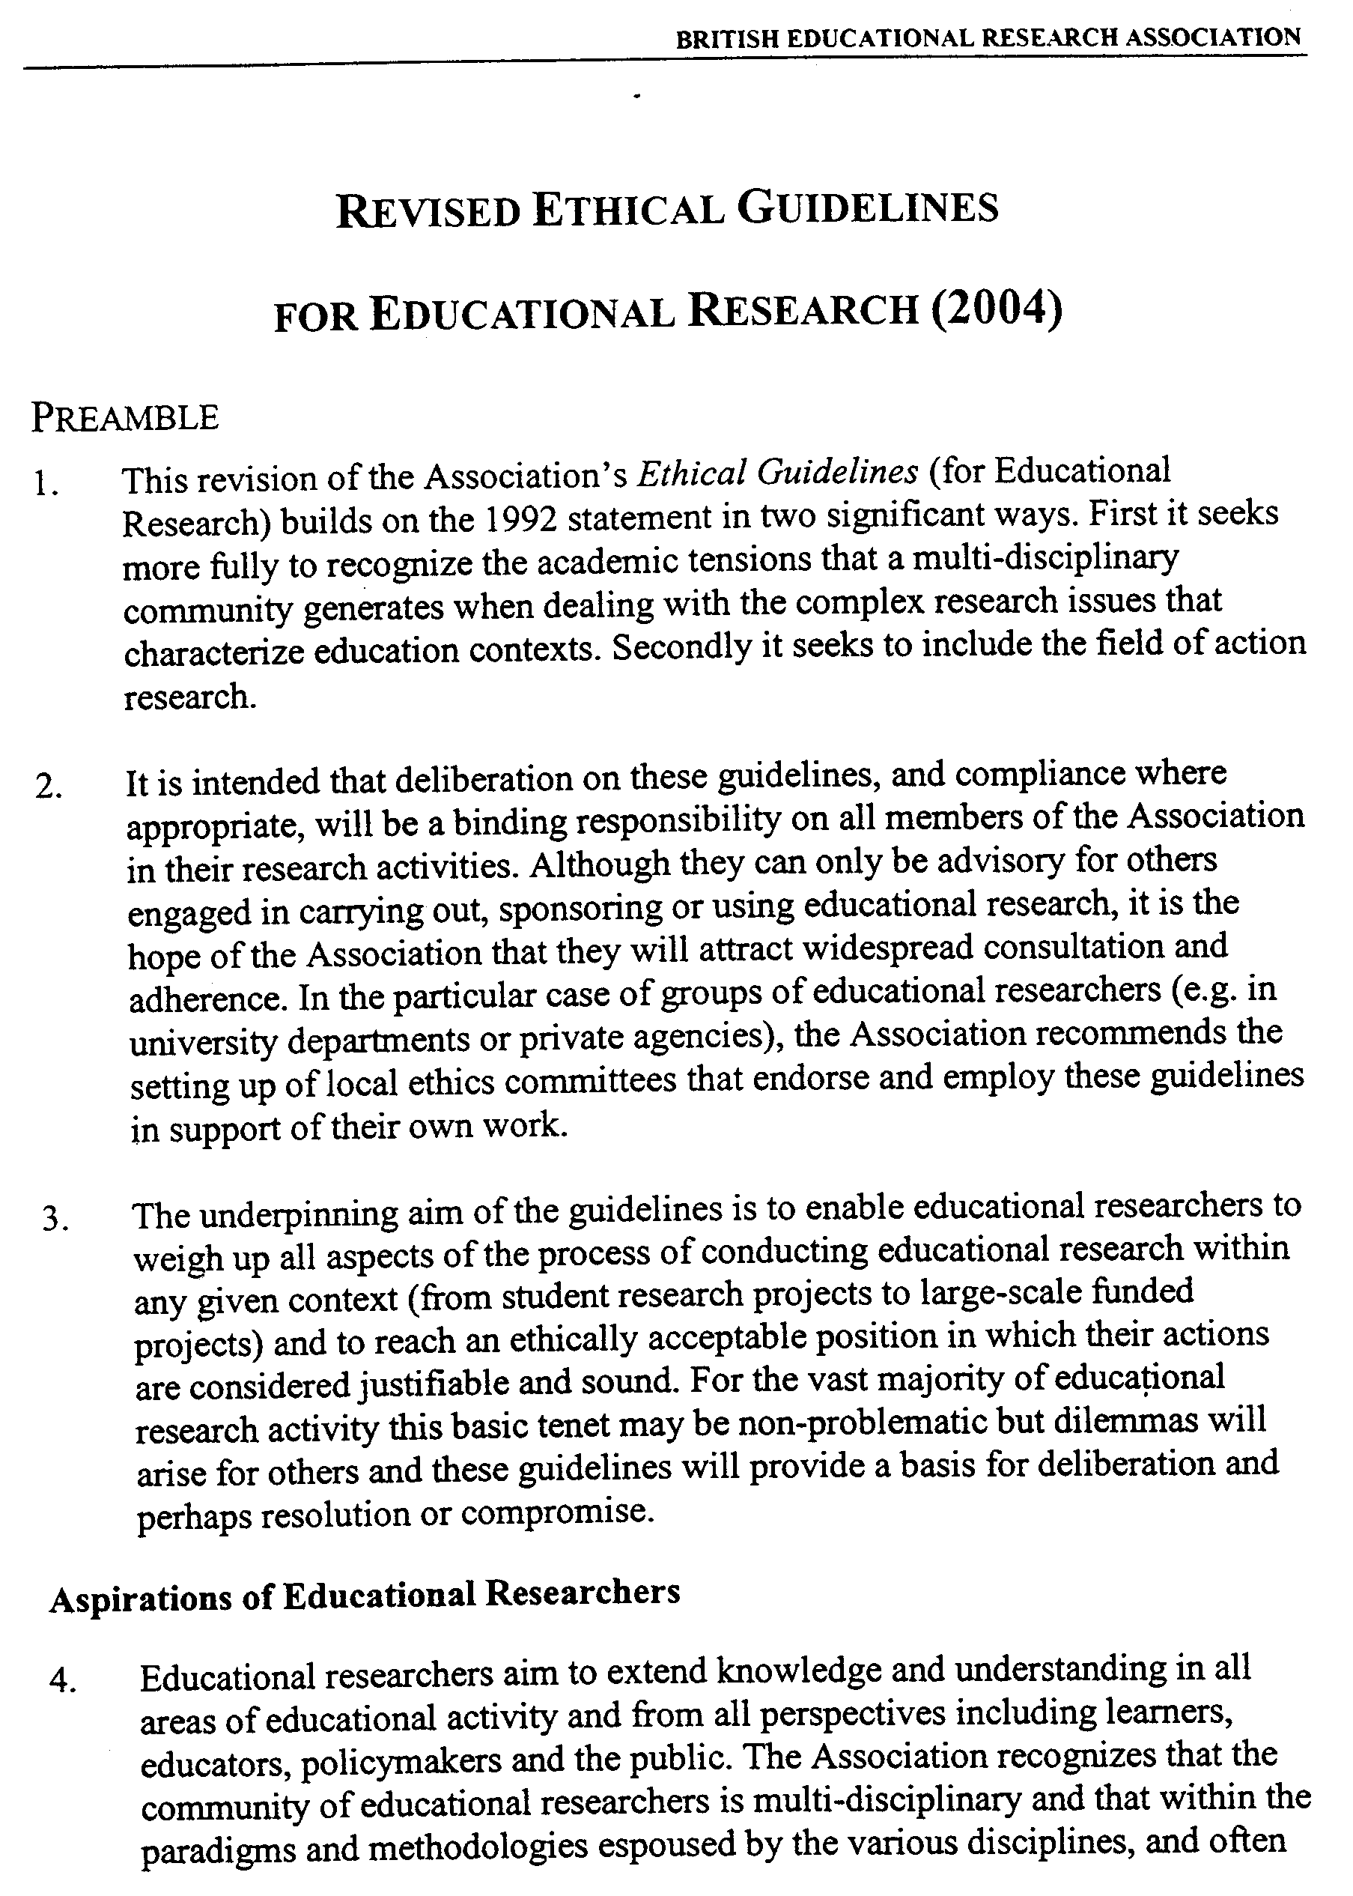

#### APPENDIX 1

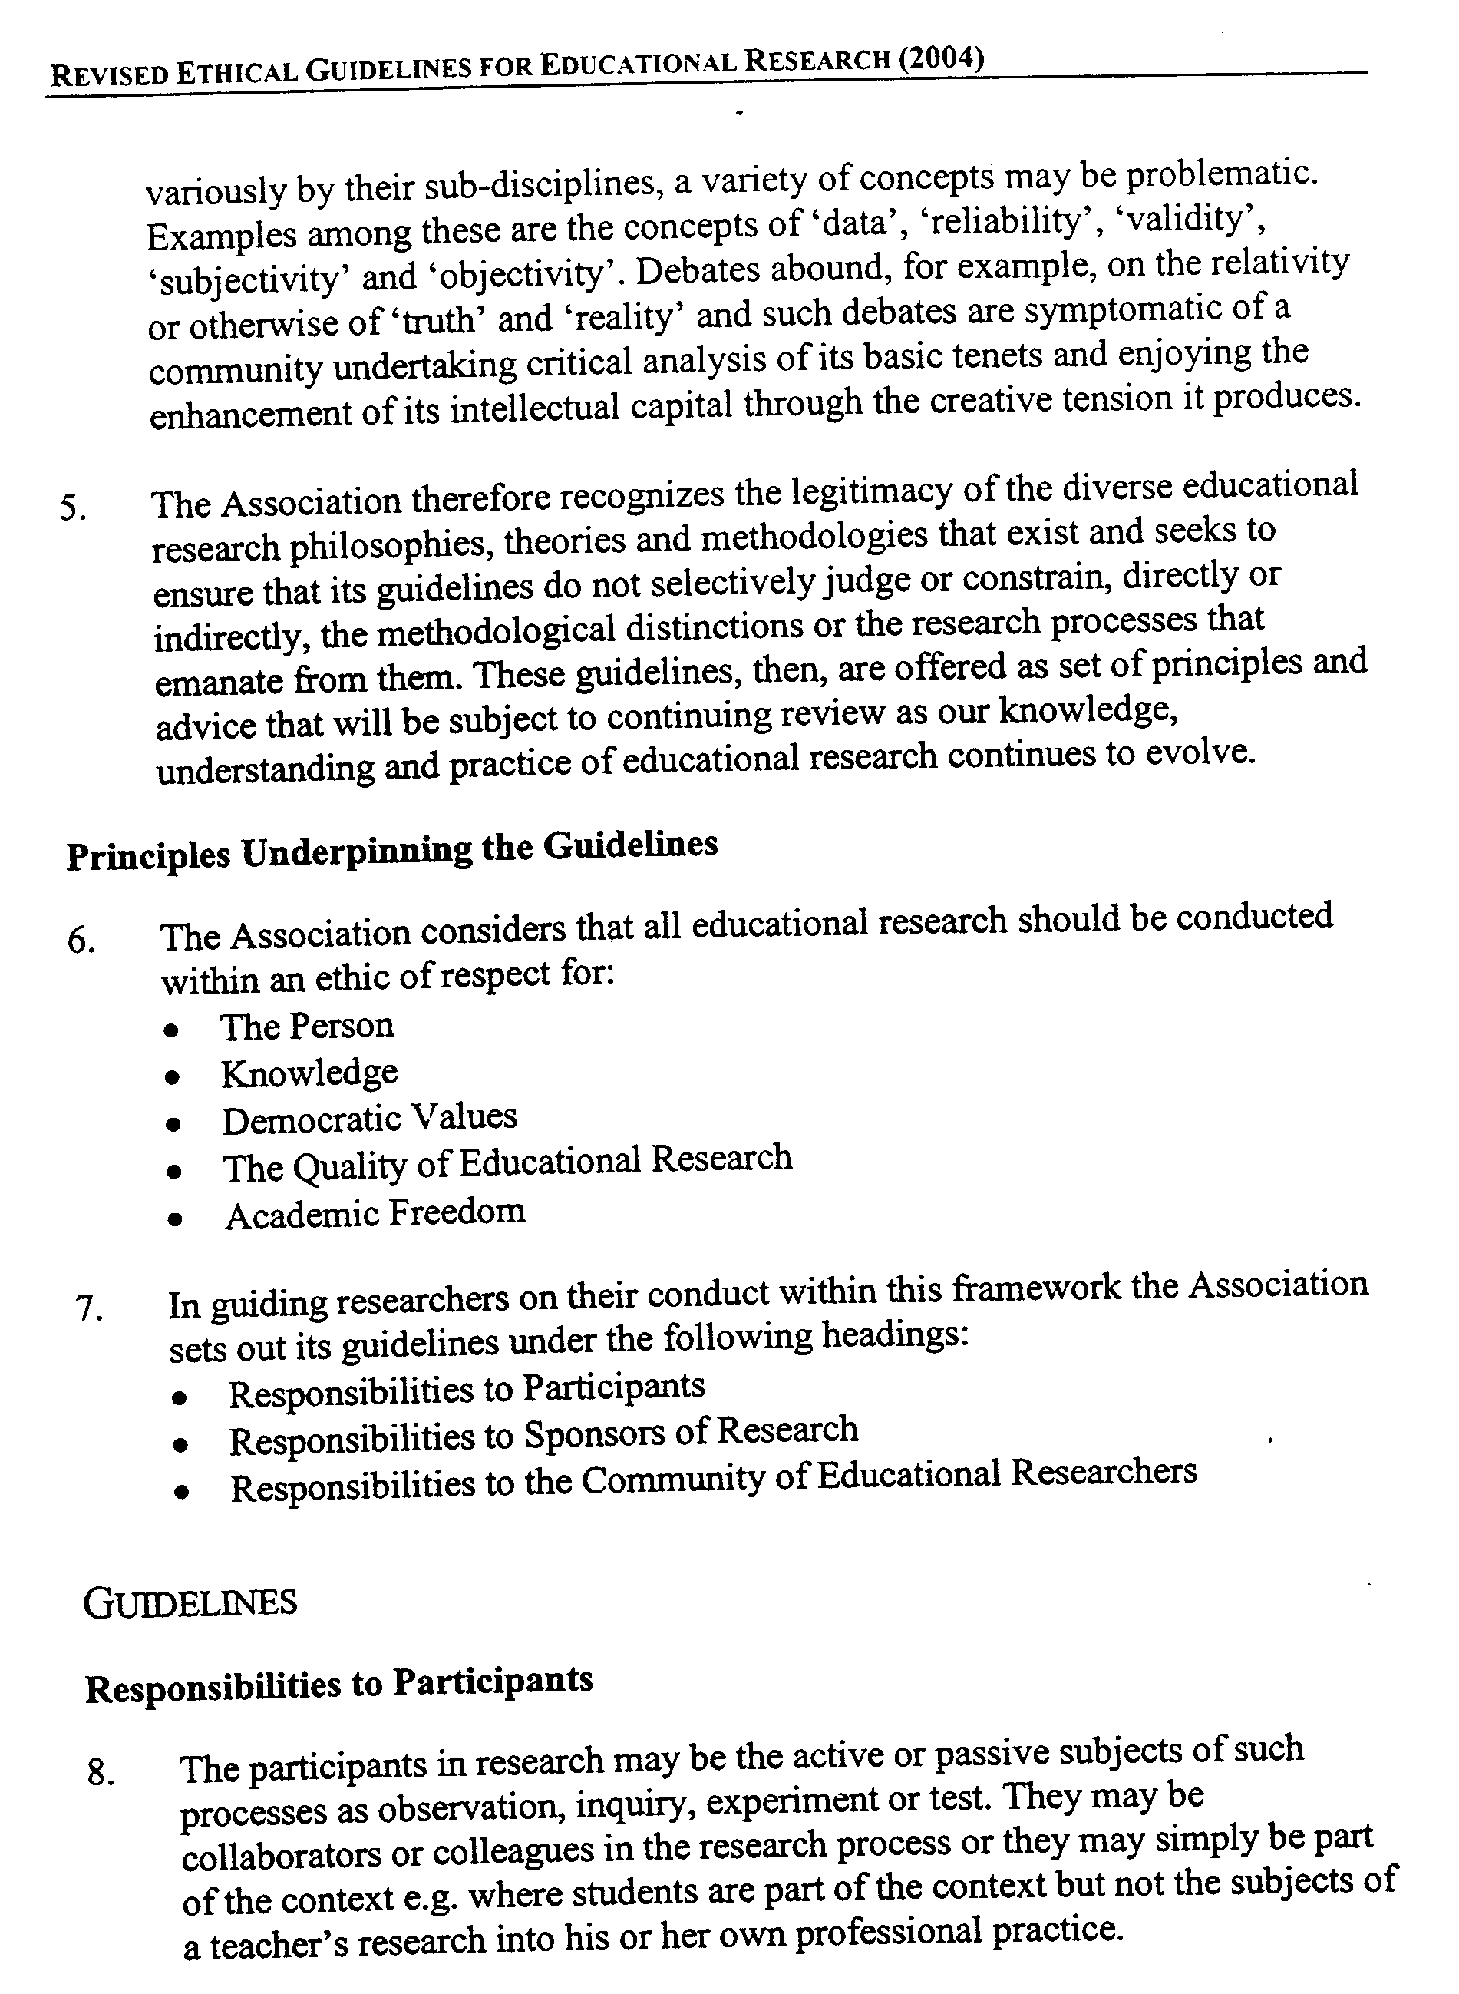

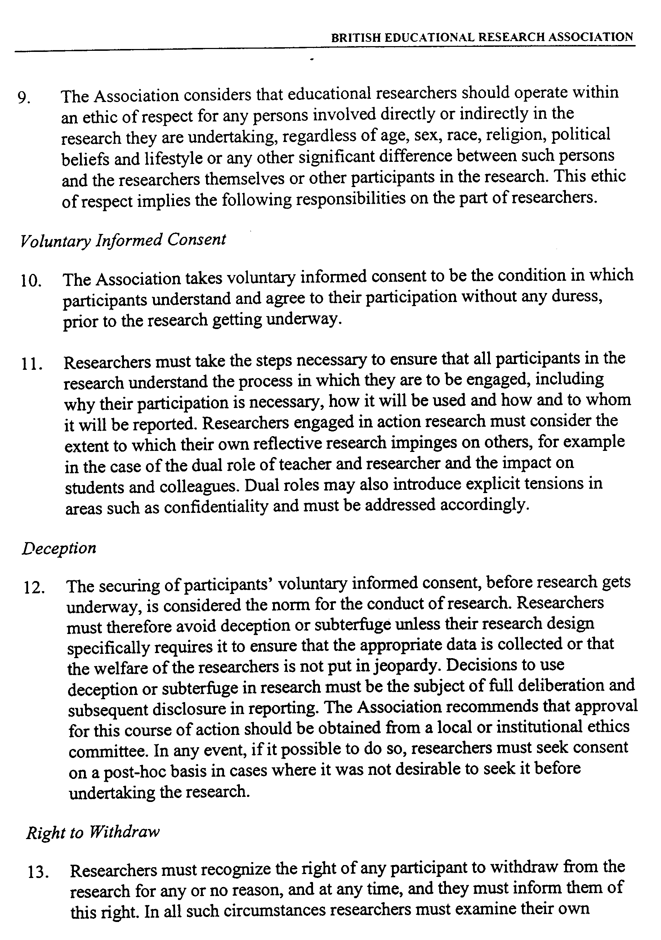

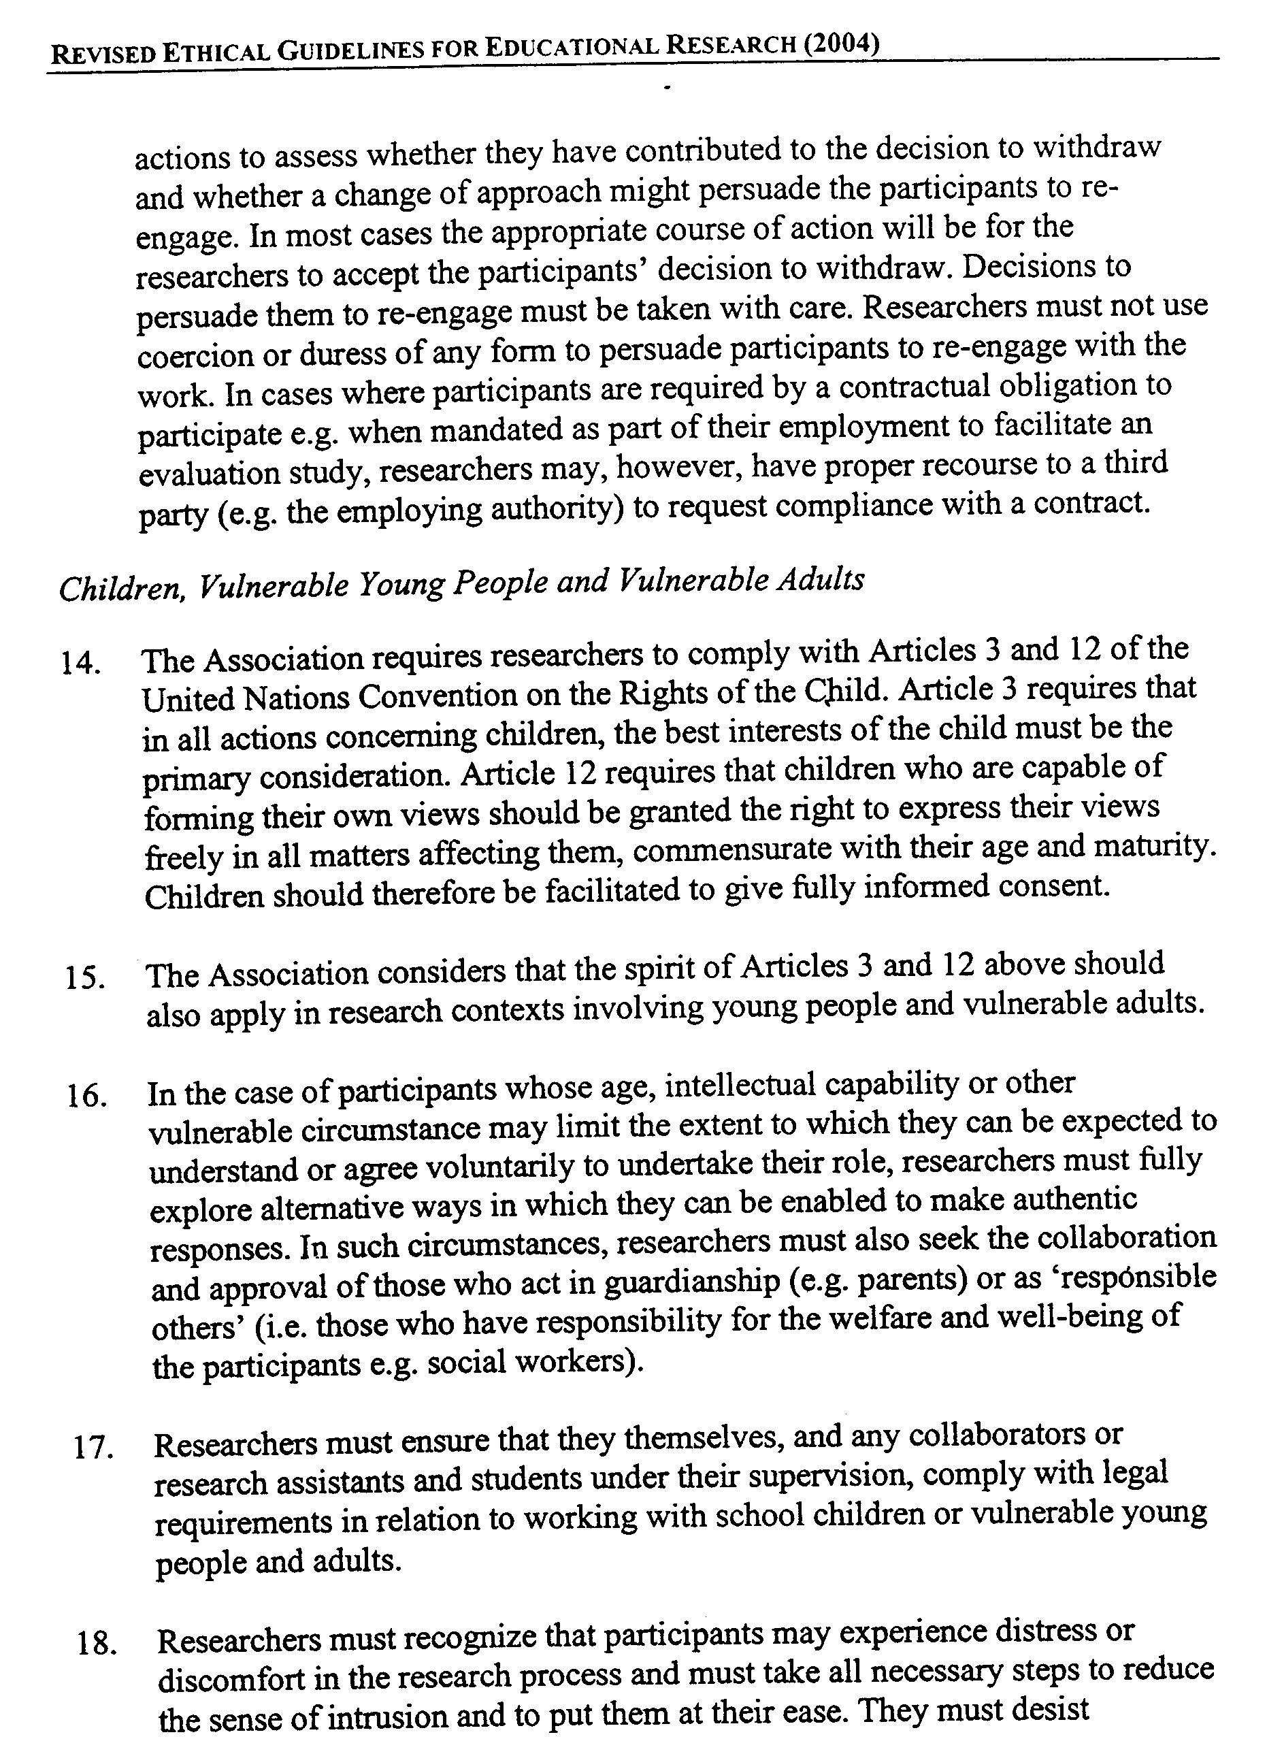

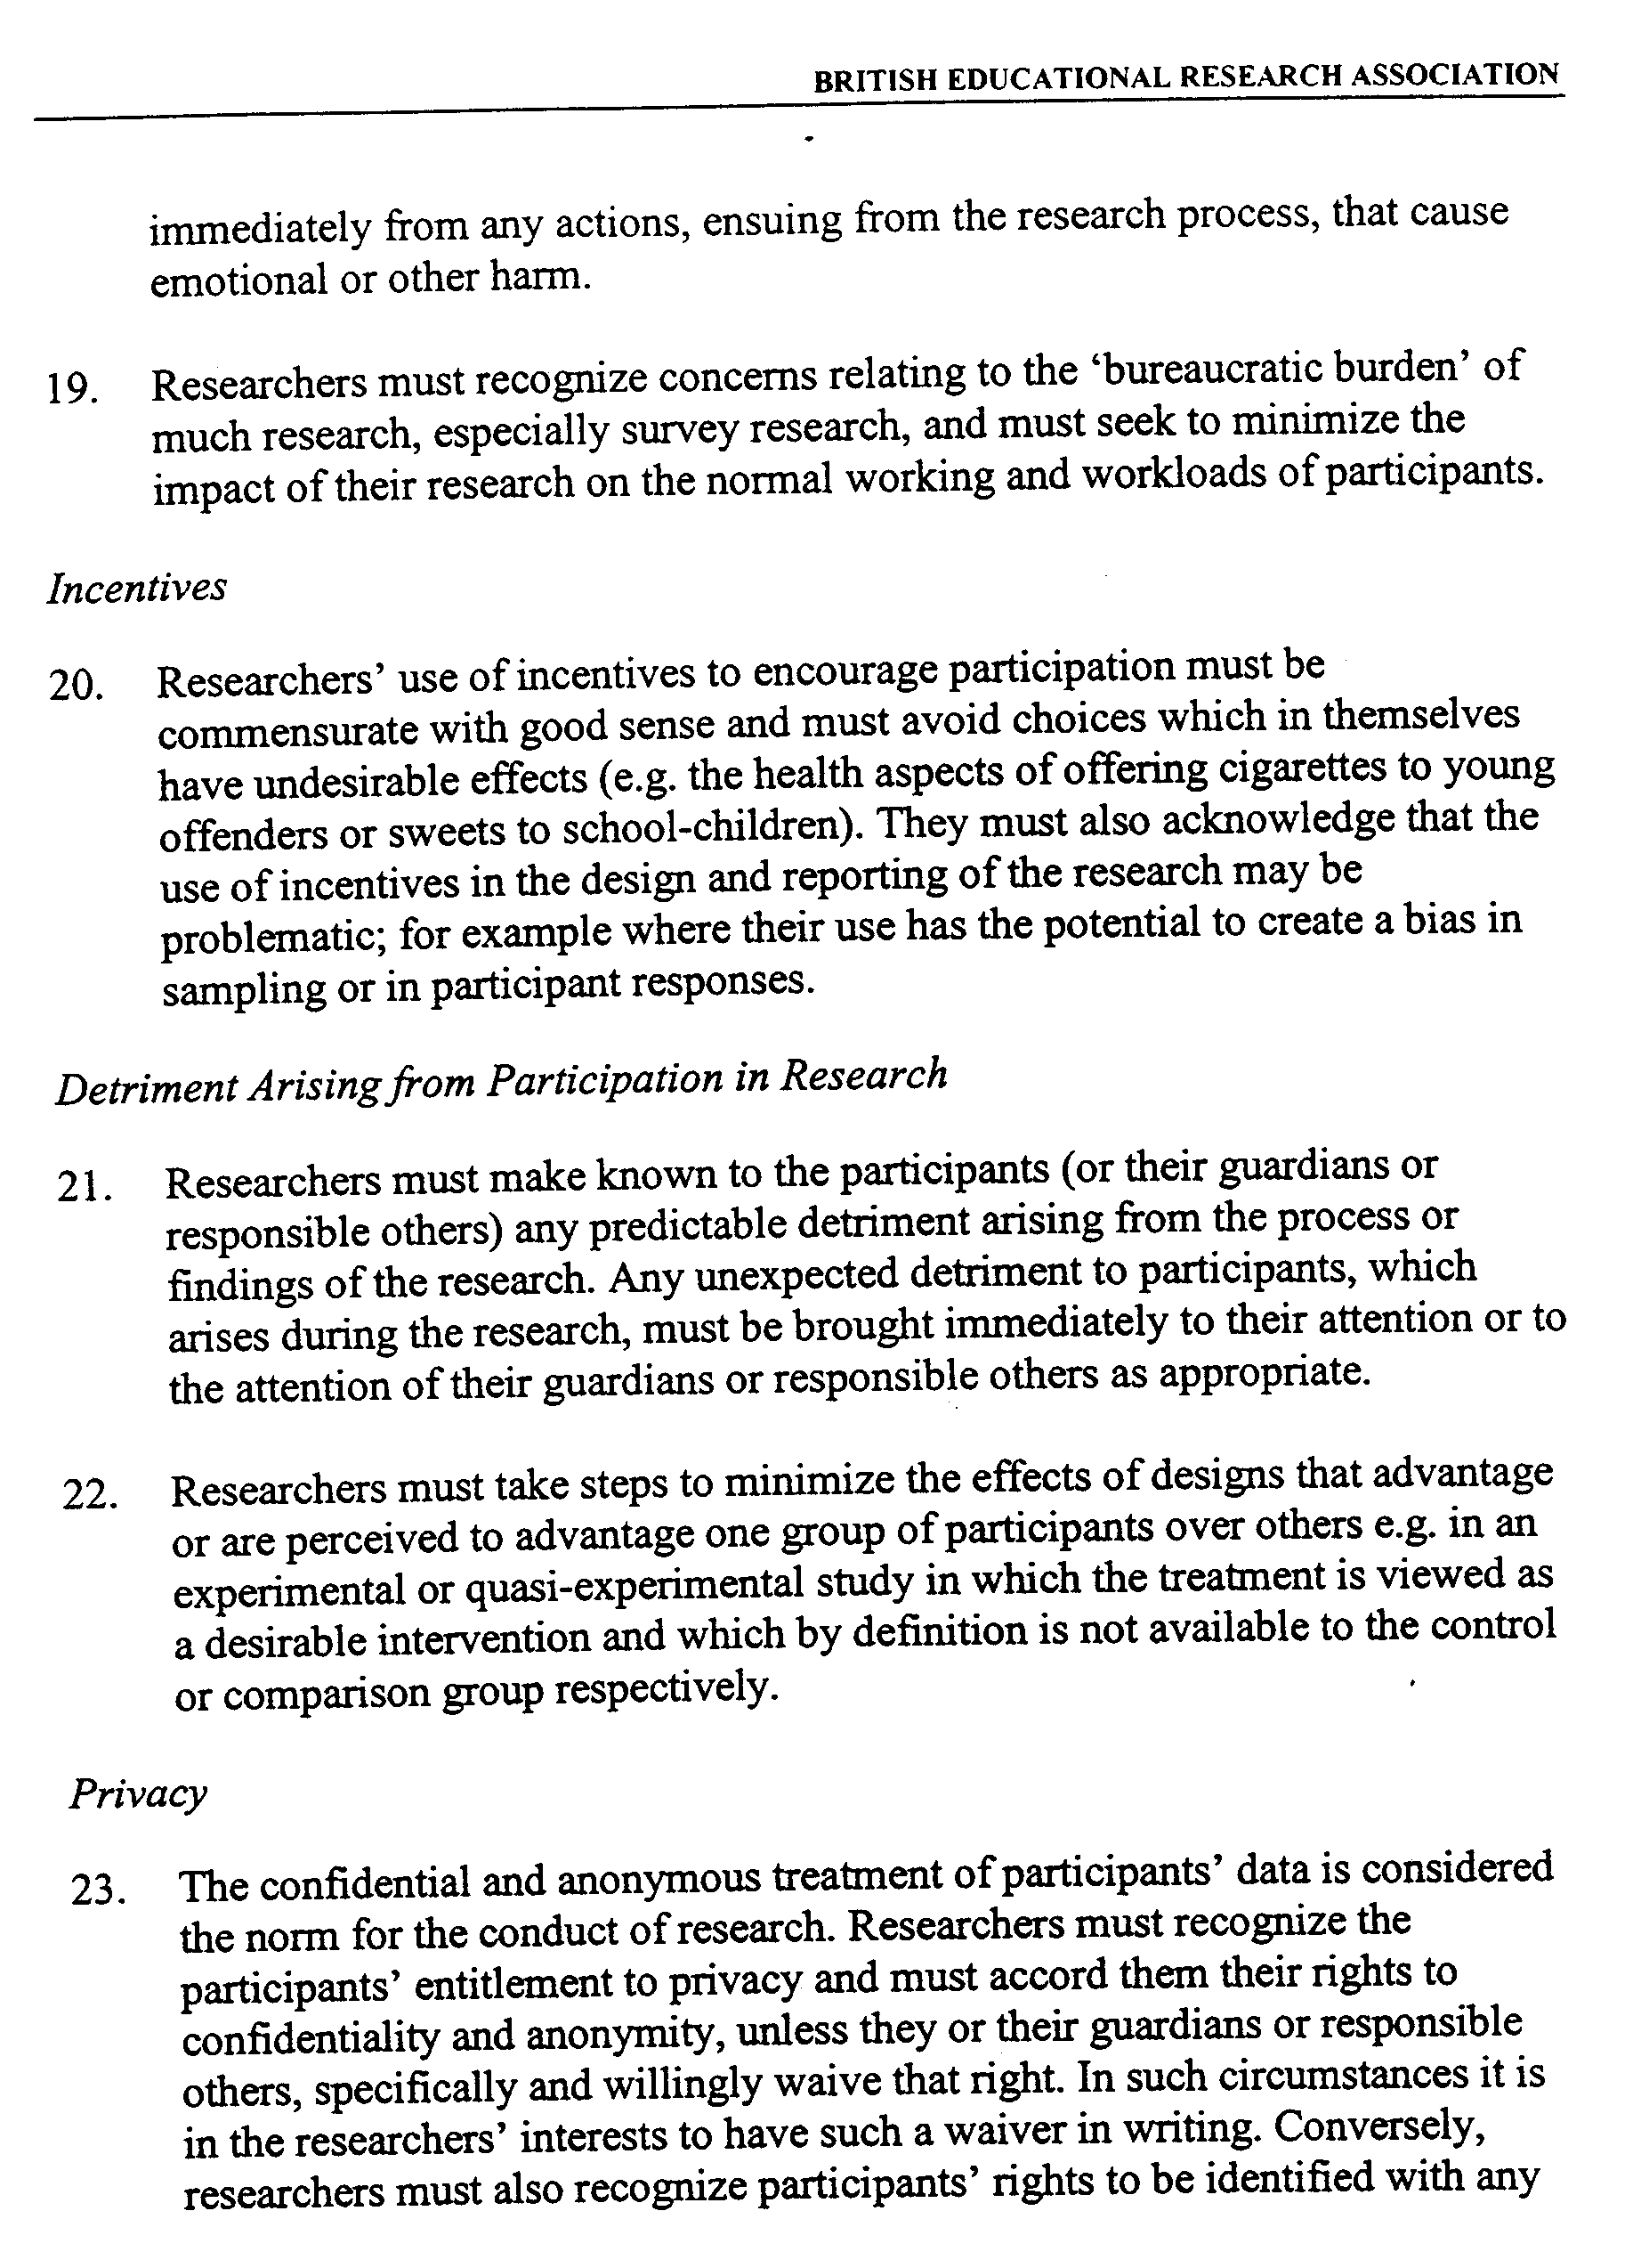

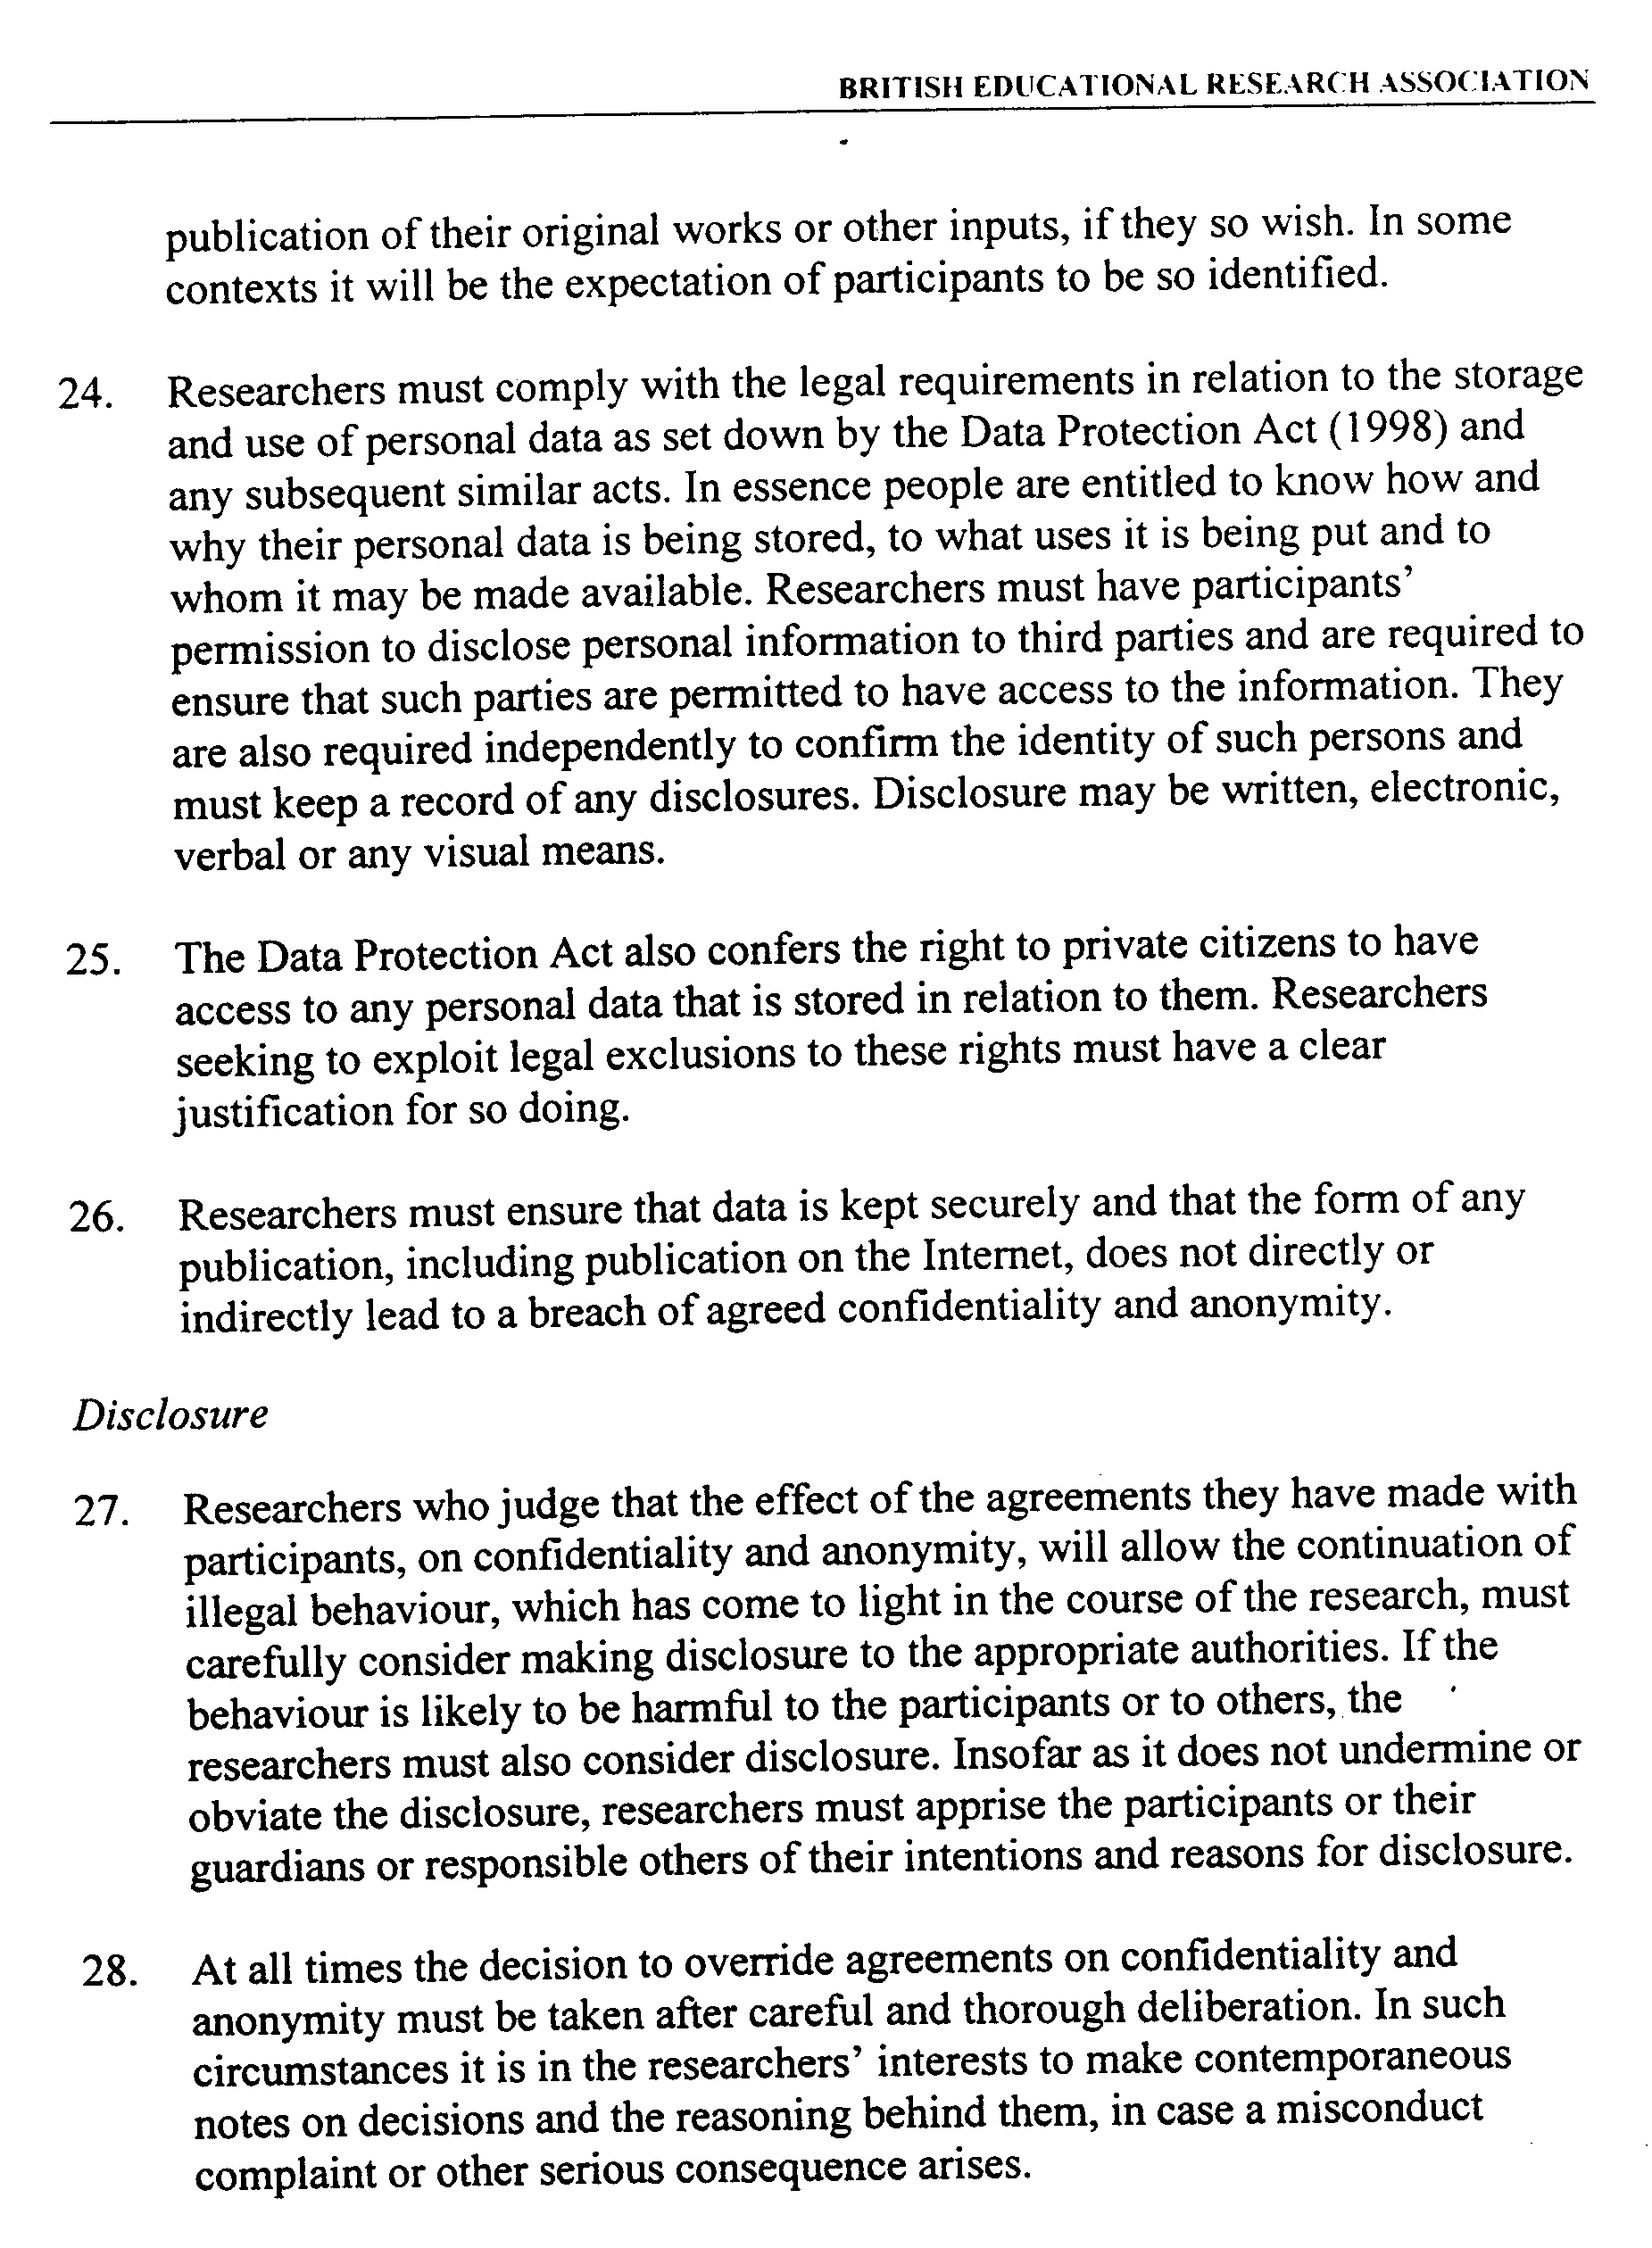

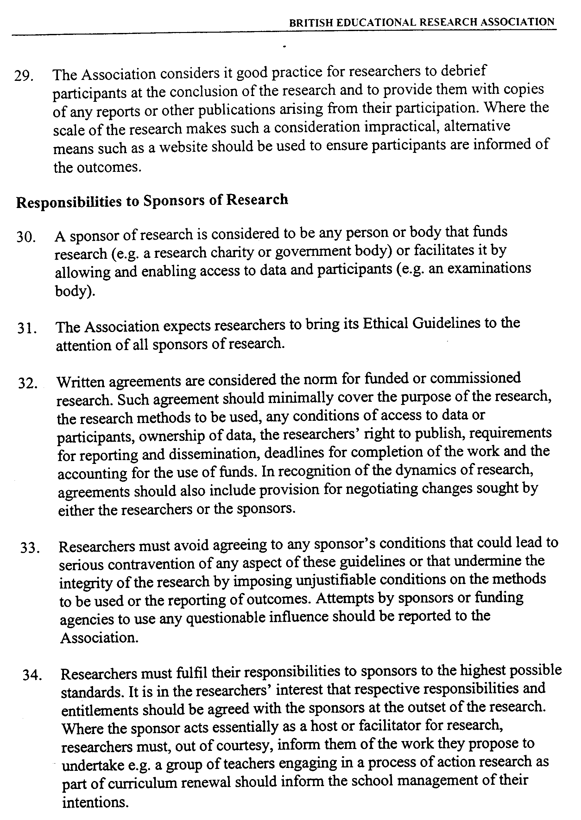

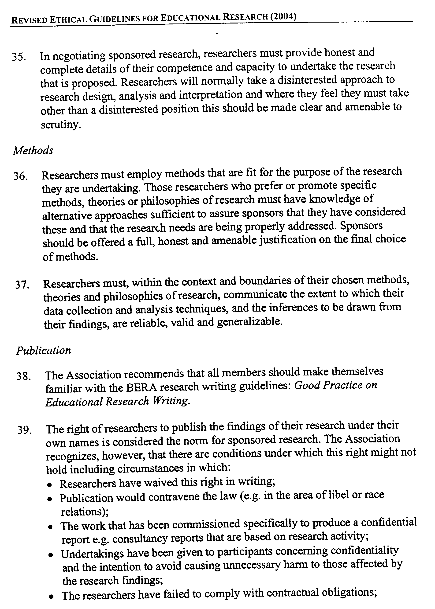

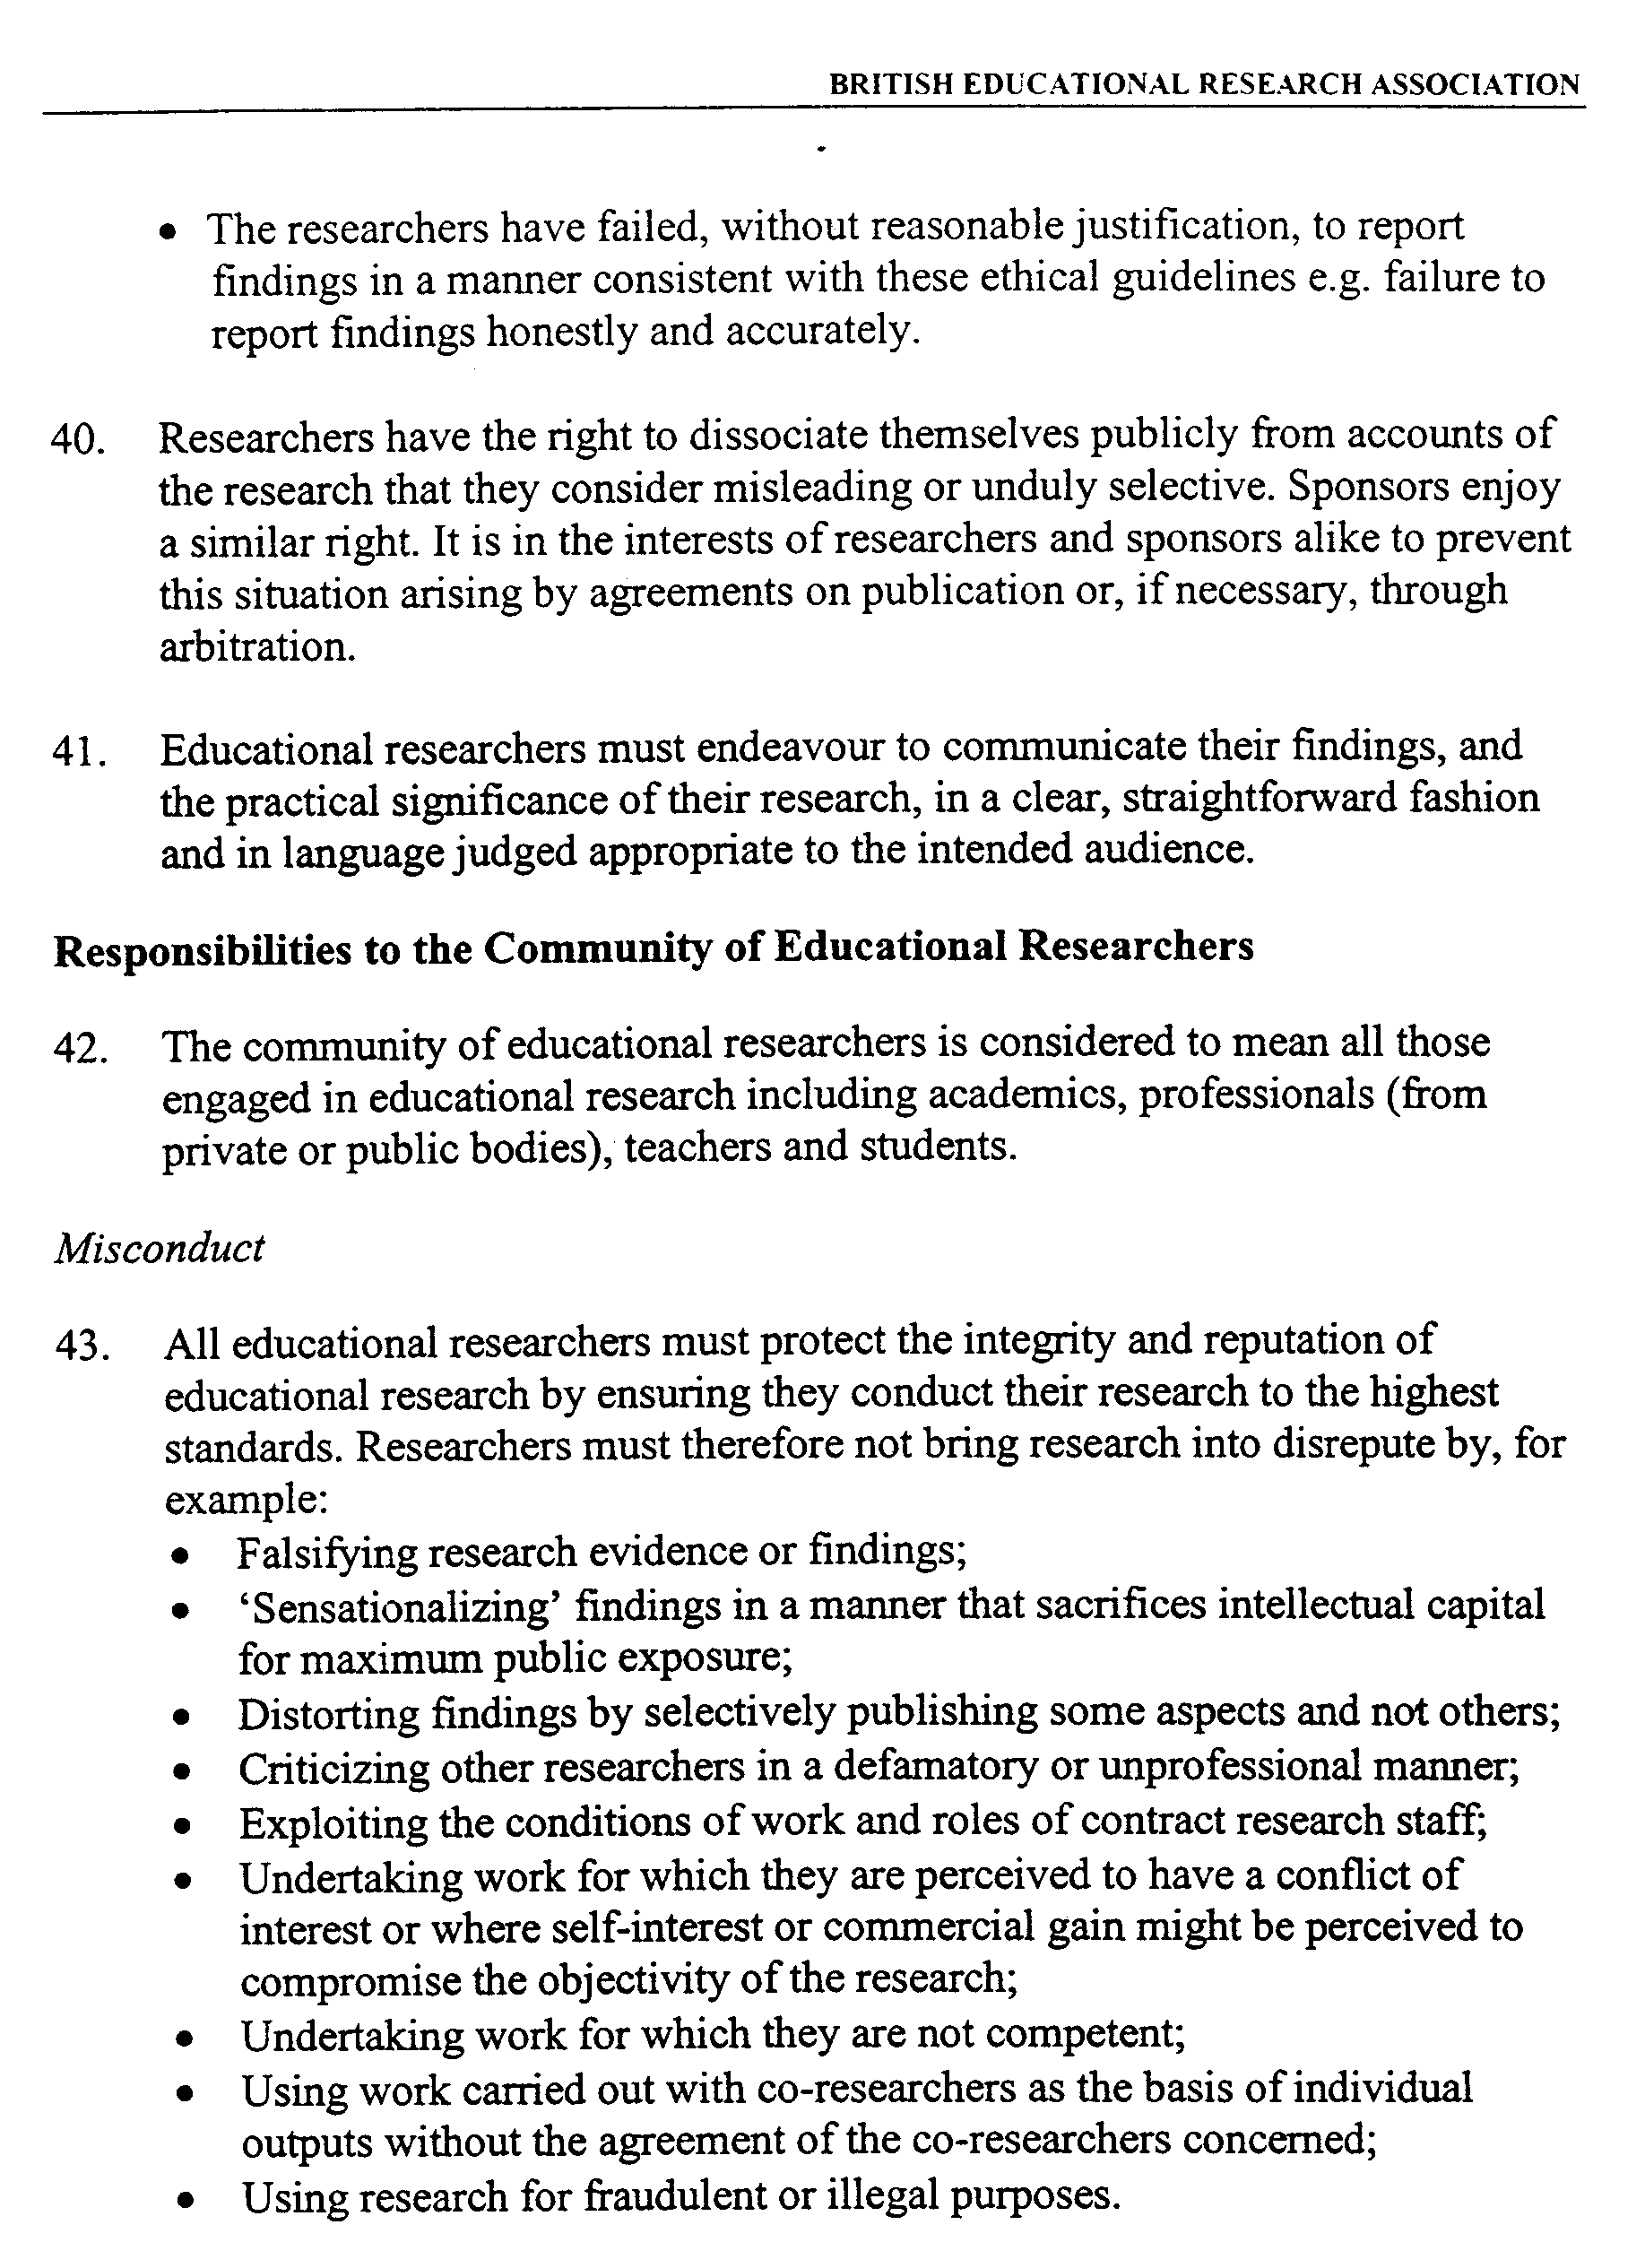



**GUIDANCE FOR CITY OF YORK SCHOOLS AND LEA SERVICES REGARDING A POLICY FOR THE USE OF PHOTOGRAPHIC IMAGES OF CHILDREN**

**May 2004**

#### APPENDIX 2

## Using Images of Children:

## photographs, videos, websites and webcams

**Guidance for City of York** **Council Schools**

###### Introduction

We live in an age in which digital technology has vastly increased the use, and potential misuse, of photography.

Publicity surrounding concerns about such matters as whether to allow filming of school events has prompted us to advise that schools and LEA Services should have a policy about the use of photography.

In developing such a policy, Heads and Governors should open the issue for discussion with parents, to maintain trust in the parent school relationship, and to enable those parents with particular concerns to specify that they withhold their consent for whatever reason.

Most children who are abused are abused by someone they know. We have taken the view, in consultation with our local police force, that the risk of a child being directly targeted for abuse through being identified by a stranger is so small that, providing reasonable steps are taken in planning to ensure an appropriate photograph, and to protect full name and contact details, the practice of photography for school events by families and the media should be allowed. In addition, the widespread use of mobile telephones as digital cameras would make banning difficult to impose and police.

Generally, photographs for school and family use, and those that appear in the press, are a source of pleasure and pride which we believe usually enhance self esteem for children and young people, and their families, and the practice should continue, within safe practice guidelines.

# **Issues of consent**

The Data Protection Act 1998 affects our use of photography. This is because an image of a child is personal data for the purpose of the Act, and it is a requirement that consent is obtained from the parent of a child or young person under the age of 18 years for any photographs or video recordings for purposes beyond the school’s core educational function (eg school web sites, school productions). It is also important to ascertain the views of the child.

As it is likely that there will be a number of occasions during a pupil’s school life when the school may wish to photograph or video that pupil, we recommend that consent is sought when the pupil starts at the school, to last for the duration of their stay.

A signed consent form, as attached to this guidance, should be obtained from the child’s parent/guardian, and kept on file, covering all cases where images of children are to be published beyond the parameters of school use.

Where children are ‘Looked After’ schools must check consent on the corporate parent’s behalf with the social worker, and there may be other situations (in adoption placements or following a resettlement from domestic violence for example), where a child’s security is known by the class teacher to be at stake, indicating the need for extra care.

Consent gained for photographs or videos may not extend to website or webcam use, so it is important to check, when introducing such technology, the status of existing consent for pupils.

Parents retain the right to withdraw consent at any stage, but they need to do so in writing.

**Planning photographs of children**

Images and details of pupils published together allow for the remote possibility that people outside the school could identify and then attempt to contact pupils directly. The measures described below should help to minimise the risk of such unsolicited attention.

1. Where possible, use general shots of classrooms or group activities rather than close up pictures of individual children. Consider the camera angle; photographs taken over the shoulder, or from behind are less identifiable.
2. Use images of children in suitable dress, and take care photographing PE or swimming events to maintain modesty, using team tracksuits if appropriate, for example.
3. Remember to include images of children from different ethnic backgrounds in your communications wherever possible, and positive images of children with disabilities to promote your school as an inclusive community, and to comply with the Disability Discrimination Act.
4. Logos or emblems on sweatshirts etc can identify children. Depending on the use to which the photograph will be put, consider airbrushing logos.
5. Consider alternatives. Is a photograph of the children necessary, or could an article be illustrated by the children’s work for example?

**3. Identifying pupils**

The DfES advise the following, as a broad rule of thumb, where consent is unclear:

1. If the pupil is named, avoid using their photograph. If the photograph is used, avoid naming the pupil.

We recommend that:

1. You use the minimum information. Ask yourself whether it is really necessary to accompany a picture with the pupils’ names, the year group, or the school.
2. When **fully** naming pupils in any published text, whether in the school’s brochure, website, or in the local press, avoid using their photograph, unless you have parental consent to do so.

## 4. Using photographs of children supplied by a third party

### Copyright does not apply to images for private family use. However, copyright does exist in commercial photographs and it rests with the photographer. Copyright is a right that the photographer automatically enjoys as the creator of the work to prevent other people exploiting his or her work and to control how other people use it.

Before using a photograph supplied by a third party you should check that the third party owns the copyright in the photograph and you should obtain their written or verbally recorded permission to use it. If you use a photograph without the copyright owner’s permission you could find that an action is taken against you for copyright infringement.

Images downloaded from the Internet are also subject to copyright.

Third Parties will generally be under the same obligations as your school to obtain parental consent to the use and distribution of photographs. You should therefore ask the third party to guarantee to you that all relevant consents have been given and that they are entitled to provide you with the image.

## Use of images of children by the press

(Please refer to the recommendations in section 3 above; ‘Identifying Pupils’)

There may be occasions where the press take photographs at your school of pupils. The consent form attached (PC2) attempts to highlight the potential risks for parents so that they can make an informed decision about whether to agree to their children being featured in the press and whether their full name should accompany the photograph.

The manner in which the press use images is controlled through relevant industry codes of practice as well as the law. However, given your responsibility to parents and pupils, it is sensible to politely check that broadcasters and press photographers you may be chaperoning on your school premises are aware of the sensitivity involved in detailed captioning, one to one interviews, and close or sports photography.

**School prospectuses and other literature**

Although most school literature is sent to a specific audience, it would be best to avoid using personal details or full names of any child in a photograph. Follow the DfES advice above.

**Videos**

You must have parental consent before any child can appear in a video. Parents can make video recordings of nativity plays and other such events for their own personal and family use, as they are not covered by the Data Protection Act (please refer to section 10). Potential difficulties in this area can be avoided if the school adopts the policy of taking an official video of the event and making copies available to parents.

**Websites**

This is an area that gives particular concern to parents because of the potential misuse of images by paedophiles. With digital photography there is the remote possibility that images of children could be produced, manipulated, and circulated, without the parents’ or children’s knowledge. The dual concern which follows such a risk is that children might be exploited, and a school might be criticised or face action.

It is important to take care with identification, and to respect parental views on the use of any photography of children on a website.

We recommend that you visit the DfES website ‘Superhighway Safety’ at www.safety.ngfl.gov.uk/schools for further guidance and advice.

**Webcams**

The regulations for using webcams are similar to those for CCTV (closed-circuit television). This means that the area in which you are using the webcam must be well signposted and people must know that the webcam is there before they enter the area, in order to consent to being viewed in this way. Children should be consulted, and adults would need to consent, as well as the parents of all the affected children.

In gaining consent, you must tell the person why the webcam is there, what you will use the images for, who might want to look at the pictures and what security measures are in place to protect access.

The current DfES advice (July 2003) is that unless a webcam is a response to a specific threat or difficulty in relation to either crime or health and safety, it may pose more difficulties for the school than it would actually resolve. If you want to use a webcam, we would advise careful parental, staff, and legal consultation.

**Parental right to take photographs**

Parents are not covered by the Data Protection Act 1998 if they are taking photographs or making a video recording for their own private use. The Act does not, therefore, stop parents from taking photographs or making video recordings at school events, such as nativity plays.

Parents are not permitted, however, to take photographs or to make a video recording for anything other than their own personal use (e.g. with a view to selling videos of a school event). Recording and/or photographing other than for private use would require the consent of the other parents whose children may be captured on film. Without this consent the Data Protection Act 1998 would be breached. The consent form attached reminds parents of this fact.

Data Protection considerations aside, it is possible to consider banning all filming/recording/photography of school productions, sports days etc if you feel that this is appropriate. We believe, however, that many parents would consider it to be over-cautious to impose such a ban and we would not, at this stage, recommend this course of action. Should you wish to impose any such ban we would advise you to take legal advice in order to ensure that the correct steps are taken, whilst acknowledging that such a ban would be difficult to enforce.

The important thing is to be sure that people with no connection with your school do not have any opportunity to film covertly. Ask your staff to quiz anyone they do not recognise who is using a camera or video recorder at events and productions, and include this instruction in your consent form or any event tickets.

**The storage of photographs**

Photographs must be maintained securely for authorised school use only, and disposed of either by return to the child, parents, or shredding as appropriate.

**Official school photographs**

Schools will periodically invite an official photographer into school to take portraits/photographs of individual children and/or class groups. It is essential that when considering such an activity schools undertake their own risk assessment in terms of the validity of the photographer/agency involved and establishing what checks/vetting has been undertaken. Procedures should also ensure that levels of supervision are appropriate to safeguard the welfare of children at all times when visitors are present on the school site.

**Useful sources of information**

‘Keeping your child safe on the internet’ publication by UK online and the Home Office www.wiseuptothenet.co.uk

The Information Commission website at www.dataprotection.gov.uk

Press Complaints Commission Code of Practice at www.pcc.org.uk/cop/cop.asp

Internet Watch Foundation at www.internetwatch.org.uk

Produced with thanks in particular to Hampshire County Council

If you need any further information, please contact the City of York Area Child Protection Committee Manager, Ashbank, 1 Shipton Road, York YO30 5RE (01904 555695)

### **Using Images of Children – PC1**

### **Date**

### **Consent form for use by City of York Council Schools**

To: Name of the child’s parent or guardian: ____________________________________________

Name of child: _____________________________________________________________

School: _____________________________________________________________

This letter explains why we need to ask you for your consent to any photographs of your child whilst at school. When you have read the letter, you should complete and return the form attached to let us know your wishes.

Generally, photographs for school and family use, and those that appear in the press, are a source of pleasure and pride which we believe can enhance the self-esteem of children, young people, and their families, and so are to be welcomed.

However, we live in an age in which digital technology has vastly increased the use, and potential misuse, of photography, and there has been publicity surrounding concern about the safety of filming school events, and about the risk of a child being identified by a photograph in the local press, and as a result being targeted for abuse.

On advice from the City of York Police, the City of York Local Education Authority, and others, we have taken the view that the risk of a child being identified by a stranger is so small that, providing reasonable steps are in place in terms of school security, planning to ensure an appropriate photograph and to protect the full name and contact details of children, the practice of photography for school events by families and the media should continue. In any case, the widespread use of mobile telephones as digital cameras would make banning virtually impossible to impose and police.

The DfES broad rule of thumb for schools is that “if the pupil is named, avoid using the photograph. If the photograph is used, avoid naming the pupil”. For our own school publications, we will follow this advice for photographs to be used for circulation beyond the school. The press however like to reflect the local community by naming children who appear, and may decline to photograph events if this facility is denied to them.

We are mindful of the fact that for some families there may be reasons why a child’s identification is a matter of particular anxiety, and if you have special circumstances either now, or at any time in the future, which would affect or change your consent on this issue, you need to let your child’s class teacher know.

If your child is old enough to express their own view, you may want to consult with them about the categories of consent, and we invite you to use this letter to explore their feelings about being photographed at school.

Please complete the form attached. Talk to the class teacher if you are unclear.

Using images of children May 2004– PC2

Consent form for use by City of York Council schools

|  |  |  |  |  |  |  |  |  |  |  |
| --- | --- | --- | --- | --- | --- | --- | --- | --- | --- | --- |
| To | Name of the child’s parent or guardian: | | | |  | | | | | |
| Name of child: | | | | |  | | | | | |
| School: | |  | | | | | | | | |
|  | | | | | |  | | | | |
| Occasionally, we may take photographs of the children at our school. We may use these images in our school’s prospectus or in other printed publications that we produce, as well as on our website. We may also make video or webcam recordings for school-to-school conferences, monitoring or other educational use. | | | | | | | | | | |
|  | | | | | | | | | | |
| From time to time, the media may visit our school to take photographs or film footage of a visiting dignitary or other high profile event. Pupils will often appear in these images, which may appear in local or national newspapers, or on televised news programmes. | | | | | | | | | | |
|  | | | | | | | | | | |
| To comply with the Data Protection Act 1998, we need your permission before we can photograph or make any recordings of your child. Please answer questions 1 to 4 below, then sign and date the form where shown. **PLEASE RETURN THE COMPLETED FORM TO THE SCHOOL AS SOON AS POSSIBLE.** | | | | | | | | | | |
|  | | | | | | | | | | |
|  | | | | | | | | | | Please circle your answer |
| 1. May we use your child’s photograph (unidentified) in the school prospectus and other printed publications that we produce for promotional purposes? | | | | | | | | | | **Yes / No** |
|  | | | | | | | | | |  |
| 1. May we use your child’s image (unidentified) on our website? | | | | | | | | | | **Yes / No** |
|  | | | | | | | | | |  |
| 1. May we record your child’s image (unidentified) on video or webcam? | | | | | | | | | | **Yes / No** |
|  | | | | | | | | | |  |
| 4. Do you consent to your child being photographed or filmed in press events agreed by the school? | | | | | | | | | | **Yes / No** |
| 5. Do you consent to your child’s full name being published with a press photograph? (At the present time, some local newspapers will not agree to publish a photograph without a full name.) | | | | | | | | | | **Yes / No** |
| Please note that websites can be viewed throughout the world and not just in the United Kingdom where UK law applies. | | | | | | | | | | |
| Unidentified above means we will only use the first name | | | | | | | | | | |
| Please also note that the conditions for use of these photographs are on the back of this form. | | | | | | |  | | | |
| I have read and understood the conditions of use on the back of this form. | | | | | | | | | | |
|  | | | | | | | |  | | |
| Parent’s or guardian’s signature: | | | |  | | | | Date: |  | |
|  | | |  | | | | |  |  | |
| Name (in block capitals): | | | |  | | | | | | |

Conditions of school use

1. This form is valid for five years from the date you sign it, or for the period of time your child attends this school. The consent will automatically expire after this time. It is your responsibility to let us know if you want to withdraw or change your agreement at any time.
2. We, the school, will not use the personal details or full names (which means first name **and** surname) of any child in a photographic image on video, on our website, in our school prospectus or in any of our other printed publications.
3. We will not include personal e-mail or postal addresses, or telephone or fax numbers on video, on our website, in our school prospectus or in other printed publications.
4. If we use photographs of individual pupils, we will not use the name of that child in the accompanying text or photo caption, unless we have your agreement.
5. If we name a pupil in the text, we will not use a photograph of that child to accompany the article.
6. We may include pictures of pupils and teachers that have been drawn by the pupils.
7. We may use group or class photographs or footage with very general labels, such as “a science lesson” or “making Christmas decorations”.
8. We will only use images of pupils who are suitably dressed, to reduce the risk of such images being used inappropriately.
9. **As the child’s parents/guardian, we agree that if we take photographs or video recordings of our child/ren, which include other pupils, we will use these for** **personal and family use only.** I/we understand that where consent has not been obtained from the other parents for any other use, we would be in breach of the Data Protection Act 1998 if we used our recordings for any wider purpose.

(This form is produced with credit to Hampshire County Council for their original work.)