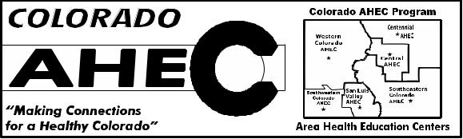
Colorado Area Health Education Center

State Program Office

University of Colorado Anschutz Medical Campus

Official Rent Receipt

For AMC Health Profession Students on Rural Rotation

Date: ______________

This is to certify that I have received from _____________________________, Student’s Full Name

In the amount of $__________ in payment for rent for ________ nights lodging.

First Night of Housing_____________ Last Night of Housing _______________.

(Students Note: You will only be reimbursed for one day of travel and actual rotation dates which will be confirmed with the course coordinator. This receipt must be received in the AHEC Program office within 45 days of the last date of your rotation. Reimbursement will not be paid to a student’s parents or siblings).

_____________________________________ Landlord Signature

Note to landlords: Students are required to have this completed and signed receipt in order to receive reimbursement for rental expenses during rural rotations. You should enter actual amounts the student paid. Students will be reimbursed up to $15 for each night. Thank you.

LANDLORD CONTACT INFORMATION:

(All information below is required.) PLEASE PRINT

Name: _________________________________________________________

Address: ________________________________________________________

City: _____________________________ Zip Code: _____________________

Phone: _____________________ Email: _____________________________

SUBMIT THIS FORM TO: _________________________________

COAHECHousing@ucdenver.edu

