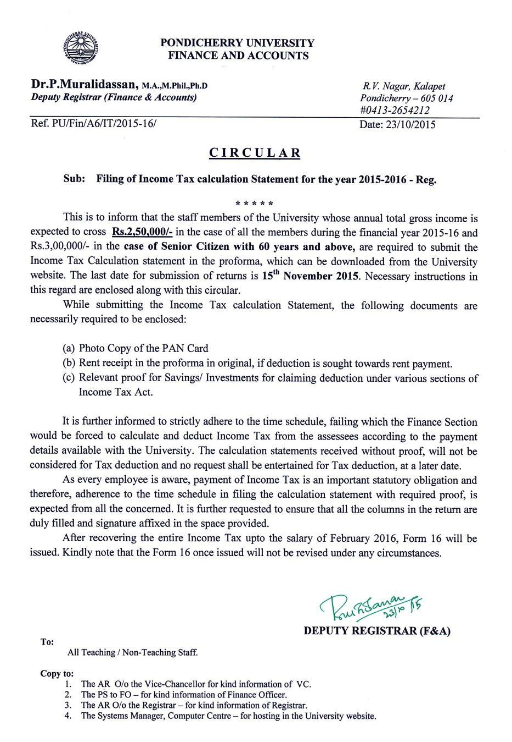
PONDICHERRY UNIVERSITY

STATEMENT OF CALCULATION OF INCOME TAX
FOR THE FINANCIAL YEAR 2015-16

(Please carefully read the instruction/note attached herewith before filling up this statement)
PART – A (Refer Note 1)

- PAN Number (in Block Letters)
- E.C.No.
- Name of the Employee
- Designation
- Name of the Dept/Section

Individual / Senior Citizen
: | (Should Enclose Xerox copy of Pan-card)
:
: | Male/Female | :
: | Mobile No. | :
: | Date of Birth | :
 | Age | :
 | (If above 60 indicate Senior Citizen)

 | PART – B
1. (I) Total Gross Salary Income
(Refer Note 2) :
a) Gross Salary received |  | : Rs.
b) Pay Arrears received |  | : Rs.
c) D.A. Arrears/ Bonus received |  | : Rs.
d) Honorarium received (DDE, Community College/P.G
Diploma Courses, etc., |  | : Rs.
e) OTA received |  | : Rs.
f) Remuneration received |  | : Rs.
g) Children’s Tuition fee reimbursement received |  | : Rs.
h) Medical Reimbursement (Total during the year)
exceeding Rs.15000 received |  | : Rs.
i) University’s Contribution to NPS |  | : Rs.
j) 10 days EL Encashment |  | : Rs.
(II) ADD (a) Any other perquisites Remuneration,.
etc. received (Refer Note. 3) |  | : Rs.
2. LESS: (i) HRA exempted (Refer Note 4) Rent Receipt Format enclosed |  | : Rs.
(ii) Transport Allowance exempted |  | : Rs.
(Max 1600/pm)
(iii) Professional Tax paid |  | : Rs.
(iv) Only Rs.1300/-pm exemption for Island allowance |  | : Rs.
(Refer Note 4) |  | ---------------------
3. Total Salary Income | (1 – 2) | : Rs.
 |  | ---------------------
4. Income from House Property
i) For Self Occupied property
LESS: Interest paid on HBA/Housing Loan {Max 2.0 Lakhs} |  | : Rs.
 | Section 24(b)
- For Income from Let out property

a) | Income from Let out property | : Rs.
b) | LESS House Tax paid | : Rs.
c) | Net Value of income [(a) – (b)]
d) | LESS 30% of Net Value (c) for repairs and maintenance | : Rs.
e) | LESS Interest paid on HBA/Housing loan | : Rs.
f) | Income chargeable under income from house property
 | (c ) – [ (d) +(e) ] | : Rs.
5. Income from Other Sources
(i) Interest from Bank FD |  | : Rs.
(ii) Bank Interest on Savings Bank A/C (Mandatory) |  | : Rs.
(iii) Remn./Honorarium received from other University/
Institutions (Valuation/ Invigilation work etc., |  | : Rs.
(iv) Any Other Income |  | : Rs.
 |  | --------------------
6. Aggregate of (3) – 4(i)+(5) or (3) +4(ii) +(5) |  | : Rs.
 |  | --------------------

7. LESS | Deduction under Section 80 C, 80 CCC
 |  | & 80 CCD * (Refer Note 6)
(i) a) Contribution in Provident Fund(GPF/CPF) |  |  |  |  |  |  |  |  |  |  |  |  |  |  | : Rs.
 |  | b) Life Insurance Premium paid |  |  |  |  |  |  |  |  |  |  |  |  | : Rs.
 |  | c) Repayment of Housing Loans paid (Principal) |  |  |  |  |  |  |  |  |  |  |  |  | : Rs.
 |  | d) Tuition fees paid (Two Children) |  |  |  |  |  |  |  |  |  |  |  |  | : Rs.
 |  | e) Group Insurance premium |  |  |  |  |  |  |  |  |  |  |  |  | : Rs.
 |  | f) PLI Premium paid/PPF |  |  |  |  |  |  |  |  |  |  |  |  | : Rs.
 |  | g) NSC Investment |  |  |  |  |  |  |  |  |  |  |  |  | : Rs.
 |  | h) Investment on Govt. Securities |  |  |  |  |  |  |  |  |  |  |  |  | : Rs.
 |  | i) Investment on approved shares |  |  |  |  |  |  |  |  |  |  |  |  | : Rs.
 |  | j) Contribution in Pension Fund |  |  |  |  |  |  |  |  |  |  |  |  | : Rs.
 |  | k) Investment in approved mutual funds ( |  |  |  |  |  | Sec 80 CCC |  |  |  |  | ) |  | : Rs.
 |  | l) Investment on other approved institutions |  |  |  |  |  |  |  |  |  |  |  |  | : Rs.
 | m) Employee Contribution |  |  | (NPS) Sec 80 CCD (1) |  |  |  |  |  |  |  |  |  |  | : Rs.
 | n) Other’s Refer Note: 6) |  |  |  |  |  |  |  |  |  |  |  |  |  | : Rs.
Total Deduction Claimed (Subject to maximum of Rs.1, 50,000) |  |  |  |  |  |  |  |  |  |  |  |  |  |  | : Rs.
8. Less Employer Contribution |  |  | (NPS) Sec 80 CCD (2) |  |  |  |  |  |  |  |  |  |  |  | :Rs.
9. Additional deduction of Rs.50,000/- for contribution to NPS |  |  |  |  |  |  |  |  |  |  |  |  |  |  | :Rs.
 |  | Proof to be enclosed |  |  |  | Sec 80CCD (3)
10. LESS Contribution to Rajiv Gandhi equity saving |  |  |  |  |  |  |  |  | scheme 80CCG |  |  |  |  |  | : Rs.
(Maximum Rs.25,000/-)(less than Rs. 10,00,000) (Refer Note 11) :Rs.

11. | LESS Contribution in Medical policy |  |  |  | (Sec 80 D) * |  |  |  |  |  |  | : Rs.
 | (Refer Note 7)
12. | LESS Expenditure on Medical Treatment incurred
 | for physically Handicapped dependant |  |  |  |  |  | (Sec 80 DD)* |  |  |  |  | : Rs.
 | (Refer Note 8)
13. | Interest paid on Loan taken for Education |  |  |  |  | (Sec 80 E)* |  |  |  |  |  | : Rs.
14. | LESS Interest earned on deposits in a saving A/c upto
 | Rs.10,000/- | (Sec 80 TTA)* |  |  |  |  |  |  |  |  |  | :Rs.
15. Donation (Swachh Bharat Kosh) & (Clean Ganga) |  |  |  |  |  |  |  | (Sec 80G)*
16. Total Taxable Income [6 –(7+8+9+10+11+12+13+14+15)] |  |  |  |  |  |  |  |  |  |  |  | : Rs.
 | (to be rounded off to the nearest ten rupees)
17. | Tax on Total Taxable Income (Refer Note 9) |  |  |  |  |  |  |  |  |  |  | : Rs.
18. | Tax Rebate Rs.2000 – for below Rs. 5,00,000/-
 | (LESS Total Tax – Rs.2000) |  |  | (Sec 87 A)* |  |  |  |  |  |  |  | :Rs.
19. | Education Cess (3% on Tax) |  |  |  |  |  |  |  |  |  |  | : Rs.
20. | Total Tax |  |  |  |  |  |  |  |  |  |  | : Rs.
21. | LESS Tax deducted at source/from arrears |  |  |  |  |  |  |  |  |  |  | : Rs.
22. | Balance Tax Payable (20-21) |  |  |  |  |  |  |  |  |  |  | : Rs.
23. | Proposal to recover the Balance Tax |  |  |  |  |  |  |  |  |  |  | : Rs.

I hereby authorize the Drawing Officer/Disbursing Officer to deduct the balance amount of tax from my monthly salary as detailed below.

Nov’15
Dec’15

Rs:
Rs:

Jan’16

Feb’16

Rs:
Rs:

*(All these deductions are subject to limitations stated in Income Tax Rules)
*PAN Xerox should enclose with the statement of calculation.

Declaration

I ______________________________ hereby certify that the above, information submitted by me is true and correct to the best of my knowledge and I did not suppress any material facts. In case of any discrepancy/controversy in r/o proofs furnished, I agree to go by the IT deductions made by the University based on the records of University.

 |  | Signature | :
Place | : Pondicherry | Name | :
Date | :/ / 2015 | Designation | :

IMPORTANT NOTES FOR FILLING UP THE INCOME TAX CALCULATION STATEMENT

Note 1 | The PAN number should be necessarily filled at the Part-A of the Income
 | Tax Statement Form. Any form submitted without copy of PAN number will
 | not be accepted and it will be returned to the individuals immediately. Non
 | submission of PAN will attract deduction of TDS @ 20%
 | The pay arrears/D.A. arrears received during the financial year should be
Note 2 | included under Sl.No.1 (I)
Note 3 | All the additional income received by way of honorarium, remuneration from
 | Pondicherry University and other institutions are |  |  | to be included under
 | Sl.No.1 (II)
P
Note 4 | For claiming HRA exemption a working sheet has to be attached in the
 | following methods.
 |  | HRA EXEMPTION WORKING SHEET
 | Actual HRA received (Annual) |  | : | Rs
I.
 | Rent Paid in Excess of 10% of Salary
II | i.e.10% of (Basic pay + Grade pay + DA) |  | : Rs.
 | 40% of Basic + Grade Pay +DA(Annual) |  | : | Rs..
III
 | The Least amount among I, II and III |  | : | Rs.
IV | (Proof for payment of house rent has to
 | be attached denoting the location of the
 | house, signature of the Land Lord, his
 | name and address as per rent receipt
 | format is enclosed)
 |  | EXEMPTION FOR ISLAND ALLOWANCE
 | Any special compensatory allowance in the nature of Border Area
 | Allowance or Remote locality allowance or Difficult Area Allowance of
 | Disturbed Area Allowance - Rs.1,300 per month.
Note 5 | The copy of the permission letter obtained from the University for house
 | construction and copy of the certificate issued by the Institution which
 | released House Building Advance/Housing Loan etc, by clearly mentioning
 | payments of principal and interest, are to be necessarily submitted for
 | claiming deduction under Sl.No.4. Otherwise the claim will be summarily
 | rejected.
Note 6 | (i) The remittances towards Provident Fund, Insurance premium, HBA
 | (principal), PLI etc made by the assessee directly |  | other than salary recovery,
 | are to be proved through proper evidences. Otherwise the contribution made
 | through salary recovery alone will be taken into account for allowing
 | deduction under Section 80 C (Sl. No.7)
 | (ii) Term deposit for a fixed period of not less than five years in the State
 | Bank of India or Public Sector Bank or Scheduled Bank etc.
Note 7 | Under Section 80 D deduction is allowed for medical insurance premium
 | paid under approved schemes which are popularly known as MEDICLAIM
 | for maximum of Rs.35,000 for the Senior Citizen (60 years and above) and
 | Rs.25,000 for others.

Note 8 Under Section 80 DD deduction is allowed in respect of expenditure incurred for medical treatment of the handicapped dependant etc. and deposit made for maintenance of handicapped dependants for a maximum amount of Rs. 75,000. To avail this deduction the dependant should be an handicapped. with disability of 40 % and above and the assessee should produce the dependency certificate, physical disability certificate and proof for incurring the expenditure for treatment, rehabilitation, maintenance etc and Rs.1,25,000/- in the case of severe disability.

 |  | - 2 -
Note 9 | INCOME TAX CALCULATION TABLE FOR TAXABLE INCOME
I. FOR INDIVIDUALS
a) upto Rs. 2,50,000/- |  | : Tax : Nil
b) from Rs.2,50,001 to Rs.5,00,000 : 10 % of income exceeding Rs.2,50,000/-
c) from Rs.5,00,001 to Rs.10,00,000 |  | : Rs.25,000 plus 20% of
 |  | income exceeding Rs.5,00,000
d) Above Rs.10,00,001 |  | : Rs.1,25,000 plus 30% of
 |  | income exceeding Rs.10,00,000
*Rebate of Rs.2000/- will be available taxable income less than Rs.5,00,000/-
II | FOR SENIOR CITIZEN
 | (60 YEARS)
a) upto Rs. 3,00,000 |  | : Tax : Nil
b) from Rs.3,00,001 to Rs.5,00,000 |  | : 10 % of income exceeding
 |  | Rs.3,00,000/-
c) from Rs.5,00,001 to Rs.10,00,000 |  | : Rs.20,000 plus 20% of
 |  | income exceeding Rs.5,00,000/-
d) Above Rs.10,00,001 |  | : Rs.1,20,000plus 30% of
 |  | income exceeding Rs.10,00,000/-
Note 10 Under the Income Tax rules, deduction from gross income towards tax benefit will
be allowed strictly subject to production of relevant proofs to the satisfaction of the
Pay Drawing and Disbursing Officer. Hence all the employees are hereby informed
to produce the proofs along with IT Calculation Statement in time for such
deductions as claimed by them. Otherwise such deduction will be automatically
disallowed.
Note 11 First time investors get the exemption 50% under the Section. That 50% amount
should not exceeding Rs.25,000/- under section 80CCG

Schedule for submission of Income Tax Calculation forms.

- Last date for submission Income Tax
Calculation Statement in the Finance Section : 15th November 2015 With Proof for claiming deductions

b) Form 16 Will be issued from : June 2016

PONDICHERRY UNIVERSITY
FINANCE AND ACCOUNTS

Dr.P.Muralidassan, M.A.,M.Phil.,Ph.D | R.V. Nagar, Kalapet
Deputy Registrar (Finance & Accounts) | Pondicherry – 605 014
 | #0413-2654212
Ref. PU/Fin/A6/IT/2015-16/ | Date: 23/10/2015

C I R C U L A R

Sub: Filing of Income Tax calculation Statement for the year 2015-2016 - Reg.

* * * * *

This is to inform that the staff members of the University whose annual total gross income is expected to cross Rs.2, 50,000/- in the case of all the members during the financial year 2015-16 and Rs.3,00,000/- in the case of Senior Citizen with 60 years and above, are required to submit the Income Tax Calculation statement in the proforma, which can be downloaded from the University website. The last date for submission of returns is 15th November 2015. Necessary instructions in this regard are enclosed along with this circular.

While submitting the Income Tax calculation Statement, the following documents are necessarily required to be enclosed:

- Photo Copy of the PAN Card

- Rent receipt in the proforma in original, if deduction is sought towards rent payment.

- Relevant proof for Savings/ Investments for claiming deduction under various sections of Income Tax Act.

It is further informed to strictly adhere to the time schedule, failing which the Finance Section would be forced to calculate and deduct Income Tax from the assessees according to the payment details available with the University. The calculation statements received without proof, will not be considered for Tax deduction and no request shall be entertained for Tax deduction, at a later date.

As every employee is aware, payment of Income Tax is an important statutory obligation and therefore, adherence to the time schedule in filing the calculation statement with required proof, is expected from all the concerned. It is further requested to ensure that all the columns in the return are duly filled and signature affixed in the space provided.

After recovering the entire Income Tax upto the salary of February 2016, Form 16 will be issued. Kindly note that the Form 16 once issued will not be revised under any circumstances.

DEPUTY REGISTRAR (F&A)

To:
All Teaching / Non-Teaching Staff.

Copy to:
- The AR O/o the Vice-Chancellor for kind information of VC.
- The PS to FO – for kind information of Finance Officer.
- The AR O/o the Registrar – for kind information of Registrar.
- The Systems Manager, Computer Centre – for hosting in the University website.

RECEIPT OF HOUSE RENT

Under Section 1 (13 – A) of Income Tax Act

Received a sum of Rs. _____________ (Rupees _____________________________________

____________________ only) towards House Rent @ Rs. (Rupees

__________________________________ _________________only) per month from ___________ to __________________ from Dr/Sri/Smt _________________________________________ in respect of House No __________

situated at

__________________________________________________________________________________

__________________________________________________________________________________

____________________________________________________________________________

(Affix Revenue Stamp of Rs.1/-)

Signature of the House Owner

Date:

Name:

Address: _______________________

______________________________

______________________________

______________________________

PAN No: _______________________

Note:

- PAN of Owner not mandatory

- Revenue stamp necessary for Transaction more than Rs.5000/-

