Pledge receipt template

Dear James,Thank you so much for making this pledge to us! Your promise for the future helps us effectively forecast our plans for creating sustainable habitats for our sea turtles.
Below is your pledge information we received. We look forward to working with you to complete this pledge! Be on the lookout from our team for ways to complete this. Just so you know, any future donation can be applied towards this if you so choose.
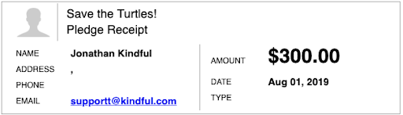
Thank you so much!
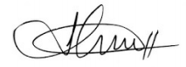
Jonathan
The Sea Turtle Foundation

