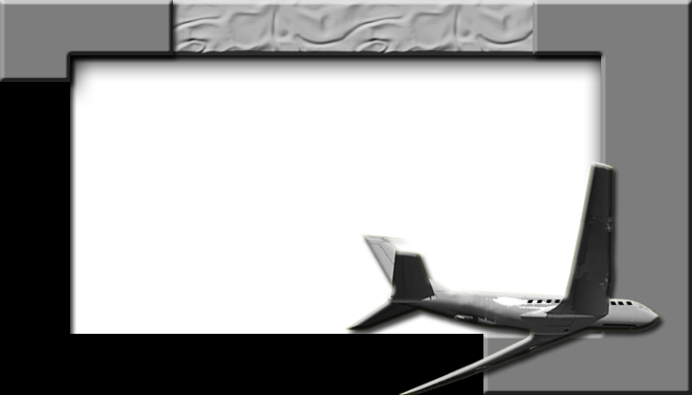

|  |  |
| --- | --- |
| Name: |  |
| Address: |  |
|  |  |
| Phone: |  |

|  |  |  |
| --- | --- | --- |
| Name: |  | |
| Address: |  |
|  |  | |
| Phone: |  | |

|  |  |
| --- | --- |
| Name: |  |
| Address: |  |
|  |  |
| Phone: |  |

|  |  |
| --- | --- |
| Name: |  |
| Address: |  |
|  |  |
| Phone: |  |

|  |  |
| --- | --- |
| Name: |  |
| Address: |  |
|  |  |
| Phone: |  |

|  |  |
| --- | --- |
| Name: |  |
| Address: |  |
|  |  |
| Phone: |  |

|  |  |
| --- | --- |
| Name: |  |
| Address: |  |
|  |  |
| Phone: |  |

|  |  |
| --- | --- |
| Name: |  |
| Address: |  |
|  |  |
| Phone: |  |

|  |  |
| --- | --- |
| Name: |  |
| Address: |  |
|  |  |
| Phone: |  |

|  |  |
| --- | --- |
| Name: |  |
| Address: |  |
|  |  |
| Phone: |  |