How to write
CVs and cover letters

lse.ac.uk/careers

Contents

Welcome 1

Before you start 2

How LSE Careers can help 3

Layout and design 4

Personal details 8

Education 10

Work experience 12

Achievements, interests

and additional skills 14

References 16

CV checklist 18

Cover letters 20

Further resources 25

B

Welcome

Welcome to How to write CVs and cover letters.

We have structured this guide around some of the most common questions that our careers consultants are asked by LSE students.

This isn’t the definitive guide to CVs and cover letters as every application is individual. You will always have choices about the emphasis you give certain parts of your life, the way you write and the design you use.

Because of this we have tried to make our guide as general as possible. All our examples and advice relate to writing CVs and cover letters for jobs in the UK.

If you need advice about writing a specialised kind of CV (like a CV for academia or a very creative position), or would like support applying for roles outside the UK, then you might like to consult our website or seek some one-to-one advice from a careers consultant.

Don’t forget that LSE Careers offers CV and cover letter seminars throughout the year and CV and cover letter discussions where you can have your application individually reviewed. Just go the careers website for up to date information: lse.ac.uk/careers

Jenny Blakesley
Director, LSE Careers

1

Before you start

Basic principles

Relevance

Curriculum vitae means “story of your life”. However, with only one or two pages for your CV you can’t afford to treat this literally. Be selective about what you include. Always ask yourself the question “Is this going to be relevant to the employer who is reading this?” If it isn’t, then discard it.

Tailoring

Your CV needs to match the particular job you are applying for. For example, if the job requires skills in teamwork and creativity, you need to ensure the employer can clearly see that you have gained these skills somewhere in your life. Maybe you worked in a team on a course project or perhaps you had a creative idea for an event which a society organised. The important thing is that the employer can see that your CV is tailored to them and not a generic CV that is being sent to every employer.

Layout and design

You can influence where the employer looks on your CV by the amount of space you allocate to certain sections. For example, in your education section for most circumstances you’ll want to draw employers to your LSE degree. You can do this by giving it more space than any other courses or degrees you have done. You should also think carefully about your choice of headings to highlight key experience.

My spelling and grammar aren’t very good, what can I do?

Always use the spell check on your computer (but remember it’s not fool-proof) and make sure that it is set to UK English. If English isn’t your first language, you may find it useful to ask a native English-speaking friend to read what you have written. The Language Centre can also help you with spelling and grammar but please note there is a cost attached to some services.

Gaps in your CV

Employers can be suspicious about extensive periods of unexplained time on a CV and as a general rule, it is always best to explain these gaps. Obviously, you don’t need to account for every week or even every month, but if, for example, you took a year between school and university to go travelling, it is best to account for it and mention it on your CV. However if there are very personal or sensitive reasons which prevented you being in work or study (including things like criminal convictions, long periods of illness and caring for family members) then you do not have to declare these on your CV. You should, however, be prepared to talk about any gaps in your CV at interview.

There is a balance between explaining everything that has happened and deciding what information is strictly relevant to an employer.
If you are unsure about your situation then come in and see a careers consultant.

Language

Using positive, action oriented words creates the impression of a positive, proactive person. Use words such as “achieved”, “created” and “organised” and avoid tentative words such as “maybe”, “attempted” and “perhaps”. The aim is to make your CV as persuasive as possible. Present information in the most positive light but remember there is a clear distinction between doing this and exaggerating. Make sure your spelling and grammar is accurate. The LSE Language Centre runs excellent English language courses. Contact details and further information can be found at lse.ac.uk/languages

Truthfulness

As well as it being against the law to lie on your CV, you should be willing to talk about anything on your CV at interview, even details in your interests and extra-curricular activities sections. You don’t know what kinds of things your interviewer might also be interested in or have knowledge about so make sure they can’t expose anything that isn’t completely accurate.

2

How LSE Careers can help

Research

It’s important to do as much research as you can before applying for a job. The LSE Careers website – lse.ac.uk/careers – contains information on different employment sectors, ways of planning your career and marketing your skills. You will also find a range of reference material in the LSE Careers Resource Centre.

CV and cover letter seminars

Our careers consultants run regular seminars during term-time which are full of advice on how to construct CVs and cover letters and how you can best market yourself to prospective employers. There are also specialist seminars focusing on specific sectors, such as writing CVs for academia or finance, as well as basic and advanced seminars which cover different stages of careers – from recent graduates to experienced hires. You can use LSE CareerHub to search for and book seminars at careers.lse.ac.uk

What is the difference between a résumé and a CV?

If you see an advert asking for a résumé it’s likely that they have in mind a one-page document with a number of design features such as narrower margins and a smaller font size in order to create more space. In terms of content, a résumé usually covers the same areas as a CV, but with less space to go into detail. See page 7 for an example.

“I found LSE Careers very useful when it came to understanding the structure of a UK style CV.”

LSE student

CV and cover letter feedback

We have a dedicated team of CV and cover letter advisors who will go through these documents with you in one-to-one appointments. Appointments are 15 minutes long during October and 20 minutes the rest of the year and can be booked on LSE CareerHub. Morning appointments can be booked from 9.30am the day before you’d like the appointment. If you’d like an afternoon appointment, this can be booked from 9.30am on the same day. Before booking an appointment, work your way through this booklet and our online resources to make sure you are prepared to discuss your CV.

Academic CVs

These are different in several respects from other CVs.

For example, they do not have the same length restrictions and are expected to contain more detail about your academic achievements. For more information, look at the PhD section of the LSE Careers website. Our careers consultant for PhD students runs lunchtime seminars on writing academic CVs and applying for jobs in and outside academia. You can use LSE CareerHub to book on to these seminars as well as one-to-one PhD/Postdoctorate appointments at careers.lse.ac.uk

3

Layout and design

1 How long should a CV be?

In almost all cases your CV should be no longer than two sides of A4. The exception to this is an academic CV, which will usually have an extra page about publications and conferences. A minority of organisations will expect a one-page CV, but for most a two-page CV is acceptable unless otherwise specified.

2 What is the difference between a “skills based” CV and a “chronological” CV?

In most cases you’ll use a chronological CV, which has standard sections such as education and work experience. Your achievements in each section will be ordered in reverse chronology (ie, most recent first). However, there may be occasions where you start off with a section on the skills you have gained, with examples of where you gained them; this is a “skills based” CV. It’s most commonly used when you have significant relevant experience or an existing career and are looking to change direction and need to emphasise skills that are transferable.

“It’s important to be clear and concise to make it as easy as possible for the recruiter to be drawn to the key information, so don’t include big chunks of writing. Also, use the space wisely and really consider the formatting and layout; for example use bold or capital headings to break up the information.”

Cancer Research UK

3 Should I use a CV template?

We advise you not to because a CV is a personal document and should be unique to you.

4 Should I use different colours on my CV?

No - black ink on white paper is standard. Using more exciting colours will certainly make you stand out, but perhaps not in a positive way unless you’re applying for a creative or design role.

5 What font should I use?

Avoid unusual fonts; they have the effect of making the reader focus on the font rather than the content. Sans serif fonts, like Arial, can make your CV look clean, neat and most importantly readable. Use a font size between 10 and 12.

6 Should I use bullet points or text?

There are no rules about this but try to avoid a CV that is too “text heavy”. Some of the most effective CVs use a combination of text and bullet points. Experiment and see what looks clearest, what is most easy to read and what has the most impact visually.

4

7 Should I send my CV as a Word document or a PDF?

Whilst either format is almost always accepted by employers, it is generally recommended to send a PDF version if possible. A PDF will look the same on any computer, whereas sometimes a Word document might look different (overflowing to three pages for example) depending on the version of Word the recruiter has.

8 Are there any good examples of CVs I can use?

There are a number of example CVs on the LSE Careers website.

However, it is never a good idea to just copy one exactly.

Your information is unique and to present it in the most favourable light you will need to make changes to any example you find.

9 Should I attach my CV if I’m completing an online application form?

Only if specifically asked to do so.

10 I have previous work experience. Should I present my CV differently?

The same basic principles apply, for example giving your most relevant information highest priority on your CV. However, you may want to consider different CV formats to best present your skills. Even though you have more experience, your CV still needs to be on a maximum of two pages, so you may have more editing to do.

Did you know?

Top reasons employers give for unsuccessful applications include: poor spelling and grammar, not answering the question asked, not following instructions, lack of research on the organisation and not practising for tests that are part of the application process.

Top tips: format, font and space

The amount of space given to a section reflects the amount of importance you attach to it. Decide on a format for headings and body and stick to it.

Fonts like Arial and Calibri are recommended as they are clear and simple. If you use something different, make sure you’re consistent and the font doesn’t detract attention from your content. It’s also important to remember that some fonts take up more space on a page than others.

Print out your CV to see what it looks like in reality. Is there a lot of white space or too much text? Are the margins too large or small? Your CV could be read in as little as 8 seconds. Make sure it’s immediately appealing to the eye.

5

First page of a typical two-page CV
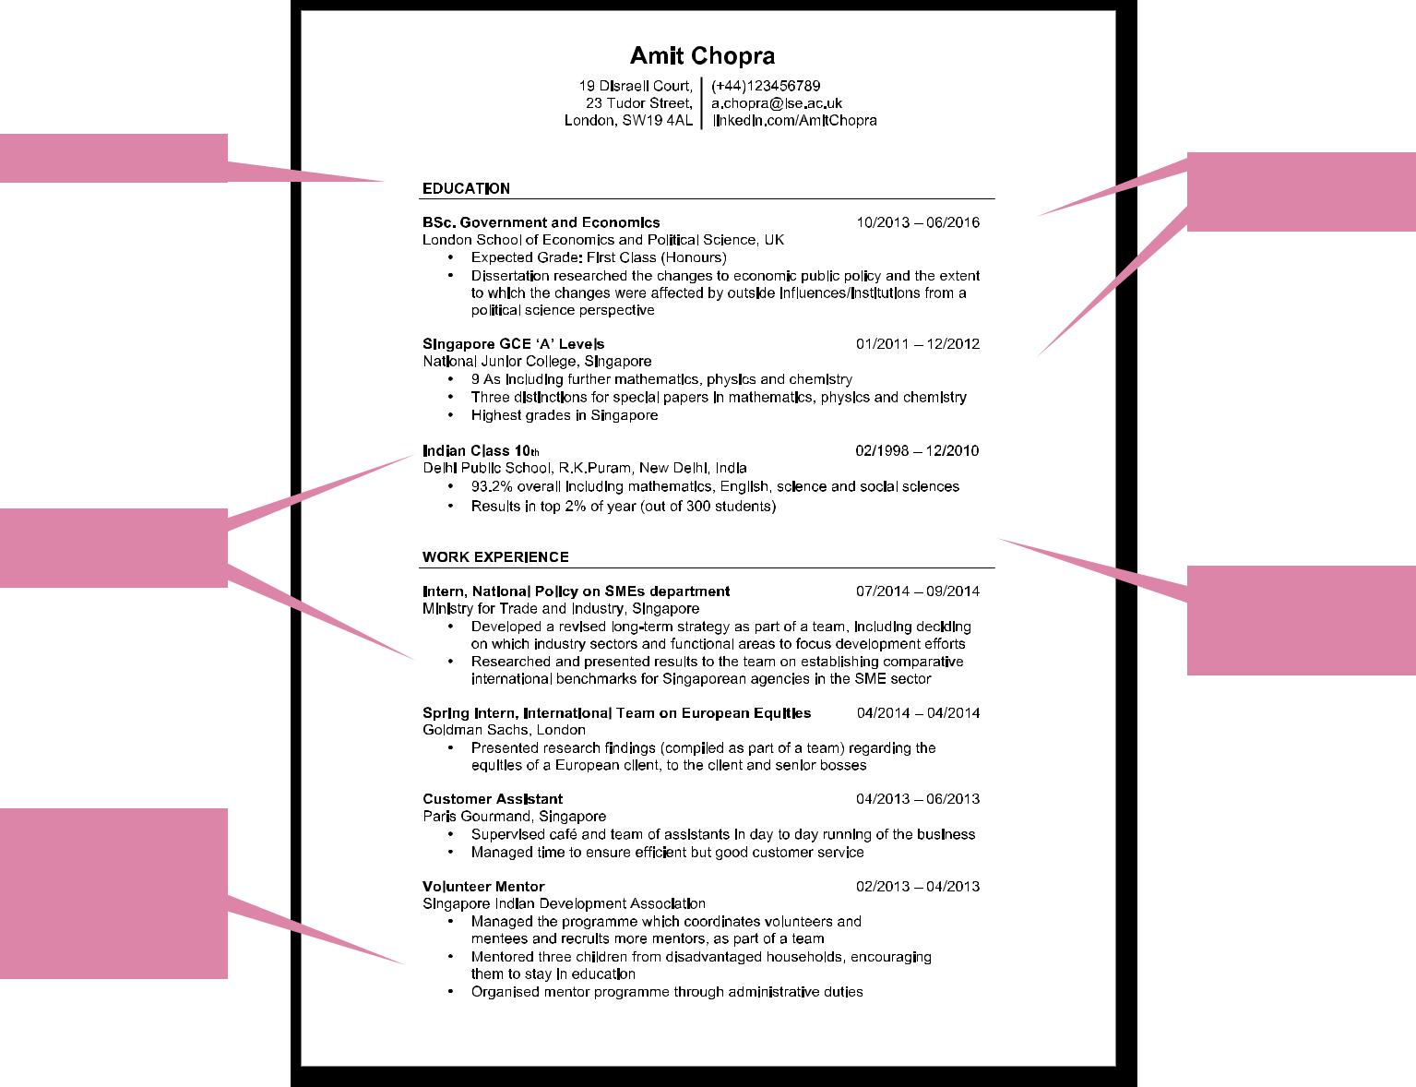

Clear headings
Dates all in the

same place

Sections clearly

differentiated

Plenty of white

space creates

uncluttered design

Good use of bullet

points and space

to emphasise

key skills and

responsibilities

6

Example of a single page CV (sometimes called a “résumé”)
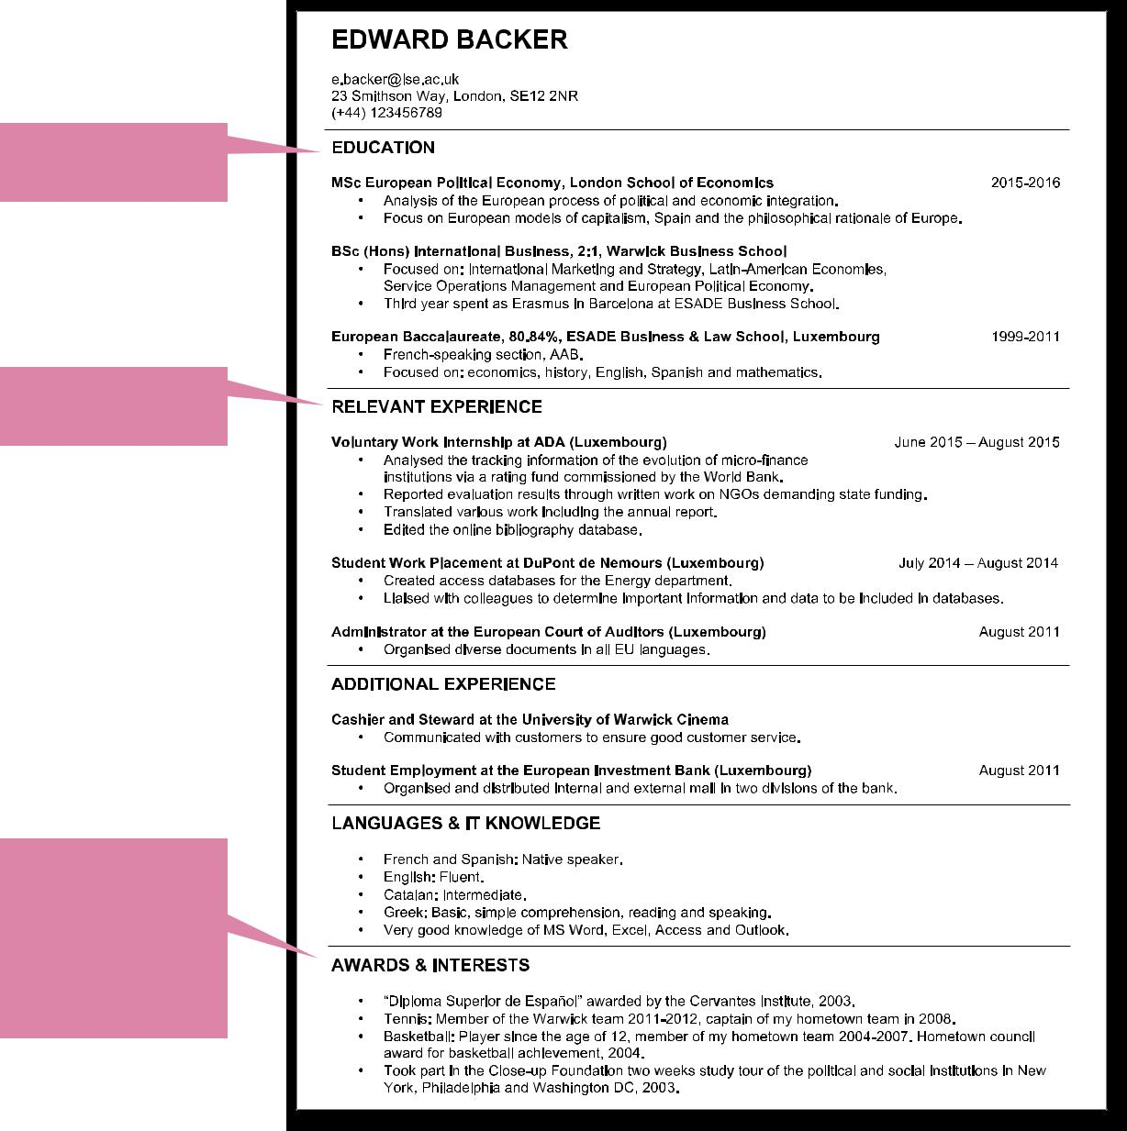

Smaller margins

than two-page CV

Very concise

information

Very clearly

defined sections

Less white
space on a

single sided CV

Combines sections

which might be

separate on a

two-page CV eg,

“Awards” and

“Interests”

7

Personal details

Large clear name. No need to write “curriculum vitae” anywhere

Up to date contact details

Include your LinkedIn profile or any personal websites or blogs if you feel they are relevant and you want an employer to see them

1 Should I include my home address and my LSE address?

It’s helpful to do this if you are spending long periods away from your LSE address and an employer will be contacting you during this time. Tell the employer the dates when you are at each address so they know which one to use.

3 Should I attach or scan a photo of myself?

You should not be asked for a photo in the UK. Read an employer’s application advice carefully and use resources like “Going Global”, which LSE Careers subscribes to, to research the recruitment norms of different countries. Going Global can be accessed through the LSE Careers website under “Exclusive resources”.

2 Should I include a career profile/objective?

A career profile (or career objective) is a short statement, usually at the top of your CV, saying something about you and your career aims. For new graduates or postgraduates, career profiles are not really necessary as this content will be addressed in your cover letter. Profiles can run the risk of sounding clichéd. If all you have to say is, “Current student with an MSc Social Anthropology with good communication skills, excellent team work skills and ability to work independently, now seeking job in finance”, then the space would be better used to display significant facts about your education and experience.

Profiles can be a useful addition to a CV if you have some very specific experience and you are very clear about the particular career area you are going for. Profiles can also be useful if you are asked to send a CV without a cover letter. If you are changing career they can help you to state briefly your previous area of experience and what you’re aiming for now.

4 Do I need to mention my gender and age?

No. It is entirely optional whether you include this information. It is often deducible from other information (like your name and the date of your qualifications). It is illegal for employers to ask you to declare your age and also illegal, except in certain rare situations, for employers to discriminate on grounds of gender.

8

5 Do I need to mention my nationality and work permit status?

There may be cases where an employer is interested in knowing your nationality in order to find out whether they will need to apply for a work permit for you. However unless they ask you to state your nationality on your CV or application form there is no requirement for you to do so at this stage. You can also wait to raise the subject at interview stage as this will allow you to “sell” yourself in person before discussing the possibility of a work permit.

If any other information on your CV suggests that you may need a work permit and this is not the case, ensure that you state your nationality or that you have permission to work in the UK.

For information and advice on visa and work permits please contact the International Student Immigration Service (ISIS) or read the information on their website lse.ac.uk/isis

6 How do I talk about disability?

LSE Careers offers tailored services for disabled students including a dedicated careers consultant specialising in disability and employment, and longer, flexible appointments available to accommodate individual needs.

You can visit us or email careers.disability@lse.ac.uk for advice on recruitment processes, disclosure, reasonable adjustments to recruitment processes and the workplace environment, legal issues and other disability careers issues.

Whether or not you disclose your disability is a very personal choice. We have further information for students with disabilities on the LSE Careers website (lse.ac.uk/disabilitycareers) and you can visit gov.uk/browse/ disabilities/work for details about employment rights.

For advice on disability issues during your time at University visit the Disability and Well-being Service, email disability@lse.ac.uk or call 020 7955 7707.

9

Education

Picks out a

relevant module

to explain

Explains non-UK

qualification

EDUCATION

BSc. Government and Economics | 10/2013 – 06/2016
London School of Economics and Political Science, UK

• Expected Grade: First Class (Honours)

- Dissertation researched the changes to economic public policy and the extent to which the changes were affected by outside influences/institutions from a political science perspective

Singapore GCE ‘A’ Levels | 01/2011 – 12/2012
National Junior College, Singapore
- 9 As including further mathematics, physics and chemistry
- Three distinctions for special papers in mathematics, physics and chemistry

- Highest grades in Singapore

Indian Class 10th | 02/1998 – 12/2010
Delhi Public School, R.K.Puram, New Delhi, India
- 93.2% overall including mathematics, English, science and social sciences

- Results in top 2% of year (out of 300 students)

Gives

expected

result

1 What part of my education should I give most prominence?

You should give most prominence to the part of your education that is most relevant to the job you are applying for. Usually, this is your most recent education but do not be afraid to emphasise an earlier qualification if it is more relevant. This may include specific modules or projects.

2 Do I have to list all my qualifications and modules?

Unless the employer specifically asks you to, you do not have to list every qualification and module but you should remember to include all those that are relevant to the application you are making.

Try to be selective. Listing your A levels is fine but try to summarise your GCSE grades. For example write “10 GCSEs including Maths and English, all at grades A* to B”. Don’t overlook the importance of group projects, research and dissertations.

Remember that the person reading the CV will be experienced in spotting gaps in the information you do give. If you do not give grades or a complete record of the exams you have taken, expect to be asked about these at interview.

10

3 Some of my qualifications are non-UK. How do I translate them into UK ones?

It’s not possible to directly translate them as educational systems vary widely and a grade or degree classification can mean quite different things from country to country. The best way to approach this is to explain your qualification so that the reader understands its significance. You can use phrases such as, “equivalent to top five per cent of year”, or “highest possible grade”. GPAs and percentages will normally be recognised.

For more information look at the NARIC website (naric.org.uk). There is a telephone number you can call if you want to speak to a specialist about comparing qualifications. If you are unsure about anything, contact the organisation you are applying to directly.

4 Do I need to give the full addresses of the places I have studied?

No, giving the city is enough; for example, “Sciences-Po, Paris”.

You can add the country if you feel the city is not very well known.

5 How should I present predicted grades?

In most situations this is more important for undergraduates than postgraduates as many employers specify a certain class of degree as an entry requirement. First of all consult your tutor to find out what they think your final result will be. If you can’t do that then make a realistic estimate yourself based on your previous years’ grades. It is normal to use a phrase such as “expected result 2:1”.

For postgraduates, it’s of much less importance. Employers will rarely ask for a “merit” or “distinction” so, unless the job is placing particular weight on your postgraduate qualification, it’s optional.

6 Should I mention awards and scholarships?

Use these to impress the reader with your good academic track record. If you have many, going back to your time at school, it may be best to select just a few of the most prestigious or most recent, so that these stand out. For each one you give, say what the award or scholarship was for, what you were awarded eg, a prize or bursary, what proportion of people received an award in your year and any other details that quantify the achievement.

“In order to direct your potential employer to the most prominent and relevant elements of your course it can sometimes help to include a little background information on your degree. If you’re stuck for ideas, why not have a quick browse through your university prospectus to find a course summary that highlights nicely the most pertinent parts of your chosen area of study and pick out the most relevant bits?”

Laura-Jane Silverman, LSE Careers Consultant

Qualifications aren’t everything

Many employers rate experience, intelligence and aptitude above qualifications when considering candidates and applications.

11

04/201414– –04/201414

Work experience

Talks about

skills and

achievements

Uses positive

language

WORK EXPERIENCE

Intern, National Policy on SMEs department 07/201414– –09/201414

Ministry for Trade and Industry, Singapore

- Developed a revised long-term strategy as part of a team, including deciding on which industry sectors and functional areas to focus development efforts

- Researched and presented results to the team on establishing comparative international benchmarks for Singaporean agencies in the SME sector

Spring Intern, International Team on European Equities Goldman Sachs, London
- Presented research findings (compiled as part of a team) regarding the equities of a European client, to the client and senior bosses

Customer Assistant | 04/201313– –06/2013
Paris Gourmand, Singapore
- Supervised café and team of assistants in day to day running of the business
- Managed time to ensure efficient but good customer service

Volunteer Mentor 02/2013– –04/2013 Singapore Indian Development Association

- Managed the programme which coordinates volunteers and mentees and recruits more mentors, as part of a team
- Mentored three children from disadvantaged households, encouraging them to stay in education

- Organised mentor programme through administrative duties

Explains organisation and role when necessary

1 I have different experience from different sectors, gained at different points in my life. How do I deal with that on my CV?

One option is to list the experience in reverse chronological order. However it might be more effective if you grouped or “themed” your experiences. So, instead of a general heading called “Work Experience”, you could have two or more headings such as, “Legal Experience”, “Banking Experience”; or alternatively “Relevant Experience” and “Additional Experience”.

2 What counts as “work experience”?

Don’t just think of “work experience” as referring to full-time positions and internships – voluntary/unpaid work, part-time jobs and entrepreneurial activities can be of equal value. Employers are really interested in the skills that you have developed which are transferable to another position. It is your job to decide how relevant that experience is to your application and to group and prioritise your experience accordingly to highlight this. Your experience working in a part-time or voluntary capacity may also be directly relevant to the position.

12

Importance of voluntary experience

As well as enabling you to make an impact in society, getting involved in volunteering is an opportunity to develop new and existing skills, meet new people, improve your confidence, give your CV a boost and more. The LSE Volunteer Centre advertises a range of volunteer opportunities on LSE CareerHub and you can book one-to-one discussions for advice on finding a suitable volunteering opportunity for you. Find out more at lse.ac.uk/volunteercentre

3 Should I mention salary details and reasons for leaving previous jobs?

Not unless specifically asked to do so.

4 Do I need to give the full addresses of the places I worked?

No, simply mentioning the city is enough; for example, “Marks and Spencer, London” or” London School of Economics and Political Science”.

You can add the country if you feel the city is not very well known.

5 If my job title is in a foreign language, will I need to translate it?

If the title is very different and obscure then you will need to translate it into the language of the country of application. For the UK market, it’s useful to check with a careers consultant that you have an accurate translation which means something significant. Remember that a clear description of the work that you did will clarify your application.

“Experience should be recent, relevant to work history and in reverse chronological order. Never underestimate your experience – skills can be transferable so if you can demonstrate they match the role, any experience can be of interest.”

VSO International

“Make your headings work for you. You can use them to subdivide your work experience so that you can collect together the most relevant experience in one section.

Then put that section in a prominent place on your CV. For example if you are applying for a consultancy job and you have a mixture of consultancy and other work experience, create a section called ‘Consultancy work’ for your first page and another called ‘Work experience’ that can appear later in your CV.“

Maddie Smith, LSE Careers Consultant

Top tips: presenting your experience

- Your CV may form the framework of your interview. Be comfortable with what you have written and be prepared to elaborate and talk enthusiastically about anything on your CV.

- Be clear about your individual contributions to the achievements you list and be ready to explain them at interview.

- Avoid obscure abbreviations, jargon or slang.

- Your CV should be an aid to the employer helping to direct them to the skills and experience they have asked for.

- Don’t underestimate your experiences. If you can demonstrate the skills you acquired and apply them to the role you are applying for, then any experience can be of interest.

- Try to quantify successes with facts and figures – “scored in top 5 per cent”, “increased sales by £x”, “managed a team of five staff”.

- Remember that you shouldn’t lie or misrepresent any information in your application - employers can dismiss you if you do.

13

Achievements, interests and additional skills
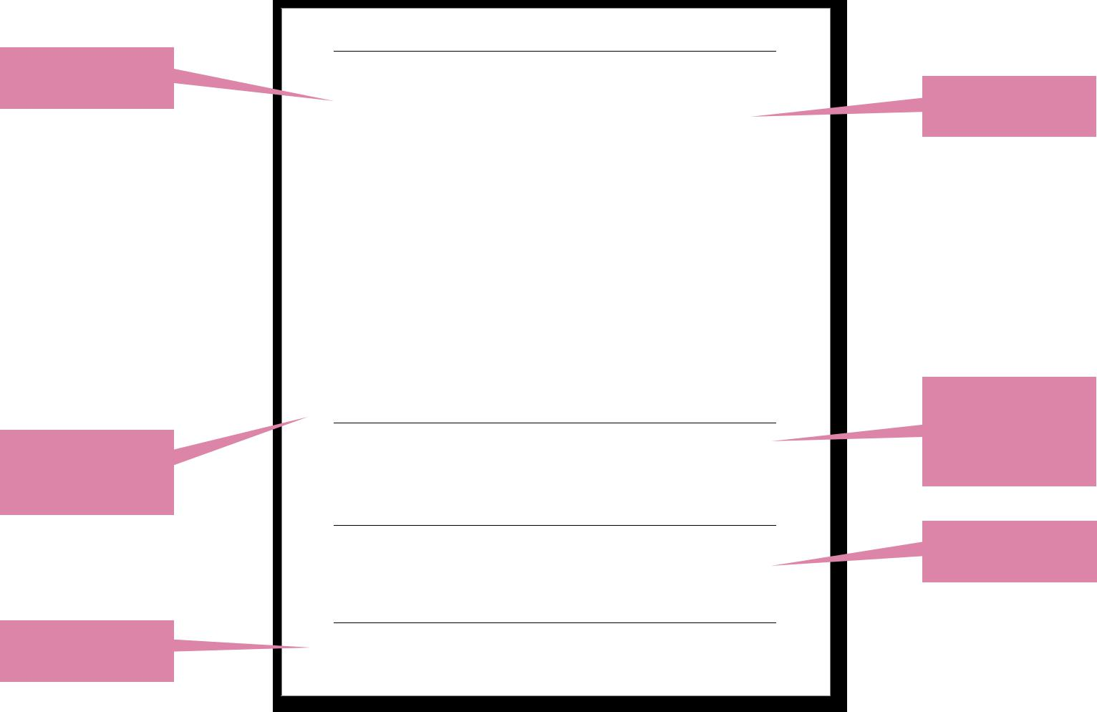

Appropriate level

of detail

Headings are

flexible in these

sections

Goes into detail

about interests

EXTRA CURRICULAR EXPERIENCE

Secretary 10/2014 – present London International Model United Nations

- Coordinate the weekly meetings of the Organising Committee and ensure timeline requirements are met
- Arrange venue and accommodation for over 70 participants

Secretary | 10/2014 – 06/2016
LSE Debate Society
- Active member and debater in the LSE Debate Team, representing LSE at inter-varsity tournaments
- Organised weekly meetings of the society, coordinating 30 members
- Planned, prepared and facilitated the LSE Open 2015, an international inter-varsity competition, attended by 200 contestants

International Editor | 10/2014 – 06/2016
The Beaver, LSE’s weekly newspaper
- Wrote a dedicated column on international affairs

President | 01/2012 – 12/2012
National Junior College Debate Club
- Debater in the NJC Debate Team
- Liaised with peers to ensure attendance at the Club, with responsibility for over 80 debaters

AWARDS AND SCHOLARSHIPS

- ‘Best second year exam performance, with reference to first years’ at LSE, out of a possible 2000 students; The CS MacTaggart Prize 2015
- Student of the Year 2013 out of 500 students; National Junior College, Singapore

IT SKILLS

- Statistical software packages including eViews, Minitab and Stata
- Touch typing ability c. 60 wpm
- Proficient in all major Microsoft Office applications, including complex formulae in Excel

INTERESTS

Backpacked through Mediterranean Europe for nine weeks, a particular highlight was visiting Florence and experiencing the Uffizi and Accademia museums

Same layout as

work experience

Be selective

and explain the

significance of

each example

Relevant IT skills

are highlighted

“While relevant experience is always viewed positively, don’t be put off applying if you don’t have this. Think about the skills you’ve developed through other work experience and extra-curricular responsibilities and be explicit about these skills in your CV.”

FTI Consulting

1 What goes in my interests section?

This section enables you to identify things that really interest or motivate you. It may also indicate what your values are, aspects of your personality and the transferable skills you have developed. It is better to include one or two things which you are really involved with and can describe fully, rather than to give a long list such as “reading, squash, cricket, dancing,

14

music” with no detail. You might also want to include team or group activities that show you can interact well with other people. You could even treat this section in the same way as the rest of your CV using dates, divisions such as “school” and “university” or grouping similar things, like sports, together to enhance impact.

2 What if I haven’t taken part in extra-curricular activities before?

You don’t have to include a section on extra-curricular activities or achievements, but employers are often interested in what you have done outside of work and academic studies. Think widely about what you have done before you came to University and whilst you have been at LSE or previous institutions. Don’t feel all is lost if you haven’t been president of a student society. Activities like volunteering, mentoring, being a course representative, organising an event to raise money or the profile of a particular cause are all relevant experience. It’s never too late to get involved in something on or off campus.

3 How important are languages and how best can I demonstrate them?

This will depend on the position that you are applying for. If languages are one of the requirements of the job it may be worth writing them in a short, very specific personal profile at the top of your CV or in a prominent position on the first page. You may need to write about how you have used languages ie, writing reports, chairing a conference, handling client requests by telephone. You will also need to describe your level of fluency using terms like native, fluent, intermediate, basic or conversational.

4 What level of IT skills do I need to demonstrate?

As long as your position is not IT related, it is generally accepted that a graduate will be able to cope with the IT skills needed to carry out a typical graduate entry role. Towards the end of your CV, you can detail your familiarity with packages, programming languages, operating systems, web design packages and the internet generally. IT skills may be a clear selling point for temporary positions or for positions within smaller organisations.

5 Should I include social media?

Don’t hide social media such as blogs, LinkedIn, Twitter and Facebook if they portray you in a professional light. Including them on your CV shows you have a grasp of new media, technological and communications skills, a passion for certain subjects or writing, and possibly a network of people who are interested in what you have to say. Personal social media accounts for private communication with friends are probably best hidden from employers. Keep them off your CV and alter the privacy settings so that only your friends can view them. It’s also worth searching for your name online to see what kinds of things employers can find out about you whilst they screen applications.

“Candidates that show a combination of experiences, behaviours and technical skills typically stand out as the most well-rounded and talented individuals. Use your application to share unique experiences and interests, and your involvement in academic and extra-curricular activities. Demonstrating skills like entrepreneurial spirit, problem solving, and ability to motivate teams or peers will also help you stand out.”

L’Oréal

CV writing tips from a recruiter

- Be concise and ensure your information has an impact.

- Keep it simple and clear – you can always elaborate at the interview.

- Analyse the job description – read it and identify which relevant skills, experience and competencies you have, or consider other experiences that could be appropriate.

- Don’t have any unexplained gaps on your application. If you have had a career break or have been travelling, let us know.

- Academic and professional qualifications should flow in a logical order.

- Check your application before submitting. Check spelling and get a friend or family member to read through if it helps.

15

References

References are usually requested by an employer on an application form or after the interview stage if the candidate has been successful. It is generally assumed that you will be able to provide references so you don’t need to mention them on your CV.

1 How many referees do I need?

Usually two, preferably one LSE academic and a recent employer.

If you do not have an employer use two academic referees instead.

2 No one in my department knows me. How will they be able to write me a reference?

Try to make contact with your personal tutor and discuss with them the types of jobs you are applying for. Your tutor will have access to useful information about you on LSE For You. Therefore it is in your interest to keep this information updated. As well as posting your CV, you can also write about the skills you have gained and comment about your class reports. All of this will be very useful information for a reference.

3 Can I use overseas referees?

Yes you can. It is helpful to give an email address in this instance.

4 Can I use a referee who is somebody I know well and who already works for the organisation?

The standard convention is to use an academic referee and your most recent employer. You do not need to name referees on your CV so it may be better to discuss the subject at a later stage in the recruitment process if you would like to use someone else.

5 Do I have to give my current employer as a reference?

It’s standard practice to do this. If you don’t, the recruiter may think you are hiding something. If you are concerned that your current employer doesn’t know you very well, or that a previous employer is more impressive and you would rather use that, it might be better to discuss this at a later stage in the recruitment process.

6 My most recent employer is from a short, casual job I have been doing. Can I use family and friends instead?

Most employers aren’t going to be interested in the actual referees you select (though they will be expecting one to be your current or most recent employer) so don’t worry if your most recent employer isn’t particularly relevant to the job you are applying for.

7 Do I need to get permission from a person before I use them as my referee?

Yes. It is even better if you can have a discussion with them and explain the types of jobs you will be applying for and the skills required.

16

8 I have two potential academic referees; one of them is a well-known, high profile professor who doesn’t know me very well, the other one is not very well known but knows me very well. Which one should I use?

It’s quite likely that the professor may not be that well known outside specialist circles and a reference from someone who knows you better would be more appropriate. However, if you are applying to organisations where the high profile professor will be known (for example if you are applying to another university or a think tank), then a reference from them may carry some weight.

9 Should I send a letter of recommendation with my CV?

In the UK the convention is not to send letters of recommendation with an application. Other countries may differ though so use resources like “Going Global”, which LSE Careers subscribes to, for further information.

17

CV checklist

We have stressed throughout this booklet the necessity of creating a CV that is targeted to a particular employer and to a particular job. Hopefully, as a result of following the principles outlined in this booklet, you now have a strong CV that will reflect your abilities. You can use the checklist on this page to make sure you have included all the important elements of your CV:

Content

Personal

Contact address/addresses and telephone numbers included?

Does your email address sound professional?

Have you included an up to date LinkedIn profile?

Education

Have you given most space to your most recent or relevant education?

Have you highlighted relevant modules, projects and dissertations?

Any academic awards?

Any key or relevant transferable skills highlighted?

Is your education section easy to follow and consistent in approach?

Anything else you need to explain (eg,”A” grade is equivalent to the top 1.5 per cent)?

Work experience/internships

Is this a comprehensive overview of all the different jobs you have had? Are there ways of separating your employment by type or sector for emphasis?

Have you included job title, dates, organisation name, type of business and location?

Have you highlighted the skills used, the impact you had, and the significance of your achievements in the position?

Is this section ordered and the skills identified targeted towards your chosen future role?

Achievements/positions of responsibility

Do you emphasise your personal contribution here?

Is specific evidence for skills displayed?

Is the significance of your achievement demonstrated?

Can you quantify it?

Have you highlighted the most relevant roles or skills for the job you are applying for?

Can you include any of these positions (eg, volunteering) in an experience section or use them to highlight suitability for a particular career area?

Skills

Have you included your IT skills and evidenced these?

How competent are you?

Speak any languages? Again, is the level of proficiency of each expressed?

Any other information to include here eg, driving licence, professional training courses?

Other interests

If there is space on your CV, do you go beyond listing lots of one-word examples?

Have you given a variety of interests highlighting different skillsets?

Can your interests be used to demonstrate responsibility, commitment and achievement?

Referees

Has the employer asked for them to be included? Unless requested then it’s not necessary to mention them at this stage.

18

Layout and design

Rationale and targeting

Does your CV follow protocol for your chosen sector (is a one-page or two-page CV the standard?)

Is it ordered in a logical, clearly structured way?

Any specific CV guidelines for the country you are applying to?

Is there evidence of targeting experience and skills to the role?

Is the structure and space allocation of sections appropriate to their importance?

Presentation

Are the headings clear and easy to read? Are they descriptive/targeted?

Does your CV have well-spaced sections?

Is it easy to scan read? Does the most relevant content stand out?

Does your CV use the same font style as your cover letter?

Are all the dates mentioned in your CV formatted and positioned in the same way so an employer can scan over them?

Written style

Is the language positive and enthusiastic in tone?

Have you checked for vocabulary, grammar, spelling and punctuation errors?

Is your CV jargon free and are acronyms explained?

Are capital letters used correctly?

Have you asked a friend to proof-read for errors?

“CVs should be a snapshot of what you have achieved in an orderly fashion that’s easy to digest. Put yourself in the position of your future employer who may be looking through hundreds of CVs – they want to know who you are, where you’ve worked, what you’ve achieved academically and personally and what you are hoping to do next.

So choose your words wisely and check for mistakes.”

Seven Hills

“I found the CV checklists very useful. I really liked how the areas which needed improvement were identified rather than glossed over and the advice is transferable to more than a particular cover letter. The methods recommended are great and practical.”

LSE student

19

Cover letters

1 What is a cover letter?

A cover letter is a one-page document that is sent and read in conjunction with your CV. It highlights relevant skills and achievements.

2 What is the purpose of a cover letter?

The cover letter is a chance for you to highlight the skills and achievements which are especially relevant to that particular employer. It will be a brief summary of your experiences to date, tailored to the competencies that are required by the employer. It is also a chance for you to demonstrate your knowledge of the organisation to which you are applying and your motivation for working there. Some recruiters will also use your cover letter to assess your written communication skills.

3 What needs to be included in a cover letter?

Recruiters expect you to show that you match the position. The secret of writing a good cover letter lies in using your qualifications and experience to show that you are the best person for the position.

One way of going about it is to begin your cover letter by focusing on your relevant achievements: academic, extra-curricular, work experience and other interesting aspects of your life. Then move on to focus on the employer, why you are applying for the job, including some interesting and relevant facts about that organisation.

Show them that you are capable of thinking clearly and you are a motivated, proactive learner. Write in a clear and logical manner and remember, the way you write and present yourself says a lot about you.

4 How long should the cover letter be?

Where possible, follow the employer’s instructions and any advice offered by them. If this is not available, something around 400 words is about right and certainly not more than one page of A4 paper.

5 What type of language should I use?

Aim for short, sharp sentences that make for concise, gripping paragraphs, which are good for busy recruiters who can’t spend a long time reading each application.

6 What is the correct layout of a cover letter?

In general, cover letters are one side of typed A4 and are set out like a formal business letter. Have a look at the example cover letters in this booklet (page 23 and 24) or on our website to see how this is done. The letter should be about three to four paragraphs long with each separated by a single line. Do not indent the paragraphs as this is considered old-fashioned.

7 How should I address my letter?

Your name and address should be clearly shown at the top, right-hand corner of the letter. Don’t think that because this information is on your CV you don’t need to put it on the cover letter. Pages can become separated easily.

8 How do I know who to write to?

It’s usual to reply to the name used in the advert or application pack. If a name is not given, call the organisation and ask for a named individual who deals with recruitment. We strongly advise that you address your cover letter to a named person. Do make sure you use the correct spelling of their name. If you are not able to find a named individual, you can use “Dear Sir/Madam”.

The correct greeting in a business letter is always formal. It normally begins with “Dear” and usually includes the person’s last name and title, ie, Professor, Dr, Mr, Ms etc. If addressing a female, does the job advert specify whether they are Mrs, Miss, or Ms? If it doesn’t say then it is best to use Ms.

“We like to see evidence of what it is you achieved, how you did it and how you worked with other people along the way. We can’t consider any of the knowledge and experience you have gained unless you put it down on paper!”

Shell

20

9 How do I sign off?

The convention in the UK is if you address the letter to a named individual, sign off with “Yours sincerely”. If your letter begins with “Dear Sir/Madam”, end with “Yours faithfully”.

10 What do I put as the subject header when sending my cover letter via email?

Title the email “Application for (job title)”, also following any additional instructions in the job advert (like including a reference number). If you are sending a speculative application you can be less specific. Try to keep your subject header concise and professional though.

11 Should I handwrite a cover letter?

If you are asked specifically to handwrite it, then you must. Make sure the letter is neat and legible. Use dark ink because it is easier for photocopying. In almost all cases though, you should send a word processed letter.

12 Can I use bullet points or subheadings in a cover letter?

There is nothing to stop you using bullet points or subheadings to help structure your cover letter. However remember that you are still writing a formal business letter which needs to be written clearly and succinctly.

13 Are there any example cover letters at LSE Careers?

Yes, we have example cover letters in the “CVs, cover letters and applications” section of our website. Remember that these
are only guidelines; your cover letter needs to be targeted and specific to the role and employer.

14 Can I discuss my cover letter with someone at LSE Careers?

We run one-to-one CV and cover letter discussions throughout the year where you can discuss the style and content of your CV or cover letter and how to target them to particular positions. However, these do not cover spelling and grammar; you should see the LSE Language Centre for help with this. You can use LSE CareerHub to book CV and cover letter discussions at careers.lse.ac.uk

15 Which is more important, the CV or the cover letter?

They are both important. If you want to maximise your chances of success you should treat them both seriously. The cover letter is often the first thing the recruiter sees and will set their expectations for what is to follow. A good cover letter will highlight your key strengths and motivations for wanting to work in a particular organisation, the CV will then go into more detail about what you have achieved. The recruiter will form an impression of you based on both documents.

“It’s really important your cover letter says something specific and unique about why you want to work for that company. Go beyond the obvious on their website, do your research and show you are genuinely motivated and enthusiastic about what the organisation does. This is what employers are looking for and will help you stand out from other applicants.”

Maddie Smith, LSE Careers Consultant

21

16 All the organisations I am looking at seem to be the same. How can I demonstrate that I know the differences?

It’s often assumed that the way to impress an organisation is to show that you have carried out a lot of research. This is true up to a point. The strongest cover letters show that you have done some research but also make a link between you and the organisation. Show initiative and speak to people working for the organisation to learn more.

17 My circumstances are unusual, how should I present these in a cover letter?

You need to think about the needs of the employer that you are approaching and try to present the information to meet those needs, emphasising the transferable skills that you have acquired. You do not need to focus on all aspects of your life to date in the letter, only those areas in which you feel the employer will be interested and which are relevant to the role.

18 Can I have a standard cover letter?

Your cover letter should be tailored to one specific vacancy (or to a particular employer if you are applying speculatively). Recruiters will be able to spot generic cover letters and furthermore, you will not be able to show specific research you have done into a particular organisation.

19 Can I send a speculative CV and cover letter?

Sometimes roles are not formally advertised so you can contact a potential employer to enquire about upcoming opportunities or to express an interest in working for them. Try to find out who deals with recruitment through calling or networking, as personally addressed applications are the most effective and professional.

You should include a CV and cover letter, and media and journalism applicants should also include one or two examples of published work. Once you have sent your speculative application, wait between one and two weeks to follow up.

“It can be tempting to think of applications as a numbers game, and that the best approach is to apply to as many employers as possible. That can cause your cover letter to look very standardised and errors to creep in. Check whether the organisation you’re applying to has a statement of values, and read the role description carefully. Then use the cover letter to guide the employer to the sections of your CV or application form that show your own values are aligned.

This will make your application appear more tailored and shows the employer that you would be a good fit.”

Morgan Stanley

Top tips: cover letters

- Keep the language friendly but formal. Think about how you would speak to an employer at interview.

- Be positive! Use action words but don’t lose sight of your own style.

- Avoid repeating key words or phrases.

- Always end on a positive note. You can end by reaffirming your enthusiasm or your suitability.

- Check your letter several times, and then get a friend to check it, then go away and check it again later.

“Format to impress: make your CV and cover letter as easy on the eye as possible, keep them succinct (we recommend no more than two pages for a CV), ensure you structure your achievements in a logical and clear way, and proof-read for spelling and grammar errors.”

The Boston Consulting Group

22

Talks about education and work experience in a way that emphasises relevant skills and achievements

Paola Vincent
33 Emmengate Street

London

SE12 3PY

Ms J Joseph

Graduate Recruitment Manager

TB4 Consultancy

Strand, London

WC2R 2LS

22 January 2016

Dear Ms Joseph

I would like to apply for the position of Trainee IT Consultant recently advertised on the LSE Careers vacancy board. I have just started a one year master’s course in Information Systems at the London School of Economics and Political Science (LSE).

As you can see from my enclosed CV, I worked during my undergraduate degree at the University of Warwick gaining valuable experience as an IT business analyst with Société Générale and as a volunteer with Peace Way Foundation. At Société Générale, one of my key achievements was to design and implement a company-specific information system which has resulted in a 25% reduction in administration time for the bank. Also, as part of the internship in the New York office, I completed a 60 page report on how a good information system strategy could be developed and implemented by senior managers. Working as a volunteer with the Peace Foundation in Bangkok further developed my cultural awareness and relationship management skills, qualities also relevant to the work of an IT consultant. As well as these qualities, my undergraduate studies have also developed my skills in researching a topic, making presentations, writing reports and analysing data.

One of the main reasons for choosing IT consultancy as a career is that I have for a long time been interested in business but also fascinated by how technology and information systems can improve organisational effectiveness. The variety of working on different projects across different sectors of work also appeals to me. My reasons for applying to TB4 are as follows: First, the range of clients TB4 works with is considerably broader than many of the other major IT consultancy firms that I have been researching. I recently read an article on www.top-consultant.com about the innovative work you have done both in the public and private sectors relating to IT systems mergers and information security, an area I’m very interested in. Secondly, having attended your recent presentation at LSE and having spoken with Jim Bowen, I was impressed by the enthusiasm with which he talked about his work and the many opportunities at TB4 for ambitious graduates.

I am very excited about this opportunity and look forward to discussing my application with you in greater detail. Should you require any further information please get in touch.

Yours sincerely,

Paola Vincent

States clearly

where position

was advertised

Writes precisely

about why

she wants to

work for TB4.

Avoids vague

generalisations

23

Recruiter’s name

and address

Customary sign off if you are writing to a named person. If you have not been able to write to a named person,

sign off with

“Yours faithfully”

24

Enrico Smith
125 Shipman House

Alnwick Street

London

W2 0PQ

Beatrice Crier

Income Development & PR Department

Youth Action

London SW1F 2RP

29 July 2016

Dear Ms Crier,

I have recently completed my second year at the London School of Economics, pursuing a BSc in Social Anthropology. I am writing to apply for the internship offered at Youth Action this summer, which I saw advertised on the Working for an MP website. Please find enclosed my CV as requested.

I am particularly drawn to the internship because it provides experience in three key areas in which I am interested.

First, I am eager to develop my skills in media. This year I hosted a weekly radio show that won two LSE Media Group Awards and I was an active contributor to the student newspaper, The Beaver.
I would welcome the opportunity to work with the UK Youth Magazine and learn more about online journalism. Second, I am interested in gaining a better understanding of fundraising because I believe it depends on highly polished communications skills. As you can see from my CV, I have worked on raising money for Drop the Debt, and I am currently a participant in Oxfam’s Laos Global Challenge.

I hope to build my future career in the not-for-profit sector and any chance to sharpen my abilities or knowledge of fundraising would be extremely helpful. Third, though I have considerable experience in the logistics of event management through my work as a Senior Steward in the LSE Events Office, I am interested in gaining experience of the public relations aspect.

I am also enthusiastic about the post because of my long-standing interest in issues of social exclusion affecting young people. In high school, I was instrumental in founding and developing the Diversity Committee, which examined problems of difference and facilitated open discussions. By chairing sensitive debates in youth forums at city, state and national level, I acquired excellent communications skills. I also gained an understanding of the intricacy of issues such as under-age drug use, school-leavers, and teenage pregnancy in my diversity work.

Youth Action attracts me because it works to understand and tackle these complicated problems by connecting a wide and varied network of autonomous member organisations, consisting of both young people and adults. I am eager to contribute to Youth Action in the work of promoting and expanding its network, advocating the benefits of high quality youth work and, most importantly, in working to help realise the potential of young people. Your organisation has a long history and is a leader in its field, and the opportunity to work with such a respected charity would be invaluable to me.

I am enthusiastic about supporting the work of Youth Action and gaining the experience that this internship provides in media, fundraising and event management. Thank you for taking the time to read my application. I am available for interview at any time and look forward to hearing from you soon.

Yours sincerely,

Enrico Smith

Applicant’s name and address

Further resources

LSE Careers website

You can find example CVs and cover letters from LSE students and alumni in the “CVs, cover letters and application forms” section of our website lse.ac.uk/careers

LSE Careers also subscribes to several specialist and exclusive careers websites which are free for you to use. These include:

- Vault: Career Insider, exclusive online careers library where you can download careers ebooks.

- Going Global, which offers employment guides to more than 40 countries and international job advertisements.

You can find these and many more resources in the “Exclusive resources” section of our website.

Only when you have gone through a number of these action points would we recommend you book a 15 minute one-to-one CV or cover letter appointment with our careers consultants.

Seminars

Our careers consultants run regular seminars during term-time which are full of advice on how to construct CVs and cover letters and how you can best market yourself to prospective employers. There are also specialist seminars focusing on specific sectors, such as writing CVs for academia or finance, as well as basic and advanced seminars which cover different stages of careers – from recent graduates to experienced hires. You can use LSE CareerHub to search for and book seminars at careers.lse.ac.uk

One-to-one discussions

Use some of the online resources and try to attend a seminar before booking an appointment so you are well prepared and can get the most from your one-to-one discussion. You will get feedback on the structure, content and targeting of your CV or cover letter but we don’t provide proof-reading services. If you want help with this contact the LSE Language Centre.

LSE Language Centre

Struggling with writing a good application in English? At the Language Centre you can sign up for courses to help improve your business English, find out about language exchanges with English speaking students, and get your application checked for spelling and grammar errors. Please note there is a cost attached to some services. You can find out more at lse.ac.uk/languages

LSE Life

Based on the ground floor of the Library, LSE Life runs seminars, events and drop-in sessions for a wide range of areas including careers, languages and study skills support.

25

Contact details

LSE Careers is open:

Monday to Friday 9.30am – 5pm

Thursday 9.30am – 8pm

Telephone: +44 (0)20 7955 7135

Address:

LSE Careers

Floor 5, Saw Swee Hock Student Centre

1 Sheffield Street

London WC2A 2AP

Email: careers@lse.ac.uk

Website: lse.ac.uk/careers

facebook.com/LSECareers

@LSECareers

How to write CVs and cover letters

Edited by Viki Chinn and Sandip Samra, April 2016

Written by Jennifer Steven, Shaun Harris, Matt Wildman

and Sandip Samra

The School seeks to ensure that people are treated equitably,

regardless of age, disability, race, nationality, ethnic or national origin,

gender, religion, sexual orientation or personal circumstances.

This brochure can be made available in alternative

formats on request – please contact LSE Careers.

Design: LSE Design Unit (lse.ac.uk/designunit)

