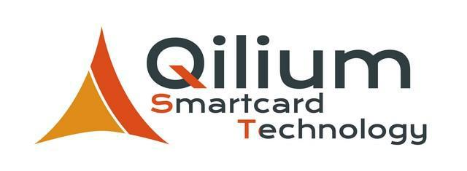
Job Proposal

Enterprise

Qilium is a dynamic and expanding Belgian SME's. Our company gives you the opportunity to take part into projects in banking and loyalty (EMV), transportation (ITSO, CALYPSO, CI-PURSE), access control, telecommunications (SIM, M2M, NFC) and smart cities. Active for over 7 years in the development of operating systems for smart card, Qilium helped many companies to manage functionality, commands and security on microcontrollers. Benefiting from a human sized company and flexibility, we are constantly innovating in order to bring added value to our customers and clear benefits to end users. Collaborating with many partners, you will have the opportunity to have an overview on various projects. You will provide concrete solutions to problems that will challenge the world of information and communications technology in the future.

Job description

Develop Custom made Operating System (OS) and associated tests (Bits & Bytes) Improve & optimizes Operating system software components

Debug systems and perform improvements

Familiarize with the tools, applications, and processes carried out during the development Analyse customer needs and implement it as functionalities

Develop and test Java card Applets

Prepare project documentations during the application development lifecycle Perform project planning, work forecasts and accurate reporting

Skill requirements

Master’s Degree in Computer Science or Telecommunication or Electrical Engineering or

Physics or Mathematics
Fresh Graduate with good degree from reputable Institution or minimum 1-2 years of similar

experience in related field

Foundation and knowledge of C, C++ and Java (Card) Knowledge of algorithms and good programming level Able to read international standards (ISO, ITSO, ICAO...) Smartcard knowledge will be an advantage

Some knowledge of GSM, CDMA, 2G and 3G telecommunication principles will be an

advantage
Strong analytical, problem-solving, and conceptual skills

Proficient in English (Verbal & Written), Good communication skill, attention to detail,

persistence, and able to work under pressure French speaking is an advantage

Autonomous, flexible, Dynamic, able to handle multi tasks, proactive, resourceful and with initiative

Contact information :
Jean-Philippe Gossieaux |  | Managing director |  | jpg@qilium.com
 |  | +32 (0) 68 65 65 26
Thibaut Wiame |  | Business Development Manager | thw@qilium.com
 |  | +32 (0) 68 65 65 27

