Initial recurring donation receipt template

Hi Davey,Thank you so much for setting up a recurring donation with us! We’re so delighted you would choose to commit to supporting the sea turtles on a regular basis.
Your first donation will draft on the next occurrence of the date you chose so be on the lookout for that! When the gift processes, we’ll send you a receipt for that, too.
You can click on the link below to manage your giving account and see the details of this donation with our donor management system, Kindful.
Thanks again!
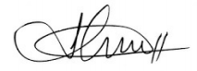
Jonathan
The Sea Turtle Foundation

