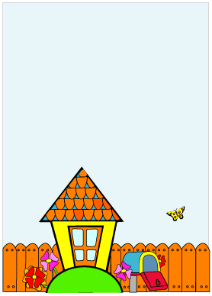

**We went out on a limb and . . .**

**now we're homeowners!**

**Join us for a**

**Housewarming Wing-Ding**

**They finally got the house!**

**Please come and help**

**celebrate at a Housewarming Party**

**at____________________**

**rsvp:**