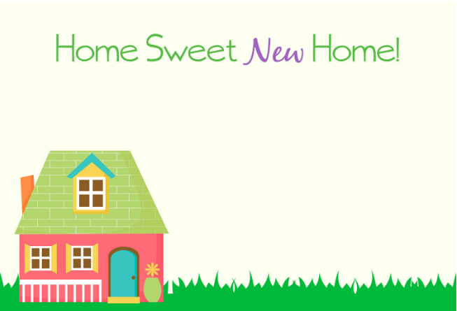

**We've packed up boxes, lamps, and chairs . . .**

**our home is somewhere new.**

**We couldn't leave and settle in**

**without telling you**

**We're finally moved,**

**and boy - it was rough!**

**We never knew we had so much stuff!**

**Our New Address Is**

**We've packed up boxes, lamps, and chairs . . .**

**our home is somewhere new.**

**We couldn't leave and settle in**

**without telling you**

**We're finally moved,**

**and boy - it was rough!**

**We never knew we had so much stuff!**

**Our New Address Is**