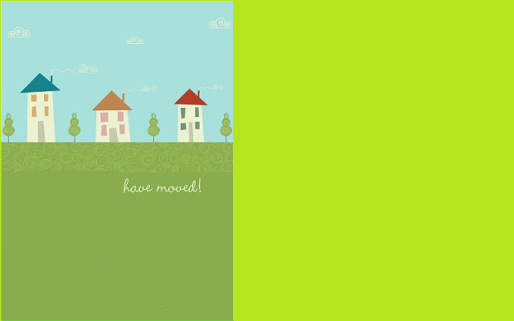

Smith Family

**We finally moved, but we'll still be around.**

**We didn't go far just across town!**

**The boxes are gone,**

**we've cleaned up the mess.**

**We'd like to give you**

**our new addressour**

**________________________________**

**We finally moved, but we'll still be around.**

**We didn't go far just across town!**

**The boxes are gone,**

**we've cleaned up the mess.**

**We'd like to give you**

**our new addressour**

**________________________________**

Smith Family