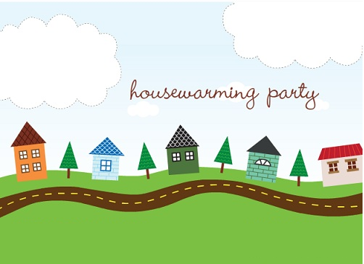

Address:________________________________________

Rsvp:

Address:________________________________________

Rsvp: