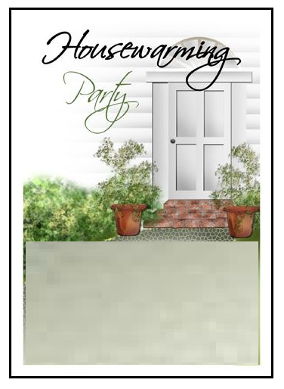

**All unpacked, we're finally here,**

**we want to celebrate,**

**with our friends so dear!**

**Please join us for a dinner party**

**at our new home.**