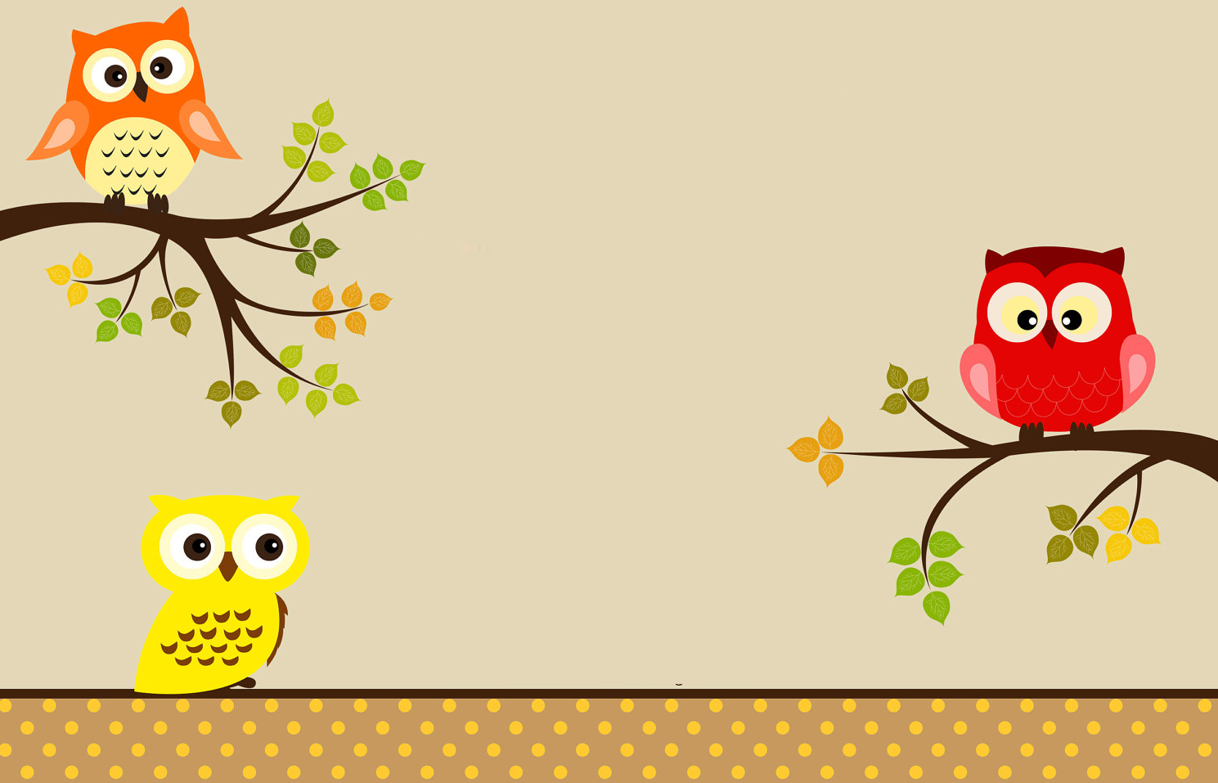

The boxes are unpacked

And I'm finally here

In a house that welcomes

Friends so dear.

_____________________

My door is always open to you!

The boxes are unpacked

And I'm finally here

In a house that welcomes

Friends so dear.

_____________________

My door is always open to you!