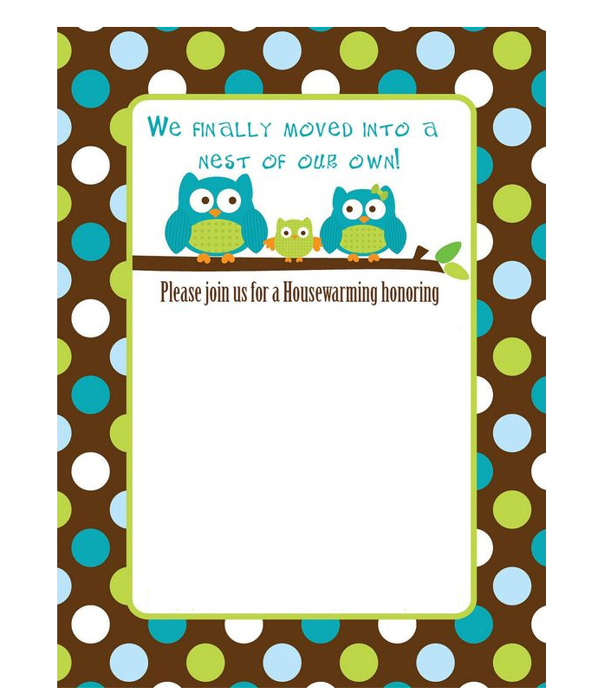

Our New Residence - You are invited to a housewarming party! Join us on 9 May, Sunday, 3-5pm as we blow the trumpet to celebrate this occasion. Hosts - Mr and Mrs Jacky, 13 Hero Street, Holy Ave, Salisbury, Maryland.