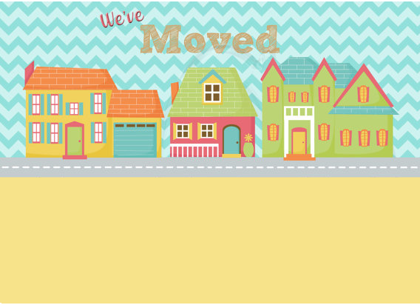

**Mr and Mrs Perez cordially invites you to dance and dinner to celebrate the completion of our new home on 18 June**

**Mr and Mrs Perez cordially invites you to dance and dinner to celebrate the completion of our new home on 18 June, Sunday at 8pm. Mercy Estate, 18 Kennedy Ave, Georgia. RSVP xxxxxxxxxxxx**