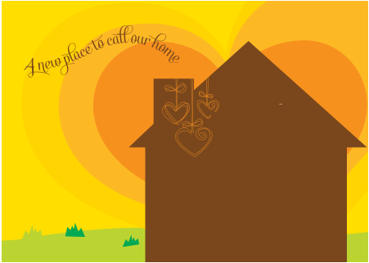

We outgrew our house

there wasn't enough space

We hope you'll come and visit

and see our new place!