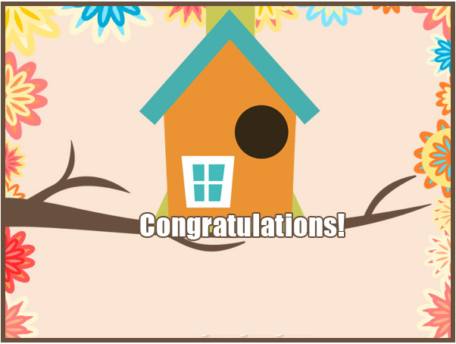

THE THINGS THAT MAKE A HOUSE A HOME

ARE THE PEOPLE THAT FILL IT UP

JOIN US FOR OUR HOUSEWARMING!

THE THINGS THAT MAKE A HOUSE A HOME

ARE THE PEOPLE THAT FILL IT UP

JOIN US FOR OUR HOUSEWARMING!