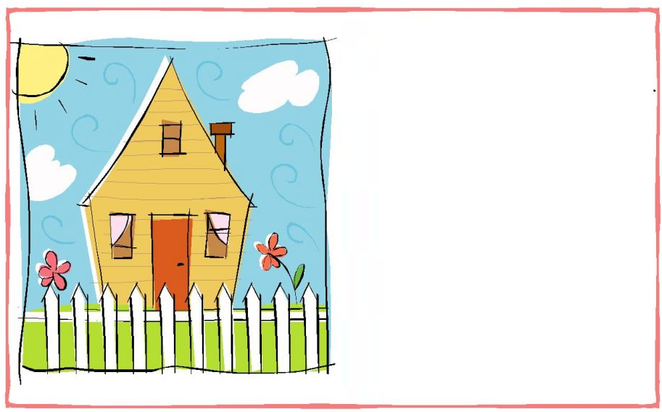

We've moved again,

but we haven't traveled far.

We're inviting you to a party

so you'll know where we are!

Housewarming Party!

Sunday, November 2nd

5568 Camphor Lane

Panama, FL 33856

.

We've moved again,

but we haven't traveled far.

We're inviting you to a party

so you'll know where we are!

Housewarming Party!

Sunday, November 2nd

5568 Camphor Lane

Panama, FL 33856

555.123.4567

Tour at 5:00 p.m.

Dinner at 7:00 p.m.