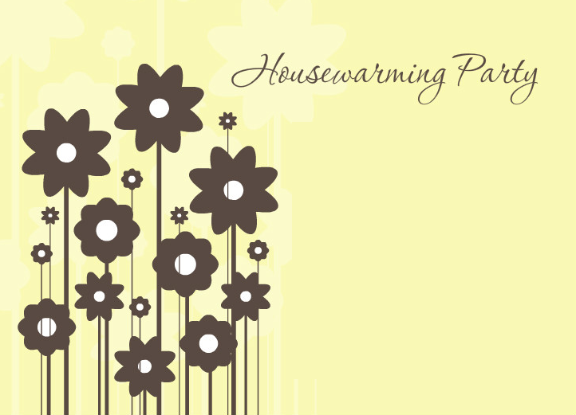

**We're finally in our new place, and all the boxes are thrown away!**

**Housewarming Party**

**Jenny and Peter**