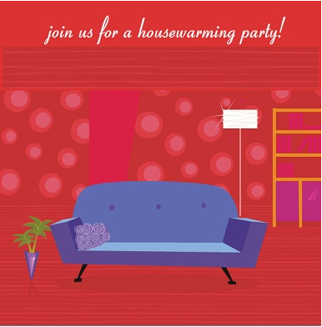

**WE ARE IN A NEW HOUSE.**

**YOU CAN REACH US AT HOME BY PHONE OR BY A CLICK OF THE MOUSE!**

**E-MAIL _____________________**

**Rsvp______________________**