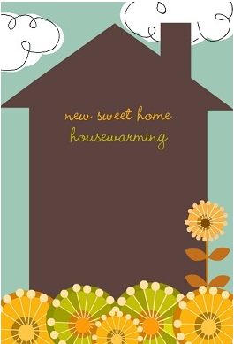

**With a roof over our head and floors under our feet. The [last name] family move is finally complete! Please stop by our housewarming party.**