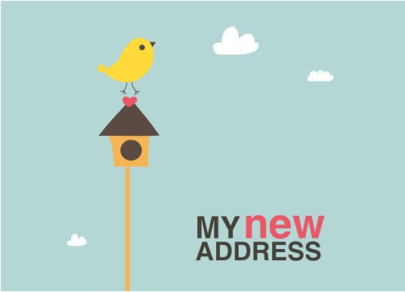

**We’re heading in a new direction and we want you to come! Meet us at our brand new house for a grand housewarming celebration!**

**Residence Address**



**We’re heading in a new direction and we want you to come! Meet us at our brand new house for a grand housewarming celebration!**

**Residence Address**

**222-222-22**