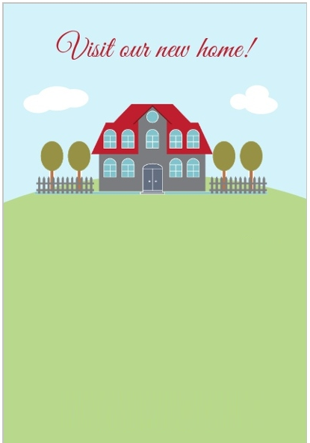

We have just moved in and believe me, knowing you has been such a comfort. We would like to get to know you better on drinks, dinner and lots of chatter at our housewarming party.

At __________