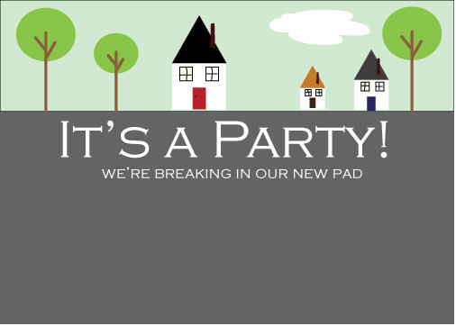

They say only people make a house, a home. With true friends like you around I am assured that my new house will be a home in no time. So why don’t you join us for a housewarming party this Saturday (date, time and complete address)

They say only people make a house, a home. With true friends like you around I am assured that my new house will be a home in no time. So why don’t you join us for a housewarming party this Saturday (date, time and complete address)