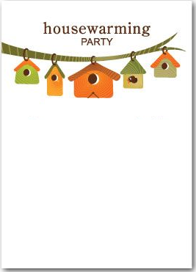

**My family and I request your presence at our new home to celebrate in the new chapter of our lives. Our housewarming party is on (date) at (address). Please do come and celebrate with us**