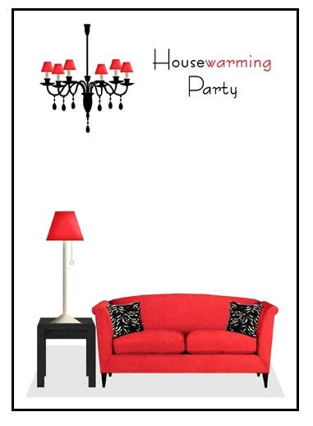

**Join us in celebrating a new chapter of our lives in our new house in a new environment on (date) at (address)**