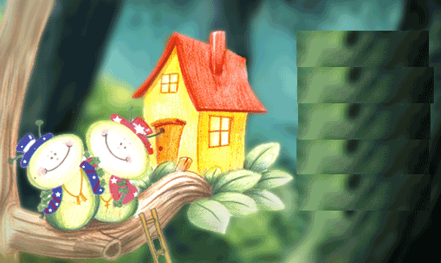

**Our flock has finally moved to our new nest**

**Join Us on**

**At __________________**

**Our flock has finally moved to our new nest**

**Join Us on**

**At __________________**

**Our flock has finally moved to our new nest**

**Join Us on**

**At __________________**

**Housewarming**



**Housewarming**