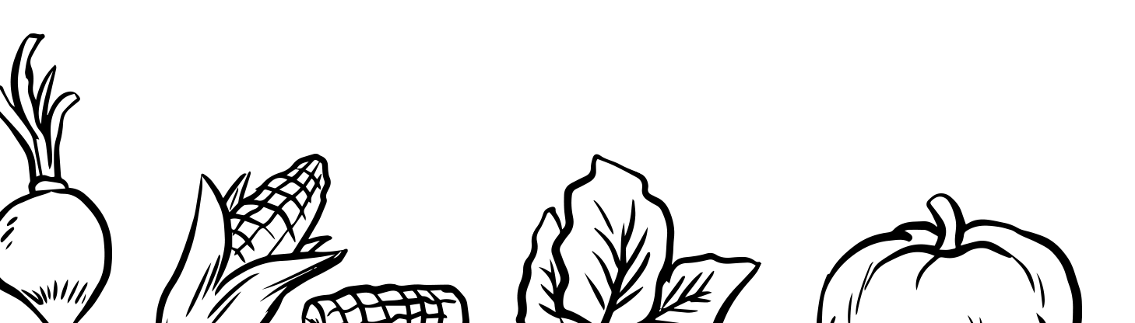

OTHER

HOME SUPPLIES

TOILETRIES

BEVERAGES

BAKED GOODS

SNACKS

DAIRY / DELI

CANNED GOODS

CONDIMENTS / SAUCES

MEAT / POULTRY / FISH

GRAINS

FRUITS / VEGETABLES