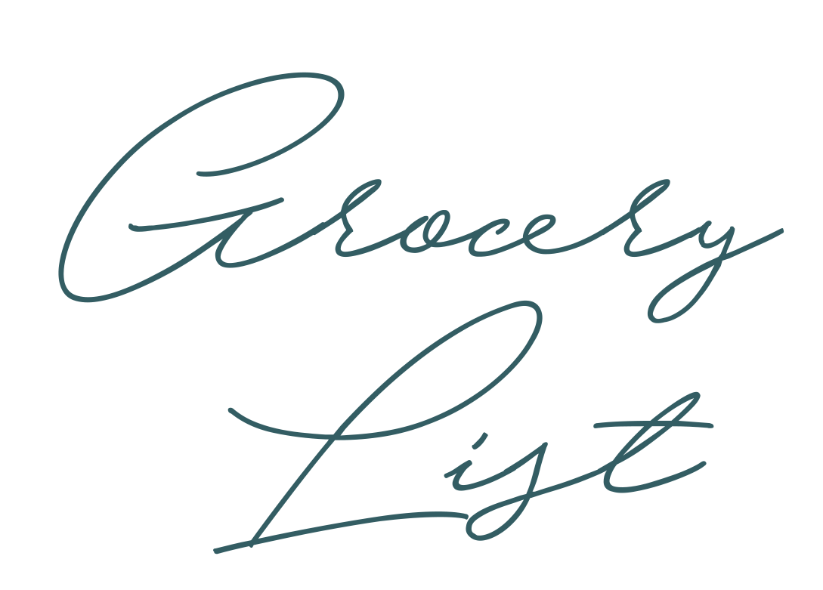

Other

v

v

v

v

v

v

v

v

Home Supplies

v

v

v

v

v

v

v

v

Toiletries

v

v

v

v

v

v

v

v

Dairy / Deli

v

v

v

v

v

v

v

v

Canned Goods

v

v

v

v

v

v

v

v

Condiments / Sauce

v

v

v

v

v

v

v

v

Meat / Poultry

Grains

v

v

v

v

v

v

v

v

v

v

v

v

v

v

v

v

v

v

v

v

v

v

v

v

Fruits / Vegetables