How to write Grant Proposal

1 Abstract

The proposal abstract (one page maximum) outlines the proposed project and should appear at the beginning of the proposal. It should be brief. You may prepare the abstract after the proposal has been developed in order to encompass all the key points necessary to communicate the objectives of the project. The initial impression it gives will be critical to the success of the proposal.

The proposal abstract should include a brief on:

- Summary on the benefits of your project and the expected impact

- Description of the project in view of the local need.

- Summary on your request.

- Summary on your objectives and proposed methods.

- The consequences of the project as a result of funding

- How your project is innovative

2 Introduction

The introduction provides a framework for the evaluators, helping them to understand where the proposal is heading. The Introduction is the beginning of the proposal narrative. It gives the evaluator a proper background on the applicant. You should address, in no particular order, as much of the following as possible:

_ Identification of the applicant

_ The reason for the grant request – issue, problem, or need _ The objectives to be achieved through this funding

_ The kind of activities to be conducted to accomplish these objectives

3 Background

This is the most important part of the proposal because everything revolves around it. It describes the circumstances or conditions that you want to change. Your concern should be external to your organization, not focused on your internal needs. You must have a baseline, which identifies the scope of the problem and your starting point in addressing it. Document everything that you can. Be specific and precise.

The proposal Background should:

1. Describe the need for this kind of project.

Guide for Proposals, Version of Monday, April 06, 2009 at 16:58, Page4

- Outline the portion of this larger problem you plan to deal with.

- Supply statistical documentation of this specific or local problem (fewer
statistics convincingly presented are better than many explained weakly).

- Include Expert opinions (including quotes).

- Include Literature review.

- Document the significance of the problem with Data.

- Include the problem identification which must be achievable and creates a need for some type of planned action.

- Establish the theme for the proposal and it must state with clarity of purpose.

- Determine the major focus of the proposed project and stresses
why this particular program should be undertaken.

- Include the problem statement which must provide entrée to the other subsections of the proposal.

4 Wider Objective(s)

The wider objective(s) describe(s) clearly the expected general outcome(s) of the project. Wider objective(s) should be achievable within the project duration. The next section:

“Statement of the Proposed Research” should be able to detail such wider objective(s)

5 Statement of proposed Research (SPR)

This section describes what you want to accomplish. You must describe the statement of the Proposed Research (SPR) using the “SMART” way

_ Specific
_ Measurable
_ Achievable
_ Realistic
_ Time-limited

You must take into consideration that:

- SPR should be stated with action oriented verbs such as “demonstrate”, “test”, “develop”, etc.

- SPR must succeed in communicating its intent.

- The SPR are the basis for determining the procedural aspects of the program,

and therefore must be carefully planned.

- The SPR must be briefly and succinctly stated; A sentence or two at most for each one.

- The quality of written SPR will largely determine the effectiveness of the evaluation design.

Guide for Proposals, Version of Monday, April 06, 2009 at 16:58, Page5

- SPR must be easily noted and not be imbedded in the narrative of the proposal.

- Prioritized SPR indicate good planning by the principal investigator.

- The expected results are to be measured against the objectives.

Don't confuse SPR with methods. Methods describe ways of executing SPR.

6 Methods & Procedures

This section is the core of your proposal, it should describe your project design, and how will you will be able to achieve your objectives. It should explain in a narrative way, different activities that you intend to take during the lifetime of the project, and it must explain the rationale for the program (relate it to the problem) and explain how the program will work. Main elements of this section should include:

_ What - Proposed activities to bring about the desired results

_ Who - The target group; also, who will be responsible for implementing methods

_ When - Timeline; charts are a good tool to use as a "snapshot" in highlighting when activities will take place and objectives will be achieved

Methods and objectives are often confused with each other; they’re closely related: “Methods” should tell how they are the means to realize the “Objectives”.

The methods section is often the longest part of a proposal. It should contain:

- Description of the methods you plan to use to accomplish each of your objectives

- Description of how you will implement these methods. Mention who will
be responsible for implement each objective (title, and background).

- Description of the plan of action.

- Description of the activities and/or processes for carrying out your program objectives, and the reasons for selecting the particular approach.

- Presentation of a reasonable scope of activities that can be accomplished within the

time allotted for the project activities and within the resources of the applicant.

- Description of the staffing expertise to be involved in order to provide greater assurance of achievement.

- Development of a sequential procedure required for the project implementation.

- Sequence of your procedures providing a structure for monitoring
and evaluation of the effectiveness of each objective.

Guide for Proposals, Version of Monday, April 06, 2009 at 16:58, Page6

7 Facilities & Equipment

The proposer should prepare a section on facilities available for the project. A list of adequate facilities confirms the capabilities of the proposing institution’s strength in the intended field of study.

The description of facilities should include that of any special equipment or unusual asset in the institution’s physical plant which might enhance the project’s success. Indicating their accessibility, the proposal should describe such items as specialized computers, pertinent library collections, laboratories, space, and unusual services. Mention should be made of and justification provided for additional items needed to complete the work, but, to state that a proposing institution is lacking enough to need excessive equipment would be to suggest weakness leading to a proposal’s poor evaluation. On the other hand, an institution’s willingness to commit equipment and space to a project’s use could only serve to heighten the proposal’s chance for award.

During the course of the project, if it is necessary at times to use another organization’s facilities or equipment, the proposal must document their availability to the project. The choice of a project site which is not home based would require substantial explanation as to its attributes and appropriateness.

It is important to note that this section on facilities and equipment might not be filled by applicants for the Young Research Grants or the Reintegration Grants

8 The Budget

This is a plan on how much you'll need to accomplish the SPRs. Anything in the methods section needs to appear in your budget, and vice versa. The budget should contain an explanation or calculation showing how you came up with the total project budget for each budget line. The following items should be taken into consideration

_ Itemize & account for all costs _ Justify budget items

_ Try not to overestimate or underestimate resource needs

Budget lines for mechanisms of the STDF may include:

_ Salaries: This budget line states the salary to be paid to everyone involved in the
project. It should contain an estimation of the percentage of time each person
listed will be spending on the project and multiply it by his or her salary.

_ Rental, lease, or purchase of equipment -. It includes office equipment, desks, copy machines, word processors (valid ONLY for Basic and Applied Research Grants)

_ Office supplies: Such as papers, chemicals, and any costs necessary for the smooth running of equipment

_ Travel: Costs related to travels (cost of tickets, perdiems, etc.)

_ Other costs: For items that don't fit into other budget line items such as publications, etc.

Guide for Proposals, Version of Monday, April 06, 2009 at 16:58, Page7

_ Indirect costs. These are costs not be associated directly to the project. They are costs that are claimed by the host institution as a compensation for costs that can't be quantified, including administrative and accounting costs, operation and maintenance of
buildings and equipment, depreciation, etc.(20% After exclusion of equipment )

Sources of funding for the above mentioned budget items, may include: funds requested from the STDF, co finance from other sources (including your own).

Annex 1 of this template illustrates a suggested budget format.

9 List of References

If the proposal contains a limited number of references, footnotes may be used in the text to cite them. If references are used extensively, they should appear after the budget and in separate list form where they are numbered as they occur in the text; they should be referred to accordingly in the text itself. Each reference listed should include the name of the author, title, publication or publisher, volume and issue number, page numbers, and date of publication.

10 Bibliography

Literature which has not been referred to in the proposal text, yet has served as source material, should be enumerated separately in a bibliography section. This section too consists of a list alphabetized by author and following the format of the list of references. A bibliography should cite the field’s most current and relevant literature.

11 Appendices

Documentation additional to that in the proposal text should be attached in appendices. The proposal should present a list of appendix items either in the proposal’s table of contents. Items incorporated into various appendices should be referred to in the text and might include: background charts, tables, graphs and line drawings; resumes of personnel preprints of publications prepared by project personnel and pertaining to the proposed project; letters from consultants or collaborative agencies expressing willingness to participate in the project; letters of endorsement from organizations or individuals familiar with the problem to be studied or with previous work of the project staff; and any other information corroborating staff competence.

Guide for Proposals, Version of Monday, April 06, 2009 at 16:58, Page8

12 Annex 1: Budget format

This format must be estimated for each year of the project

 |  |  | STDF support | Cost sharing | Total project
 |  |  |  |  | Costs
Eligible costs | Break downs
 |  |  | (L.E.) | (L.E.) | (L.E.)
 | PI (Salary per month) multiplied by number of
 | months. Please indicate the % of time spent
 | on the project
( A ) | For Each of the Assistants, please indicate the
 | salary per month multiplied by number of
Salaries | months. Please indicate the % of time spent
 | on the project
 | Consultant fees (if applicable)
 | Total salaries
( B ) | STDF purchases
Equipment (Not valid for Young | Non-STDF purchases
Research & Reintegration grants)
 | Total Equipment
 | Stationary
( C )
 | Miscellaneous Laboratory Materials
Expendable Supplies & Materials
 | Total expendable Supplies & Materials
 |  | Air tickets
 | International
 |  | Per Diem
( D ) |  | Transportation
 | Domestic
Travel |  | Per Diem
 | Conference registration
 | Total travel
 | Computer services/time
 | Report preparation
( E ) | Publications Costs
Other Direct Costs | Telephone and Postage
 | Workshops
 | Others

 | Total other direct costs
( F )
Total Direct Costs | Sum of (A ) through ( E ) above
( G ) | Total direct costs minus Equipment
Modified Total Direct Cost (MTDC) | ( F minus B )
( H )
Indirect Costs as 20% of Modified | 20% of ( G )
Total Direct Cost
( I ) | Total Direct Costs Plus Indirect costs
Total Project Cost | ( F Plus H )

Guide for Proposals, Version of Monday, April 06, 2009 at 16:58, Page9

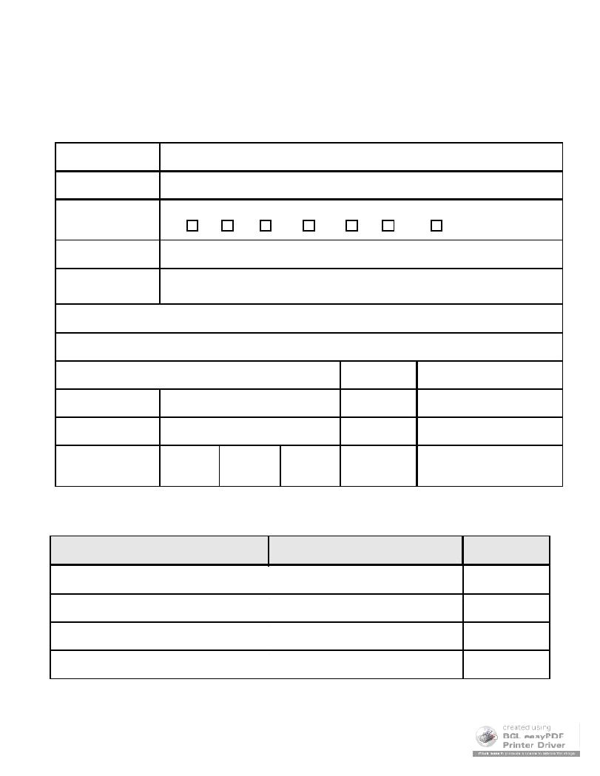
13 Annex 2: CV format

Please copy the following sections to your word processing and fill them up. Please fill ALL sections included

13.1 PERSONAL DETAILS

Surname

Other names

Title

Prof | Dr | Mr. | Mrs. | Miss | Ms | Other | Please specify
Female ₃ |  |  |  | Male ₃

Gender

Address

 |  |  |  | Post Code
Telephone Numbers |  |  |  | Evening
Mobile |  |  |  | Email
Date of birth | Day | Mo | Yr | Place of birth

13.2 EDUCATION
Please start with the most recent degree (use extra lines if necessary)

School/College/University/Other Degree obtained Dates (from-to)

Guide for Proposals, Version of Monday, April 06, 2009 at 16:58, Page10

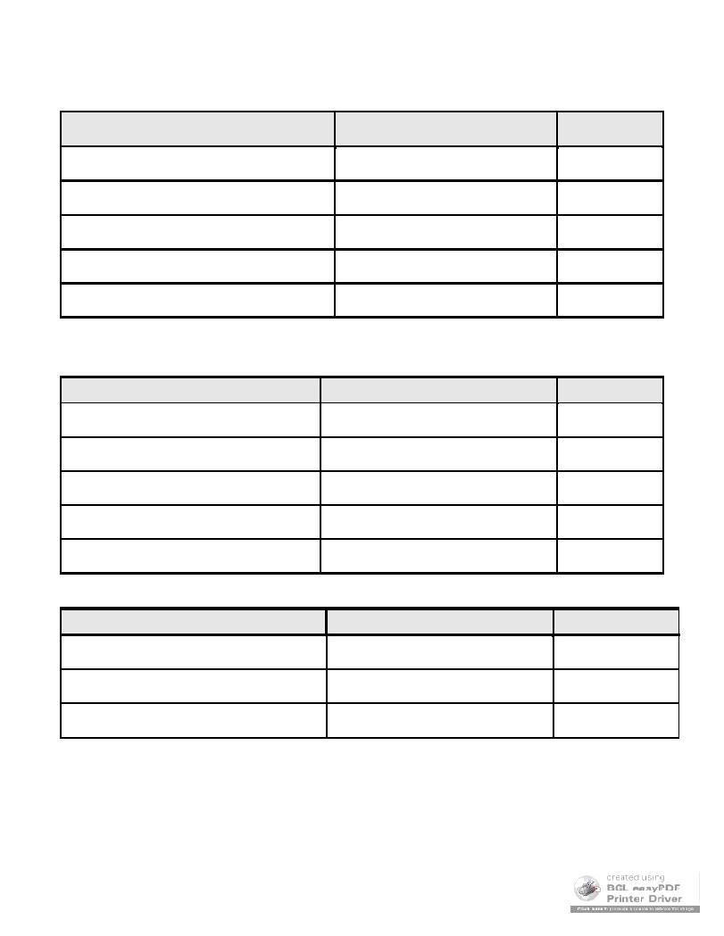
13.3 TRAINING

Please start with the most recent degree (use extra lines if necessary)

Training attended / Technical skills acquired Place

13.4 EMPLOYMENT HISTORY

Please start with your /most recent post first (Use extra lines if necessary)

Employer Position

13.5 MEMBERSHIP OF PROFESSIONAL ASSOCIATIONS Professional bodyLevel of membership

Dates (from-to)

Dates (from-to)

Year of award

Guide for Proposals, Version of Monday, April 06, 2009 at 16:58, Page11

- FIELDS OF INTEREST

- PUBLICATIONS AND PATENTS Please list ONLY (do not attach copies)

- PRESENTATIONS

- GRANTS/ AWARDS

- ADDITIONAL INFORMATION

Please state any additional relevant information

Guide for Proposals, Version of Monday, April 06, 2009 at 16:58, Page12

14 Annex 3: Logical Framework Matrix

Logical Framework Matrix (LFM) is an analytical, presentational and management tool, which helps in developing a high quality project design.

To develop an LFM for your project you need to address and answer a number of questions. Although the questions seem self evident, articulating the answers to those questions exposes many unstated assumptions and hypotheses.

LFM consists of logically connected four columns and four rows, which summaries key features of the project. The columns, on the left hand side, illustrate the hierarchy of the objectives of the project. The rows are concerned with the different levels of objectives. For each given level, a row describes the following:

_ Indicators which will be used to measure the achievements of the objectives/outputs;

_ Means of verification which indicate how the information on those indicators are to be collected and verified; and

_ External factors that might hinder the achievement of project objectives on time.

Use STDF template, available at LFM Template, to develop an LFM for your project. This template will guide you on how to fill the LFM. The developed LFM must be uploaded together with the project proposal.

Guide for Proposals, Version of Monday, April 06, 2009 at 16:58, Page13

15 Annex 4: GANTT Chart

This is a graphical representation of a project’s schedule which illustrates the work breakdown structure. It is an effective tool for planning, scheduling, coordinating, and tracking all tasks within your project.

To develop your GANTT chart, you should start by specifying the main tasks/ activities making up your project. Then break down each main task/ activity to its sub tasks/ sub activities. The amount of time required for each task/activity and sub tasks/ sub activities is represented as a horizontal bar on the chart. Those horizontal bars of varying lengths represent the sequences, timing, and time span for each task/ sub task.

In the enclosed GANTT chart template, an explanation of different requirements (e.g. duration, working days, etc.) will guide you on completing the chart.

Notes:

_ You will need to highlight the dates of reports submission in alignment with STDF guidelines.

_ You need to estimate the cost of the main activities in your project. The sum of the costs of those activities must be equal to the budget request in your project proposal.

_ Only for Basic and Applied Research Grants, a maximum of 20% indirect cost
must be considered while calculating the budget:

_ Indirect cost= 0.2 (total budget – cost of equipment).

Use STDF template, available at GANTT chart, to develop a GANTT chart for your project. This template will guide you on how to develop a GANTT chart. The developed GANTT chart must be uploaded together with the project proposal.

Guide for Proposals, Version of Monday, April 06, 2009 at 16:58, Page14

