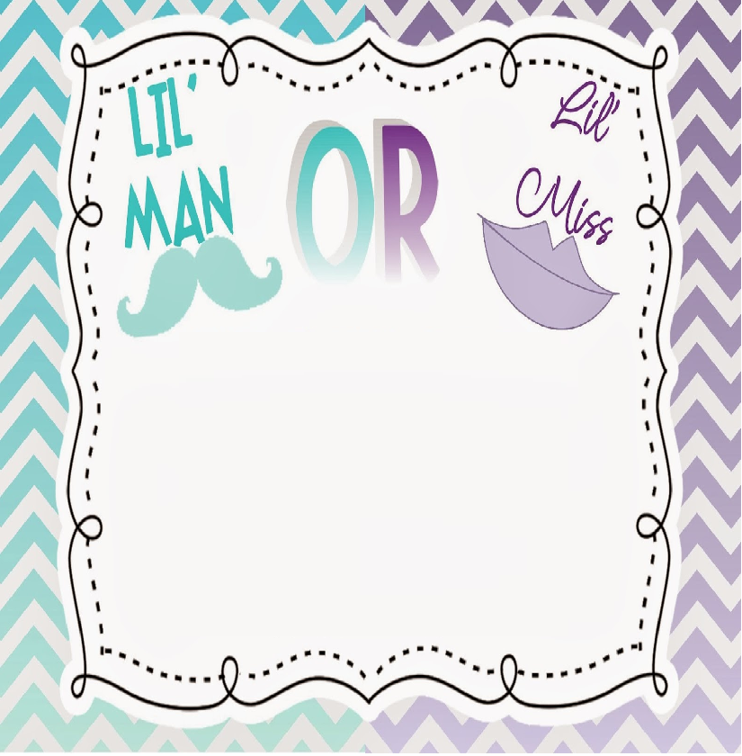

Pink or Blue for our bundle of Joy?

Come find out if were having a baby Girl or Boy?