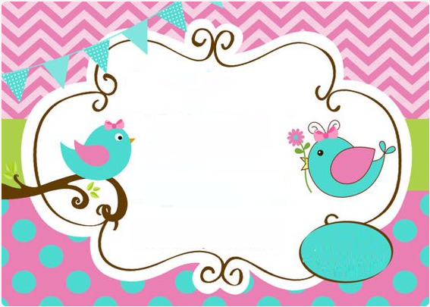

Ten little fingers,

Ten little toes,

Be it boy and girl

Nobody knows!

Come to celebrate this exciting event

On _________________