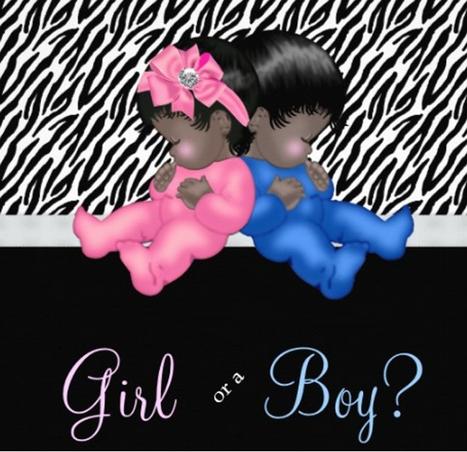

**Let us celebrate for a Baby Reveal**