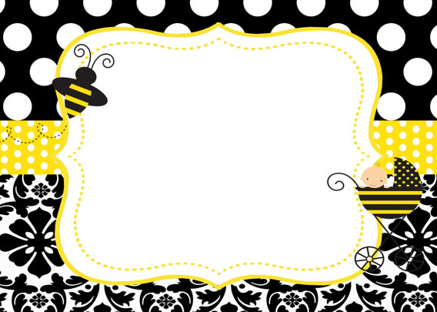

**Be it a boy or girl, nobody knows!**

**Join us as we shower NAME from head to toe!**