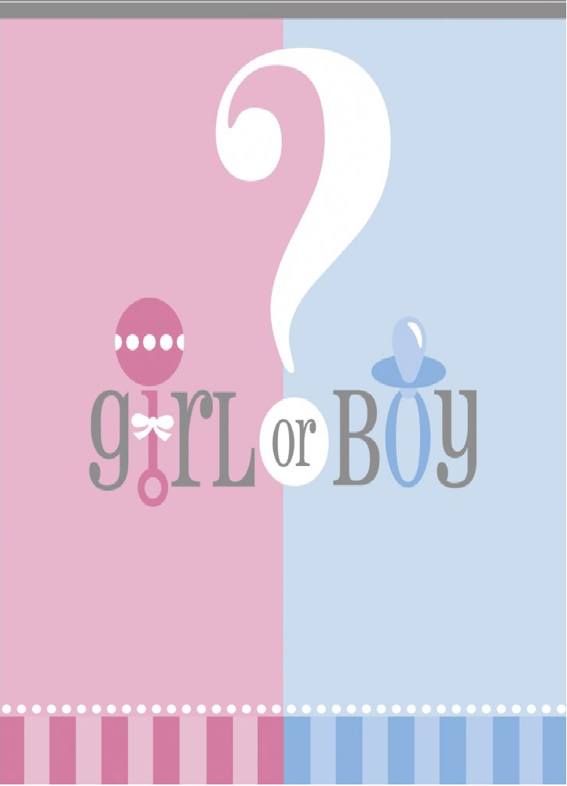

Will it be Snips n' Snails

And Puppy Dog Tails

Or Sugar n' Spice

And Everything Nice?

Please join us for a Baby Reveal Party