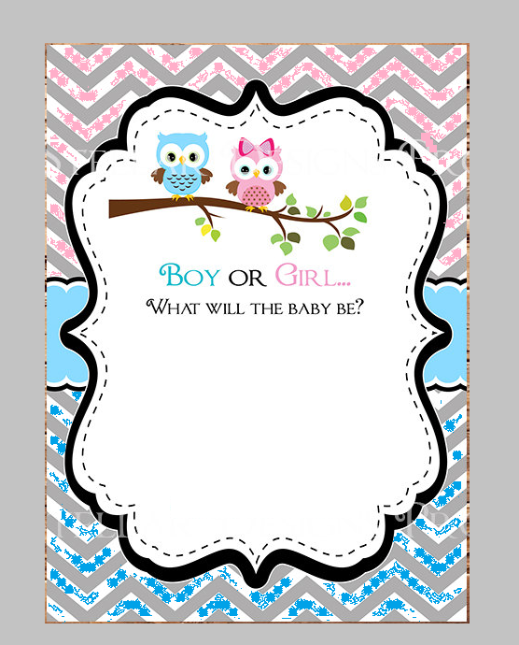

Please come join us in sharing **NAME**joy  
As she prepares for a little girl or boy!