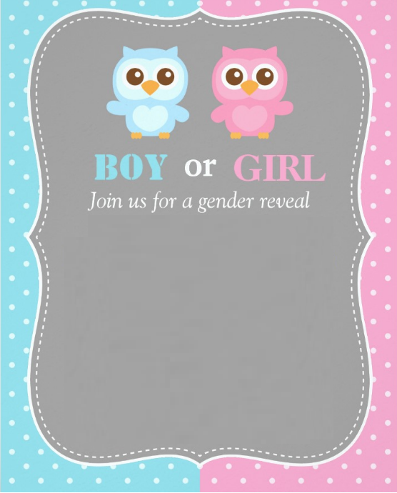

**TEAM PINK** or **TEAM BLUE**?

**You’re Invited to a Gender Reveal Party**

**Find Out Whether Baby Peterson** **Will Be a BOY or a GIRL**

**Join Us For Food, Drink, Games, and the BIG NEWS**