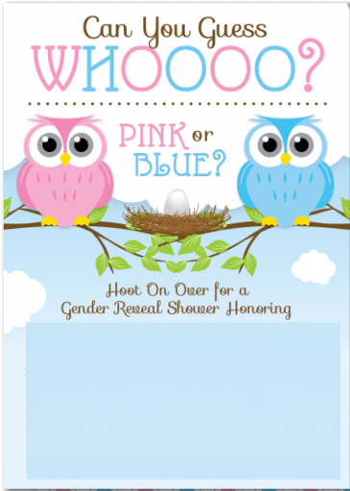

**Baby Scoth**

**Join Us For a Gender Reveal Party and be One of the First to Find Out!!!!**



**Baby Scoth**

**Join Us For a Gender Reveal Party and be One of the First to Find Out!!!!**