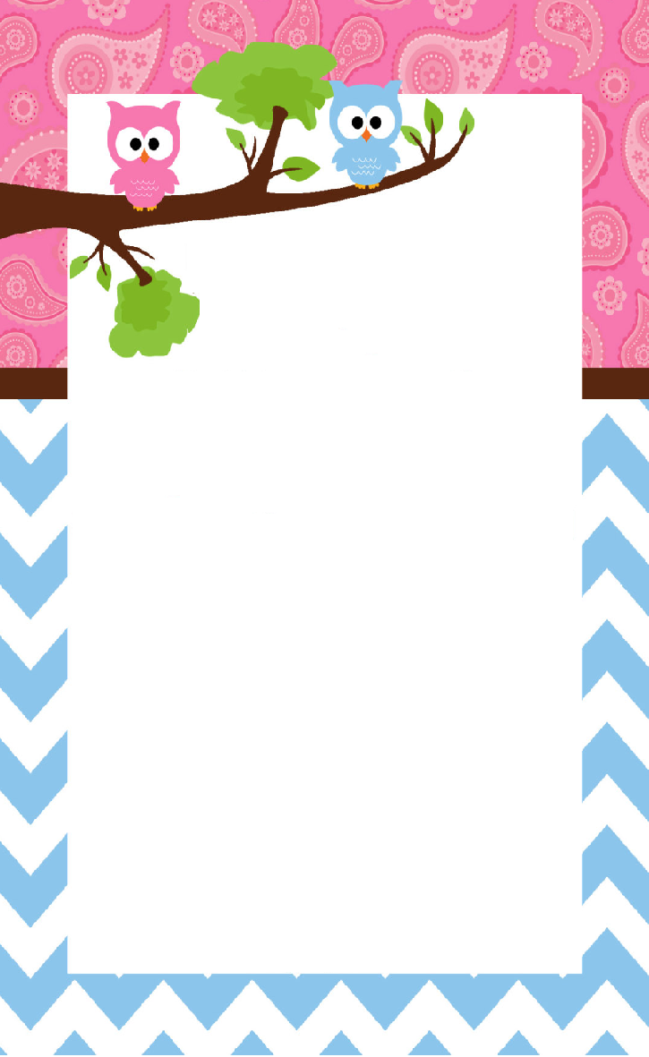

**Boy or Girl ?**

**Find out at the Same Time We Do!  
Wear BLUE or PINK**

**and Let Us Know What You Think**