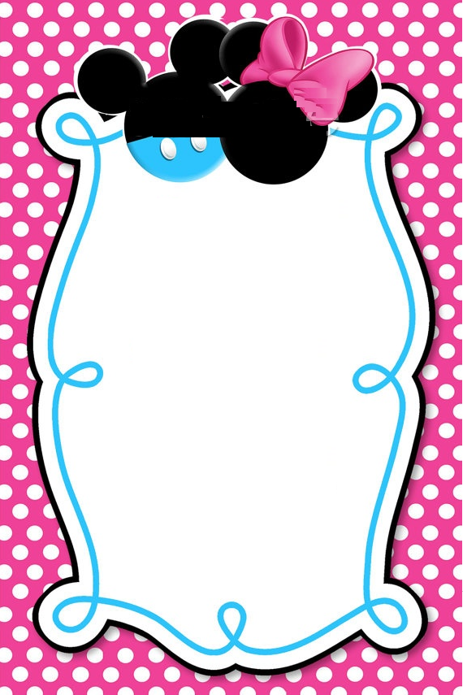

Boy or Girl?

Find out at a baby shower honoring

Baby _______

Your presence is more important than your presents.