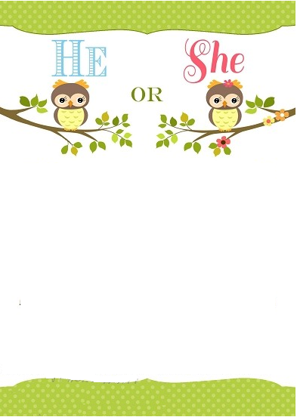

Will it Be  
ACTION FIGURES or DOLLIES?  
Join Us For A  
Gender Reveal Party  
To Learn Whether Baby Matheson is a BOY or a GIRL

On ______________________

At ______________________



Will it Be  
ACTION FIGURES or DOLLIES?  
Join Us For A  
Gender Reveal Party  
To Learn Whether Baby Matheson is a BOY or a GIRL

On ______________________

At ______________________